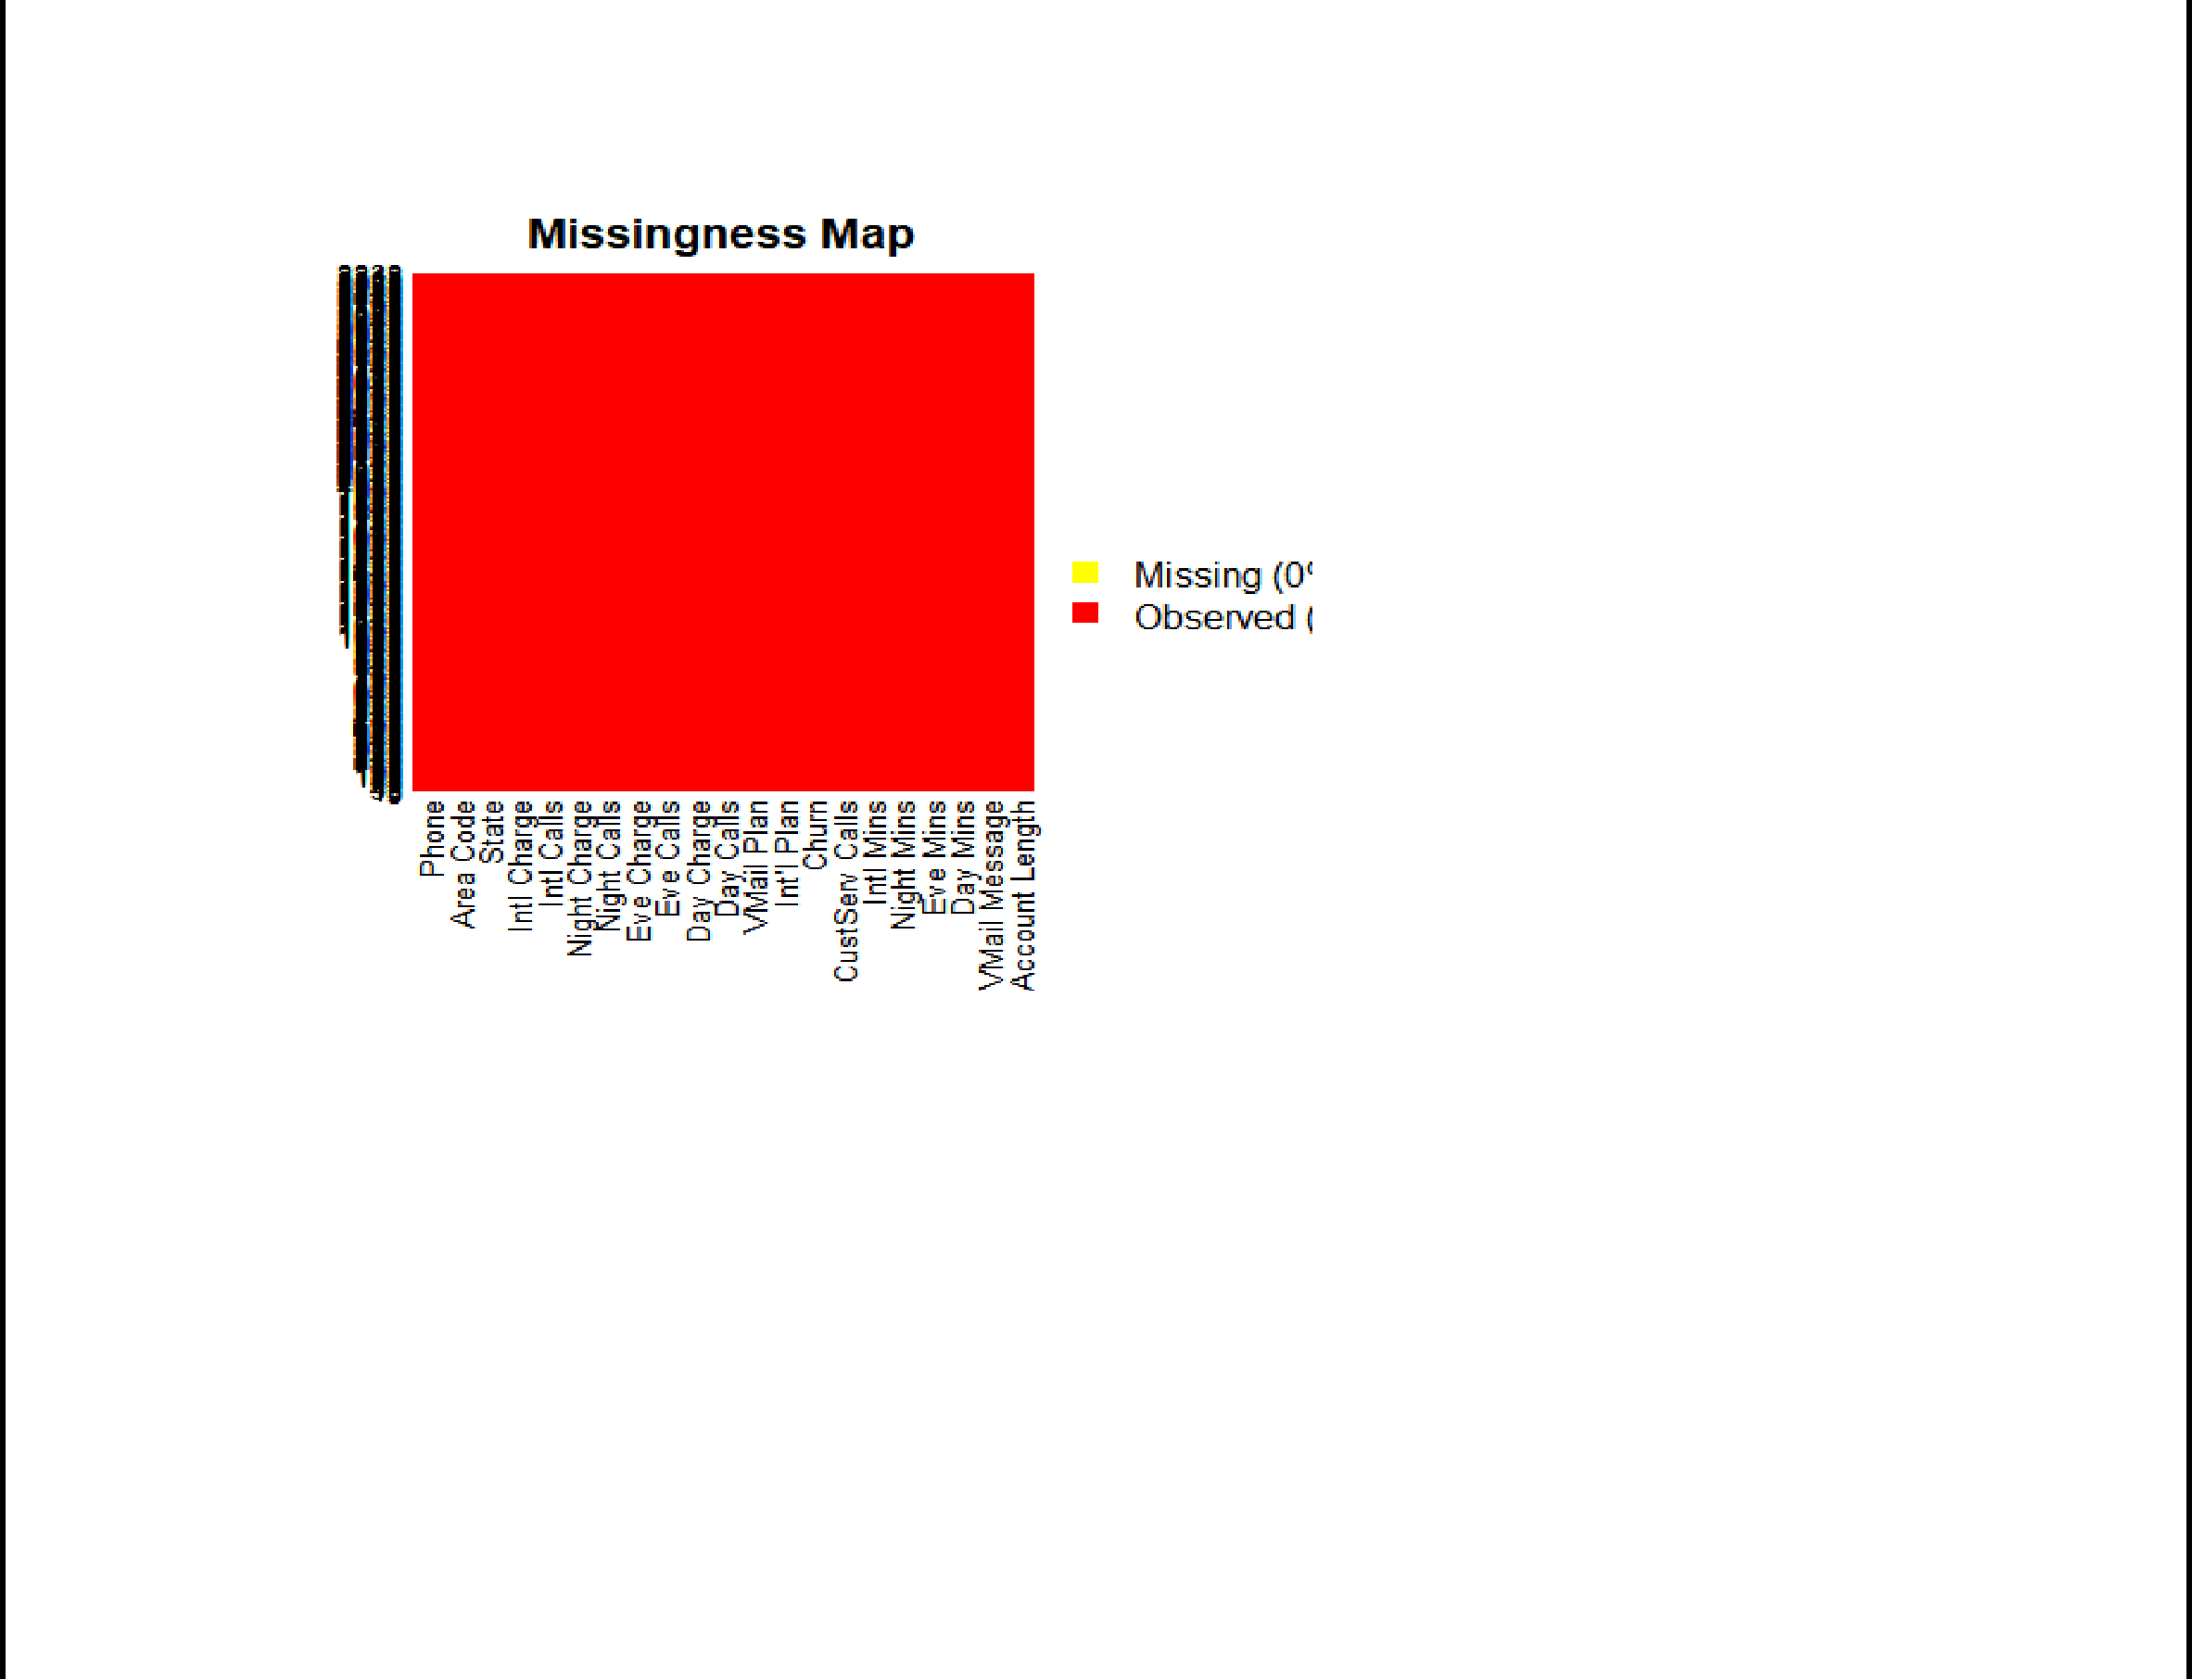

LogModel <- **glm**(Churn **~** .,family=**binomial**(link="logit"),data=training)



**print**(**summary**(LogModel))



##



* Call:
* glm(formula = Churn ~ ., family = binomial(link = "logit"), data = training)
* Deviance Residuals:



|  |  |  |  |  |  |  |
| --- | --- | --- | --- | --- | --- | --- |
| ## | Min | 1Q | Median | 3Q | Max |  |
|  |
|  | |  |  |  |  |  |
| ## | -2.1332 | -0.5222 | -0.3425 | -0.1992 | 3.2941 |  |
| ## |  |  |  |  |  |  |
| ## | Coefficients: | |  |  |  |  |



|  |  |  |  |  |  |  |  |  |  |
| --- | --- | --- | --- | --- | --- | --- | --- | --- | --- |
| ## |  |  |  | Estimate Std. Error z value Pr(>|z|) | | | |  |  |
| ## (Intercept) | | | | -7.420e+00 | 1.024e+00 | -7.249 | 4.2e-13 *** | | |
| ## `Account Length` 1.141e-03 | | | | | 1.533e-03 | 0.744 | 0.456828 |  |  |
| ## `VMail Message` | | | | 4.207e-02 | 2.027e-02 | 2.075 | 0.037983 | * |  |
| ## `Day Mins` | | | | -1.341e+00 | 3.624e+00 | -0.370 | 0.711274 |  |  |
| ## `Eve Mins` | | | | -6.519e-01 | 1.813e+00 | -0.360 | 0.719209 |  |  |
| ## `Night Mins` | | | | -4.968e-01 | 9.739e-01 | -0.510 | 0.610007 |  |  |
| ## `Intl Mins` | | | | -7.267e-01 5.875e+00 | | -0.124 0.901560 | |  |  |
| ## | `CustServ Calls` 5.299e-01 4.387e-02 | | | | | 12.079 | < 2e-16 *** | |  |
| ## | `Int'l | | Plan` | 2.096e+00 | 1.610e-01 | 13.022 | < 2e-16 *** | |  |
| ## | `VMail | | Plan` | -2.319e+00 6.533e-01 | | -3.550 | 0.000385 | *** | |
| ## `Day Calls` 2.586e-03 3.042e-03 0.850 0.395283 | | | | | | |  |  |  |
| ## | `Day | Charge` | | 7.962e+00 | 2.132e+01 | 0.373 | 0.708808 |  |  |
| ## | `Eve | Calls` | | 8.044e-04 3.055e-03 | | 0.263 | 0.792319 |  |  |
| ## | `Eve | Charge` | | 7.744e+00 | 2.133e+01 | 0.363 | 0.716583 |  |  |
| ## | `Night | | Calls` | -2.353e-03 3.160e-03 | | -0.745 | 0.456435 |  |  |
| ## `Night Charge` | | | | 1.109e+01 | 2.164e+01 | 0.513 0.608260 | |  |  |
| ## `Intl Calls` | | | | -1.044e-01 2.812e-02 | | -3.712 | 0.000206 | *** |  |
| ## `Intl Charge` | | | | 2.960e+00 | 2.176e+01 | 0.136 | 0.891786 |  |  |
| ## `Area Code` | | | | -6.509e-05 | 1.462e-03 | -0.045 0.964500 | |  |  |



* ---
* Signif. codes: 0 '***' 0.001 '**' 0.01 '*' 0.05 '.' 0.1 ' ' 1
* (Dispersion parameter for binomial family taken to be 1)

##

* Null deviance: 2230.1 on 2666 degrees of freedom
* Residual deviance: 1755.5 on 2648 degrees of freedom
* AIC: 1793.5

##

## Number of Fisher Scoring iterations: 6

**anova**(LogModel,test="Chisq")

* Analysis of Deviance Table
* Model: binomial, link: logit



##

* Response: Churn
* Terms added sequentially (first to last)

|  |  |  |  |  |  |  |  |  |
| --- | --- | --- | --- | --- | --- | --- | --- | --- |
| ## |  | Df Deviance Resid. Df Resid. Dev | | | | Pr(>Chi) |  |  |
| ## NULL | |  |  | 2666 | 2230.1 |  |  |  |
| ## `Account Length` | | 1 | 1.550 | 2665 | 2228.6 0.2132053 | |  |  |
| ## `VMail Message` | | 1 | 26.557 | 2664 | 2202.0 | 2.559e-07 | *** |  |
| ## | `Day Mins` | 1 | 92.031 | 2663 | 2110.0 | < 2.2e-16 | *** |  |
| ## `Eve Mins` | | 1 | 17.926 | 2662 | 2092.1 | 2.297e-05 | *** |  |
| ## `Night Mins` | | 1 | 1.924 | 2661 | 2090.1 | 0.1654485 |  |  |
| ## `Intl Mins` | | 1 | 9.890 | 2660 | 2080.2 | 0.0016614 | ** |  |
| ## | `CustServ Calls` | 1 | 130.903 | 2659 | 1949.3 | < 2.2e-16 | *** |  |
| ## `Int'l Plan` | | 1 | 163.266 | 2658 | 1786.1 | < 2.2e-16 | *** |  |
| ## `VMail Plan` | | 1 | 14.094 | 2657 | 1772.0 | 0.0001739 | *** |  |
| ## `Day Calls` | | 1 | 0.719 | 2656 | 1771.3 | 0.3966047 |  |  |
| ## `Day Charge` | | 1 | 0.051 | 2655 | 1771.2 | 0.8214162 |  |  |
| ## `Eve Calls` | | 1 | 0.017 | 2654 | 1771.2 0.8948703 | |  |  |
| ## `Eve Charge` | | 1 | 0.132 | 2653 | 1771.1 | 0.7158769 |  |  |
| ## `Night Calls` | | 1 | 0.536 | 2652 | 1770.5 | 0.4641722 |  |  |
| ## `Night Charge` | | 1 | 0.190 | 2651 | 1770.3 | 0.6629360 |  |  |
| ## `Intl Calls` | | 1 | 14.804 | 2650 | 1755.5 0.0001193 *** | | |  |
| ## `Intl Charge` | | 1 | 0.019 | 2649 | 1755.5 | 0.8911511 |  |  |
| ## `Area Code` | | 1 | 0.002 | 2648 | 1755.5 | 0.9644909 |  |  |



* ---
* Signif. codes: 0 '***' 0.001 '**' 0.01 '*' 0.05 '.' 0.1 ' ' 1

|  |  |  |  |  |  |  |
| --- | --- | --- | --- | --- | --- | --- |
| **plot.new**() | |  |  |  |  |  |
|  |  |  |  |  |
| **plot**(mydata**$**Churn | | **~**mydata**$**`Day Mins`) | |  |  |  |
| **title**('Basic Scatterplot') | | |  |  |  |  |
|  |  |  |  |  |  |  |

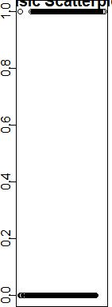

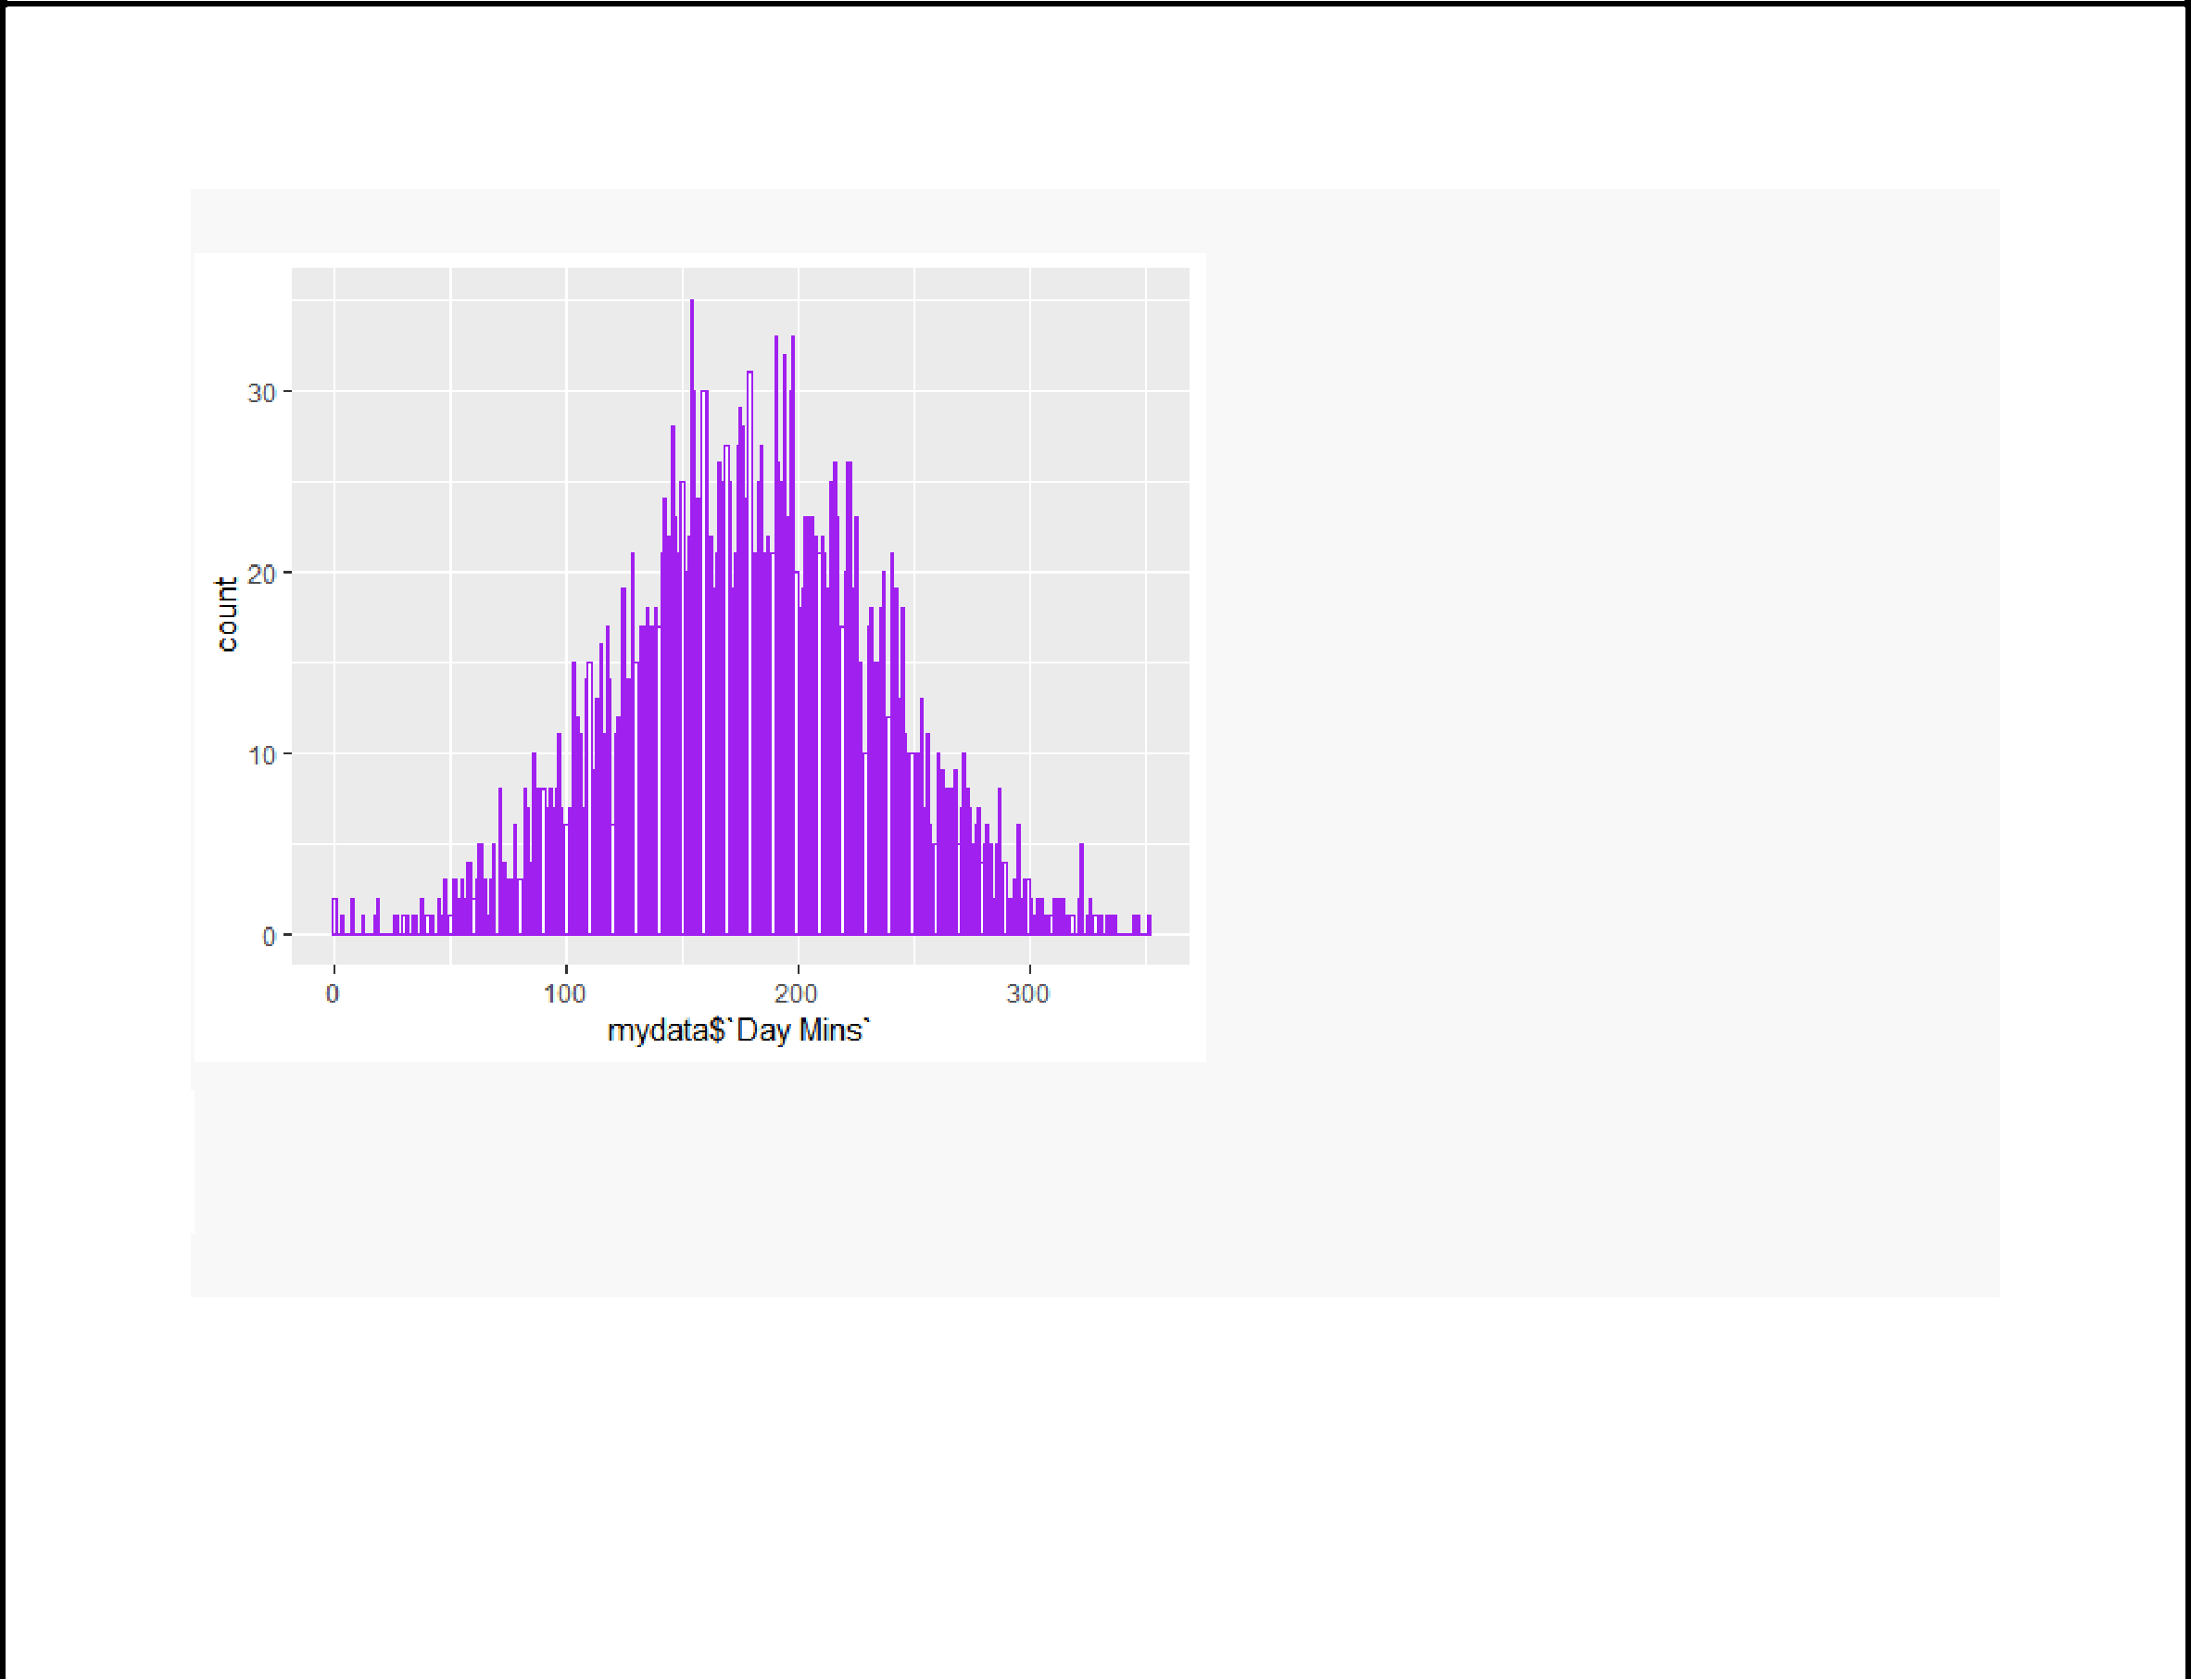**ggplot**(mydata, **aes**(x=mydata**$**`Day Mins`)) **+ geom_histogram**(binwidth =1,fill ="white",color ="purple")

*#Randomly split data into train and test set*

*#80% will be ssigned to train set, 20% will be assigned to tst set*

**barplot**(**table**(mydata**$**Churn),col= **c**("green","red"),main='bar plot of Churn')

**text**(**barplot**(**table**(mydata**$**Churn),col =**c**('green','red'),main='bar plot of Churn'),0,**table**(mydata**$**Churn)

* cex =2 , pos =3)

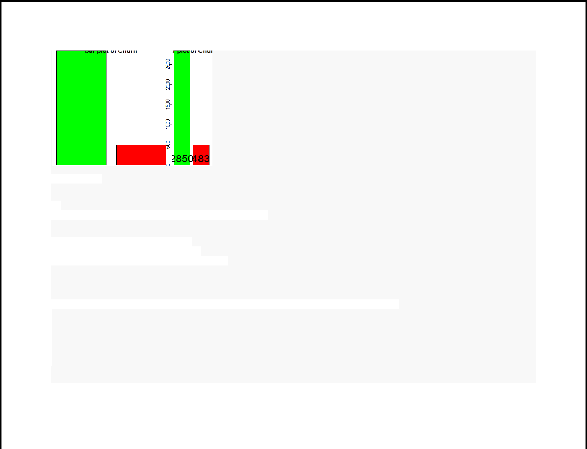

*#proportion*

**round**(**prop.table**(**table**(mydata**$**Churn))**\***100,digits =2)

##

* 01 (As per this churn is around 15%)
* 85.51 14.49

mydata_train<-mydata_n[1**:**2666,]

mydata_test<-mydata_n[2667**:**3333,]

mydata_train_labels<-mydata_n[1**:**2666,7]

mydata_test_labels<-mydata_n[2667**:**3333,7]

**sapply**(mydata_n, sd)

|  |  |  |  |  |  |
| --- | --- | --- | --- | --- | --- |
| ## Account.Length | | VMail.Message | Day.Mins | Eve.Mins | Night.Mins |
| ## | 0.1645542 | 0.2683993 | 0.1552662 | 0.1394387 | 0.1360243 |
| ## | Intl.Mins CustServ.Calls | | Churn | Int.l.Plan | VMail.Plan |
| ## | 0.1395920 | 0.1461657 | 0.3520674 | 0.2958791 | 0.4473979 |
| ## | Day.Calls | Day.Charge | Eve.Calls | Eve.Charge | Night.Calls |
| ## | 0.1216308 | 0.1552554 | 0.1171919 | 0.1394587 | 0.1378071 |
| ## | Night.Charge | Intl.Calls | Intl.Charge |  |  |
| ## | 0.1360354 | 0.1230607 | 0.1395875 |  |  |



**summary**(logit)

##

* Call:
* glm(formula = Churn ~ Account.Length + Day.Mins + Day.Cha
* CustServ.Calls + VMail.Plan + Eve.Mins + Eve.Charge
* Day.Calls + Eve.Calls + Intl.Mins + Night.Calls + Int
* family = "binomial", data = mydata_train)

##

## Deviance Residuals:

|  |  |  |  |  |  |  |  |  |  |  |
| --- | --- | --- | --- | --- | --- | --- | --- | --- | --- | --- |
| ## | Min | 1Q | Median |  | 3Q | Max |  |  |  |  |
|  |  |  |  |  |
| ## | -1.7136 -0.5583 | | -0.3989 |  | -0.2492 | 3.0223 |  |  |  |  |
| ## |  |  |  |  |  |  |  |  |  |  |
| ## | Coefficients: |  |  |  |  |  |  |  |  |  |
| ## |  | Estimate | | Std. Error | | z value | Pr(>|z|) |  |  |  |
| ## | (Intercept) |  | -7.4168 |  | 0.6846 | -10.834 | < 2e-16 | *** |  |  |
|  |  |  |  |
|  |  |  |  |  |  |  |  |  |  |  |
|  | |  |  |  |  |  |  |  |  |  |
| ## | Account.Length |  | 0.1336 |  | 0.3696 | 0.362 | 0.71771 |  |  |  |
| ## | Day.Mins | 191.3463 | |  | 1231.6229 |  | 0.87654 |  |  |  |
|  |  |  |  |  |
|  | 0.155 |  |  |  |
| ## | Day.Charge | -187.0655 | | 1231.7103 | | -0.152 | 0.87929 |  |  |  |
|  |  |  |
|  |  |  |
| ## |  |  |  |  |  |  |  |  |  |  |
| CustServ.Calls |  | 3.9702 |  | 0.3798 | 10.455 | < 2e-16 | *** |  |  |
|  |  |  |  |  |  |  |  |  |  |  |
| ## | VMail.Plan |  | -1.7024 |  | 0.6098 | -2.792 | 0.00524 | ** |  |  |
| ## | Eve.Mins | 462.5882 | |  | 642.8816 |  | 0.47180 |  |  |  |
|  | 0.720 |  |  |  |
|  |  |  |  |
|  |  |  |  |  |  |  |  |  |  |  |
| ## | Eve.Charge | -460.1275 | |  | 642.7876 |  | 0.47410 |  |  |  |
|  | -0.716 |  |  |  |
|  |  |  |  |  |  |  |  |  |  |  |
|  | |  |  |  |  |  |  |  |  |  |
| ## | VMail.Message |  | 1.5122 |  | 0.9823 | 1.539 | 0.12371 |  |  |  |
| ## | Day.Calls |  | 0.3629 |  | 0.4940 | 0.735 | 0.46264 |  |  |  |
|  |  |  |  |  |
|  |  |  |  |  |
|  |  |  |  |  |  |  |  |  |  |  |
|  |  |  |  |  |  |  |  |  |  |  |

|  |  |  |  |  |  |  |  |  |  |
| --- | --- | --- | --- | --- | --- | --- | --- | --- | --- |
| ## | Eve.Calls |  | 0.4090 | 0.5063 |  | 0.808 | 0.41921 |  |  |
| ## | Intl.Mins |  | 2.0353 | 0.4447 |  | 4.576 | 4.73e-06 | *** |  |
| ## | Night.Calls |  | 0.1657 | 0.4403 |  | 0.376 | 0.70665 |  |  |
|  |  |  |  |  |  |  |  |  |  |
| ## | Intl.Calls |  | -1.6524 | 0.5357 |  | -3.085 | 0.00204 | ** |  |



## ---  ## Signif. codes: 0 '***' 0.001 '**' 0.01 '*' 0.05 '.' 0.1 ' ' 1



##



* (Dispersion parameter for binomial family taken to be 1)



## Null deviance: 2162.0 on 2665 degrees of freedom



* Residual deviance: 1867.4 on 2652 degrees of freedom
* AIC: 1895.4



##



## Number of Fisher Scoring iterations: 5



*# Confidence interval using log-likelihood*



**confint**(logit)



## Waiting for profiling to be done...

|  |  |  |  |  |
| --- | --- | --- | --- | --- |
|  |  |  |  |  |
| ## |  | 2.5 % | 97.5 % |  |
| ## | (Intercept) | -8.7761881 | -6.0914407 |  |
|  | |  |  |  |
| ## | Account.Length | -0.5919165 | 0.8578438 |  |
|  | |  | |  |
| ## | Day.Mins | -2224.7782913 | 2605.8924991 |  |
|  | |  | |  |
| ## | Day.Charge | -2601.7748293 | 2229.2388877 |  |
| ## | CustServ.Calls | 3.2299992 | 4.7198281 |  |
|  |
|  | |  |  |  |
| ## | VMail.Plan | -2.9307458 | -0.5373346 |  |
|  | |  | |  |
| ## | Eve.Mins | -796.3103582 | 1725.2392867 |  |
|  | |  | 798.5919581 |  |
| ## | Eve.Charge | -1722.5889512 |  |
|  |  |  |  |  |

|  |  |  |  |
| --- | --- | --- | --- |
| ## | VMail.Message | -0.4038228 | 3.4527140 |
|  | |  |  |
| ## | Day.Calls | -0.6043867 | 1.3330979 |
|  | |  |  |
| ## | Eve.Calls | -0.5823325 | 1.4036271 |
|  | |  |  |
| ## | Intl.Mins | 1.1687246 | 2.9129356 |
|  | |  |  |
| ## | Night.Calls | -0.6973052 | 1.0293210 |
|  | |  |  |
| ## | Intl.Calls | -2.7201822 | -0.6195282 |
|  |  |  |  |



|  |  |  |  |  |  |  |
| --- | --- | --- | --- | --- | --- | --- |
| **exp**(logit**$**coefficients) | | |  |  |  |  |
| ## |  | Account.Length | Day.Mins | Day.Charge |  |  |
| (Intercept) | CustServ.Calls |  |
|  |  |  |  |  |  |  |
| ## | 6.010934e-04 | 1.142977e+00 | 1.260826e+83 | 5.734114e-82 | 5.299764e+01 |  |
|  |  |  |  |  |  |  |
| ## | VMail.Plan | Eve.Mins | Eve.Charge | VMail.Message | Day.Calls |  |
|  |  |  |  |  |  |  |
| ## | 1.822392e-01 | 7.933806e+200 | 1.476321e-200 | 4.536688e+00 | 1.437439e+00 |  |
| ## | Eve.Calls | Intl.Mins | Night.Calls | Intl.Calls |  |  |
| ## | 1.505333e+00 | 7.654355e+00 | 1.180211e+00 | 1.915949e-01 |  |  |
|  |  |  |  |  |  |  |



*# logistic regression model:*

fit <- **glm**(Churn**~**.,data =mydata_train ,family = **binomial**(link='logit'))



**summary**(fit)



##



## Call:

## glm(formula = Churn ~ ., family = binomial(link = "logit"), data = mydata_train)



##



## Deviance Residuals:

|  |  |  |  |  |  |  |  |
| --- | --- | --- | --- | --- | --- | --- | --- |
| ## | Min | 1Q | Median | 3Q | Max |  |  |
|  |  |



* -1.9680 -0.5111 -0.3376 -0.1979 3.1864 
* 



## Coefficients:

|  |  |  |  |  |  |  |  |
| --- | --- | --- | --- | --- | --- | --- | --- |
| ## |  | Estimate | Std. Error | z value | Pr(>|z|) |  |  |
|  | |  |  |  |  |  |  |
| ## | (Intercept) | -8.42021 | 0.76774 | -10.967 | < 2e-16 | *** |  |
|  | |  |  |  |  |  |  |
| ## | Account.Length | 0.01841 | 0.38853 | 0.047 | 0.962208 |  |  |
| ## | VMail.Message | 1.53996 | 1.01473 | 1.518 | 0.129114 |  |  |
|  |  |
|  | |  |  |  |  |  |  |
| ## | Day.Mins | 213.42834 | 1293.28315 | 0.165 | 0.868922 |  |  |
|  | |  |  |  |  |  |  |
| ## | Eve.Mins | 592.02181 | 674.48943 | 0.878 | 0.380088 |  |  |
|  | |  |  |  |  |  |  |
| ## | Night.Mins | -110.40724 | 368.95516 | -0.299 | 0.764755 |  |  |
|  | | -287.85749 | 120.73173 |  | 0.017113 | * |  |
| ## | Intl.Mins | -2.384 |  |
|  |  |  |  |  |  |  |  |

|  |  |  |  |  |
| --- | --- | --- | --- | --- |
| ## CustServ.Calls | 4.51834 | 0.40343 | 11.200 | < 2e-16 *** |
| ## Int.l.Plan | 2.06924 | 0.16257 | 12.729 | < 2e-16 *** |
| ## VMail.Plan | -1.87056 | 0.63215 | -2.959 | 0.003086 ** |
| ## Day.Calls | 0.44168 | 0.51623 | 0.856 | 0.392222 |
| ## Day.Charge | -209.05873 | 1293.37170 | -0.162 | 0.871590 |
| ## Eve.Calls | 0.43463 | 0.53648 | 0.810 | 0.417852 |
| ## Eve.Charge | -589.41466 | 674.38935 | -0.874 | 0.382120 |
| ## Night.Calls | 0.01869 | 0.46116 | 0.041 | 0.967668 |
| ## Night.Charge | 111.62067 | 368.91878 | 0.303 | 0.762224 |
| ## Intl.Calls | -1.92925 | 0.56673 | -3.404 | 0.000664 *** |
| ## Intl.Charge | 289.76049 | 120.71956 | 2.400 | 0.016383 * |
| ## --- |  |  |  |  |
| ## Signif. codes: | 0 '***' 0.001 '**' 0.01 '*' 0.05 '.' 0.1 ' ' 1 | | | |
| ## |  |  |  |  |
| ## (Dispersion parameter for | | binomial family taken to be 1) | | |
| ## |  |  |  |  |
| ## Null deviance: 2162.0 | | on 2665 degrees of freedom | | |



## Residual deviance: 1702.5 on 2648 degrees of freedom



## AIC: 1738.5



##



## Number of Fisher Scoring iterations: 6

**library**(MASS)



step_fit <- **stepAIC**(fit,method='backward')



**summary**(step_fit)



##



## Call:



## glm(formula = Churn ~ VMail.Message + Day.Mins + Eve.Mins + Intl.Mins +

|  |  |  |  |  |  |  |
| --- | --- | --- | --- | --- | --- | --- |
| ## | CustServ.Calls + Int.l.Plan + VMail.Plan + Night.Charge + | | | | |  |
| ## | Intl.Calls + Intl.Charge, family = binomial(link = "logit"), | | | | |  |
| ## | data = mydata_train) | | |  |  |  |
| ## |  |  |  |  |  |  |
| ## Deviance Residuals: | | | |  |  |  |
| ## | Min | 1Q | Median | 3Q | Max |  |
|  | |  | -0.3392 | -0.2020 | 3.1476 |  |
| ## | -1.9778 | -0.5124 |  |
|  |  |  |  |  |  |  |

##



* Coefficients: 
*  Estimate Std. Error z value Pr(>|z|)



|  |  |  |  |  |  |  |  |  |  |
| --- | --- | --- | --- | --- | --- | --- | --- | --- | --- |
| ## | (Intercept) | -7.8769 | 0.5686 | -13.853 | < 2e-16 | *** |  |  |  |
| ## | VMail.Message | 1.5052 | 1.0120 | 1.487 | 0.136929 |  |  |  |  |
|  |  |  |  |
|  |  |  |  |  |  |  |  |  |  |
| ## | Day.Mins | 4.4084 | 0.4297 | 10.259 | < 2e-16 | *** |  |  |  |
| ## | Eve.Mins | 2.5099 | 0.4622 | 5.430 | 5.64e-08 | *** |  |  |  |
|  |  |  |
| ## | Intl.Mins | -291.5210 | 120.5655 | -2.418 | 0.015608 | * |  |  |  |
| ## | CustServ.Calls | 4.5206 | 0.4022 | 11.240 | < 2e-16 | *** |  |  |  |
| ## | Int.l.Plan | 2.0630 | 0.1622 | 12.721 | < 2e-16 | *** |  |  |  |
| ## | VMail.Plan | -1.8555 | 0.6300 | -2.945 | 0.003230 | ** |  |  |  |
|  | |  |  |  |  |  |  |  |  |
| ## | Night.Charge | 1.2494 | 0.4652 | 2.686 | 0.007235 | ** |  |  |  |
| ## | Intl.Calls | -1.9404 | 0.5652 | -3.433 | 0.000596 | *** |  |  |  |
|  |  |  |
|  |  |  |  |  |  |  |  |  |  |
| ## | Intl.Charge | 293.4337 | 120.5539 | 2.434 | 0.014931 | * |  |  |  |
| ## | --- |  |  |  |  |  |  |  |  |
| ## | Signif. codes: | 0 '***' 0.001 '**' | | 0.01 '*' | 0.05 '.' | 0.1 | ' ' | 1 |  |
| ## |  |  |  |  |  |  |  |  |  |
|  |  |  |  |  |  |  |  |  |
|  |  |  |  |  |  |  |  |  |  |

* (Dispersion parameter for binomial family taken to be 1) 
* Null deviance: 2162.0 on 2665 degrees of freedom
* Residual deviance: 1704.9 on 2655 degrees of freedom
* AIC: 1726.9



##

## Number of Fisher Scoring iterations: 6

**confint**(step_fit)

## Waiting for profiling to be done...

|  |  |  |  |  |  |
| --- | --- | --- | --- | --- | --- |
| ## |  | 2.5 % | 97.5 % |  |  |
|  |  |  |
| ## | (Intercept) | -9.0107622 | -6.7808248 |  |  |
| ## | VMail.Message | -0.4650469 | 3.5078770 |  |  |
|  |  |
| ## | Day.Mins | 3.5752571 | 5.2606938 |  |  |
|  |  |
|  |  |  |  |  |  |
| ## | Eve.Mins | 1.6088317 | 3.4218238 |  |  |
|  | |  | |  |  |
| ## | Intl.Mins | -528.7346134 | -55.8150001 |  |  |
| ## | CustServ.Calls |  | 5.3151528 |  |  |
| 3.7372142 |  |  |
| ## | Int.l.Plan |  | 2.3822001 |  |  |
| 1.7458847 |  |  |
|  |  |  |  |  |  |



|  |  |  |
| --- | --- | --- |
| ## VMail.Plan | -3.1260647 | -0.6530832 |
| ## Night.Charge | 0.3391697 | 2.1636548 |
| ## Intl.Calls | -3.0675068 | -0.8511819 |
| ## Intl.Charge | 57.7541777 | 530.6286565 |

*#ANOVA on base model*

**anova**(fit,test ='Chisq')

* Analysis of Deviance Table
* Model: binomial, link: logit
* Response: Churn

##

* Terms added sequentially (first to last)

|  |  |  |  |  |  |  |  |  |  |  |
| --- | --- | --- | --- | --- | --- | --- | --- | --- | --- | --- |
| ## |  | Df Deviance Resid. Df Resid. Dev | | | | | Pr(>Chi) |  |  |  |
|  |  |  |  |  |  |  |  |  |  |  |
| ## | NULL |  |  |  | 2665 | 2162.0 |  |  |  |  |
|  |  |  |  |  |  |  |  |  |  |  |
| ## | Account.Length |  | 1 | 0.277 | 2664 | 2161.8 | 0.5985480 |  |  |  |
|  |  |  |  |
| ## | VMail.Message |  | 1 | 19.675 | 2663 | 2142.1 | 9.180e-06 | *** |  |  |
|  |  |  | |  |  |  | | |  |  |
| ## | Day.Mins |  | 1 | 103.623 | 2662 | 2038.5 | < 2.2e-16 | *** |  |  |
| ## | Eve.Mins |  | 1 | 23.581 | 2661 | 2014.9 | 1.197e-06 | *** |  |  |
|  |  |  |
| ## | Night.Mins |  | 1 | 3.199 | 2660 | 2011.7 | 0.0736818 | . |  |  |
| ## |  |  | | 17.379 | 2659 |  |  | |  |  |
| Intl.Mins |  | 1 | 1994.3 | 3.062e-05 | *** |  |  |
| ## | CustServ.Calls |  | 1 | 111.293 | 2658 | 1883.0 | < 2.2e-16 | *** |  |  |
| ## |  |  | | 152.056 | 2657 |  |  | |  |  |
| Int.l.Plan |  | 1 | 1730.9 | < 2.2e-16 | *** |  |  |
| ## | VMail.Plan |  | 1 | 8.313 | 2656 | 1722.6 | 0.0039361 | ** |  |  |
| ## |  |  | | 1.004 | 2655 |  | 0.3164303 |  |  |  |
| Day.Calls |  | 1 | 1721.6 |  |  |  |
|  |  |  |  |  |  |  |  |  |  |  |
| ## |  |  | | 0.101 | 2654 |  | 0.7509001 |  |  |  |
| Day.Charge |  | 1 | 1721.5 |  |  |  |
| ## |  |  |  | 0.705 | 2653 |  | 0.4010942 |  |  |  |
|  |  | |  |  |  |  |
| Eve.Calls |  | 1 | 1720.8 |  |  |  |
| ## |  |  |  | 0.752 | 2652 |  | 0.3857120 |  |  |  |
|  |  | |  |  |  |  |
| Eve.Charge |  | 1 | 1720.1 |  |  |  |
|  |  |  |  |  |  |  |  |  |  |  |
| ## | Night.Calls |  | 1 | 0.000 | 2651 | 1720.1 | 0.9948372 |  |  |  |
|  |  |  |  |
| ## |  |  |  | 0.088 | 2650 |  | 0.7668220 |  |  |  |
|  |  | |  |  |  |  |
| Night.Charge |  | 1 | 1720.0 |  |  |  |
|  |  |  |  |  |  |  |  |  |  |  |
| ## | Intl.Calls |  | 1 | 11.638 | 2649 | 1708.3 | 0.0006464 | *** |  |  |
| ## | Intl.Charge |  | 1 | 5.795 | 2648 | 1702.5 | 0.0160706 | * |  |  |
|  |  |  |  |  |  |  |  |  |  |  |

## ---

pred <- **predict**(fit,newdata = mydata_test,type ='response')

*#check the AUC curve*

**library**(pROC)

g <- **roc**( Churn**~** pred, data = mydata_test)

g

##

* Call:
* roc.formula(formula = Churn ~ pred, data = mydata_test)
* 
* Data: pred in 558 controls (Churn 0) < 109 cases (Churn 1).
* Area under the curve: 0.8266

**plot**(g)

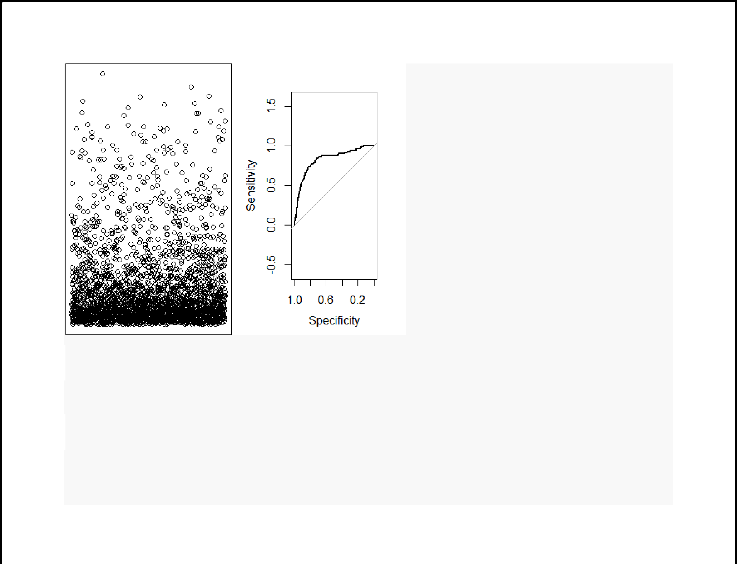

**library**(caret)

*#with default prob cut 0.50*

mydata_test**$**pred_Churn <- **ifelse**(pred**<**0.8,'yes','no')

**table**(mydata_test**$**pred_Churn,mydata_test**$**Churn)

##

* 0 1

## no 1 3

* yes 557 106

*#training split of churn classes*

**round**(**table**(mydata_train**$**Churn)**/nrow**(mydata_train),2)**\***100

##

* 0 1
* 86 14

*# test split of churn classes*

**round**(**table**(mydata_test**$**Churn)**/nrow**(mydata_test),2)**\***100

##

* 0 1
* 84 16

*#predicted split of churn classes*

**round**(**table**(mydata_test**$**pred_Churn)**/nrow**(mydata_test),2)**\***100

##

* no yes
* 1 99

*#create confusion matrix*

*#confusionMatrix(mydata_test$Churn,mydata_test$pred_Churn)*

*#how do we create a cross validation scheme*

control <- **trainControl**(method = 'repeatedcv',

number = 10,

repeats = 3)

seed <-7

metric <- 'Accuracy'

**set.seed**(seed)

fit_default <- **train**(Churn**~**.,

data = mydata_train,

method = 'glm',

metric = NaN,

trControl = control)

* Warning in train.default(x, y, weights = w, ...): You are trying to do
* regression and your outcome only has two possible values Are you trying to
* do classification? If so, use a 2 level factor as your outcome column.



* Warning in train.default(x, y, weights = w, ...): The metric "NaN" was not
* in the result set. RMSE will be used instead.

**print**(fit_default)

* Generalized Linear Model
* 2666 samples
* 17 predictor

##

* No pre-processing
* Resampling: Cross-Validated (10 fold, repeated 3 times)
* Summary of sample sizes: 2399, 2400, 2399, 2399, 2400, 2399, ...
* Resampling results:

##

## RMSE Rsquared MAE

* 0.3171573 0.1668586 0.2165651

**library**(caret)

**varImp**(step_fit)

|  |  |  |
| --- | --- | --- |
| ## |  | Overall |
| ## VMail.Message | | 1.487325 |
| ## | Day.Mins | 10.258636 |
| ## Eve.Mins | | 5.429922 |
| ## Intl.Mins | | 2.417948 |

## CustServ.Calls 11.239954

|  |  |  |
| --- | --- | --- |
| ## | Int.l.Plan | 12.720766 |
| ## VMail.Plan | | 2.945000 |
| ## Night.Charge | | 2.685836 |
| ## Intl.Calls | | 3.433245 |
| ## Intl.Charge | | 2.434045 |

**varImp**(fit_default)

* glm variable importance

|  |  |  |  |
| --- | --- | --- | --- |
| ## |  | Overall |  |
|  |  |  |  |
| ## | Int.l.Plan | 100.00000 |  |
|  | |  |  |
| ## | CustServ.Calls | 79.36943 |  |
|  | |  |  |
| ## | Intl.Calls | 21.54437 |  |
|  | |  |  |
| ## | VMail.Plan | 17.99874 |  |
|  | |  |  |
| ## | Intl.Charge | 15.22120 |  |
| ## | Intl.Mins | 15.11822 |  |
|  |
|  | |  |  |
| ## | VMail.Message | 6.87083 |  |
|  | |  |  |
| ## | Day.Calls | 5.43601 |  |
|  | |  |  |
| ## | Eve.Mins | 5.43158 |  |
|  | |  |  |
| ## | Eve.Charge | 5.40848 |  |
|  | |  |  |
| ## | Eve.Calls | 4.87659 |  |
|  | |  |  |
| ## | Night.Charge | 3.45603 |  |
|  | |  |  |
| ## | Night.Mins | 3.43761 |  |
|  | |  |  |
| ## | Day.Mins | 1.44730 |  |
|  | |  |  |
| ## | Day.Charge | 1.42506 |  |
| ## | Account.Length | 0.02108 |  |
|  |
|  | |  |  |
| ## | Night.Calls | 0.00000 |  |
|  |  |  |  |



**library**(devtools)



**library**(woe)



**library**(riv)



iv_df <- **iv.mult**(mydata_train, y="Churn", summary=TRUE, verbose=TRUE)



iv_df

|  |  |  |  |  |  |  |  |  |  |  |  |  |
| --- | --- | --- | --- | --- | --- | --- | --- | --- | --- | --- | --- | --- |
| ## |  |  |  |  | Variable | | | InformationValue | Bins | ZeroBins | Strength |  |
|  |  |  |  |  |
|  |  |  |  |  |  |  |  |  |  |  |  |  |
| ## | 1 |  |  | Day.Charge | | |  | 0.643151413 | 6 | 0 | Very strong |  |
| ## | 2 |  |  |  | Day.Mins | |  | 0.643151413 | 6 | 0 | Very strong |  |
| ## | 3 |  | CustServ.Calls | | |  | | 0.158681659 | 2 | 0 | Average |  |
| ## | 4 |  |  |  | Eve.Mins | | | 0.149576165 | 5 | 0 | Average |  |
|  | |  |  | | | | |  |  |  |  |  |
| ## | 5 |  | Eve.Charge | | | | | 0.149310982 | 5 | 0 | Average |  |
|  | |  |  | | | | |  |  |  |  |  |
| ## | 6 |  | Intl.Charge | | | | | 0.097357797 | 4 | 0 | Weak |  |
|  | |  |  |  | | | |  |  |  |  |  |
| ## | 7 |  |  | Intl.Mins | | | | 0.097357797 | 4 | 0 | Weak |  |
|  | |  | VMail.Message | | | | |  | 2 | 0 | Weak |  |
| ## | 8 |  | 0.081622650 |  |
|  |  |  |  |  |  |  |  |  |  |  |  |  |

|  |  |  |  |  |  |  |  |  |
| --- | --- | --- | --- | --- | --- | --- | --- | --- |
| ## | 9 | VMail.Plan | 0.081622650 | 2 | 0 |  | Weak |  |
|  |  |  |  |  |  |  |  |  |
|  | |  |  |  |  |  |  |  |
| ## | 10 | Intl.Calls | 0.068633851 | 2 | 0 |  | Weak |  |
|  |  |  |  |  |  |  |  |  |
|  | |  |  |  |  |  |  |  |
| ## | 11 | Night.Charge | 0.060709508 | 6 | 0 |  | Weak |  |
|  |  |  |  |  |  |  |  |  |
|  | | |  |  |  |  |  |  |
| ## | 12 | Account.Length | 0.033794008 | 4 | 0 |  | Weak |  |
|  |  |  |  |  |  |  |  |  |
|  | |  |  |  |  |  |  |  |
| ## | 13 | Day.Calls | 0.028673937 | 3 | 0 |  | Weak |  |
|  |  |  |  |  |  |  |  |  |
|  | |  |  |  |  |  |  |  |
| ## | 14 | Night.Mins | 0.022784889 | 2 | 0 |  | Weak |  |
|  |  |  |  |  |  |  |  |  |
| ## | 15 | Eve.Calls | 0.010611328 | 2 | 0 | Wery | weak |  |
|  |
|  | |  |  |  |  |  | |  |
| ## | 16 | Night.Calls | 0.009978104 | 2 | 0 | Wery | weak |  |
|  | |  |  |  |  |  | |  |
| ## | 17 | Int.l.Plan | 0.000000000 | 1 | 0 | Wery | weak |  |
|  |  |  |  |  |  |  |  |  |



iv <- **iv.mult**(mydata_train, y="Churn", summary=FALSE, verbose=TRUE)

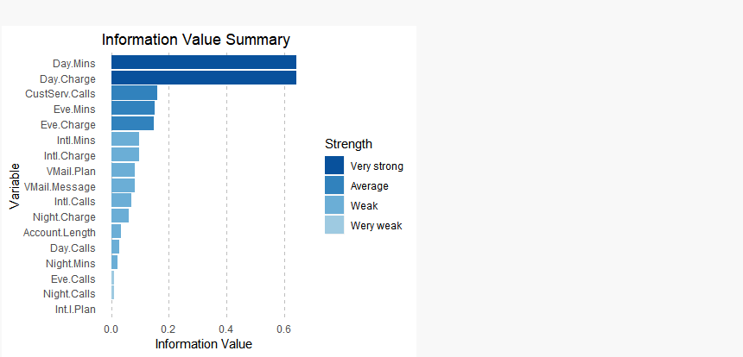

*# Plot information value summary*

TABALEAU VISUALIZATION

Library(Rserve)

Rserve()

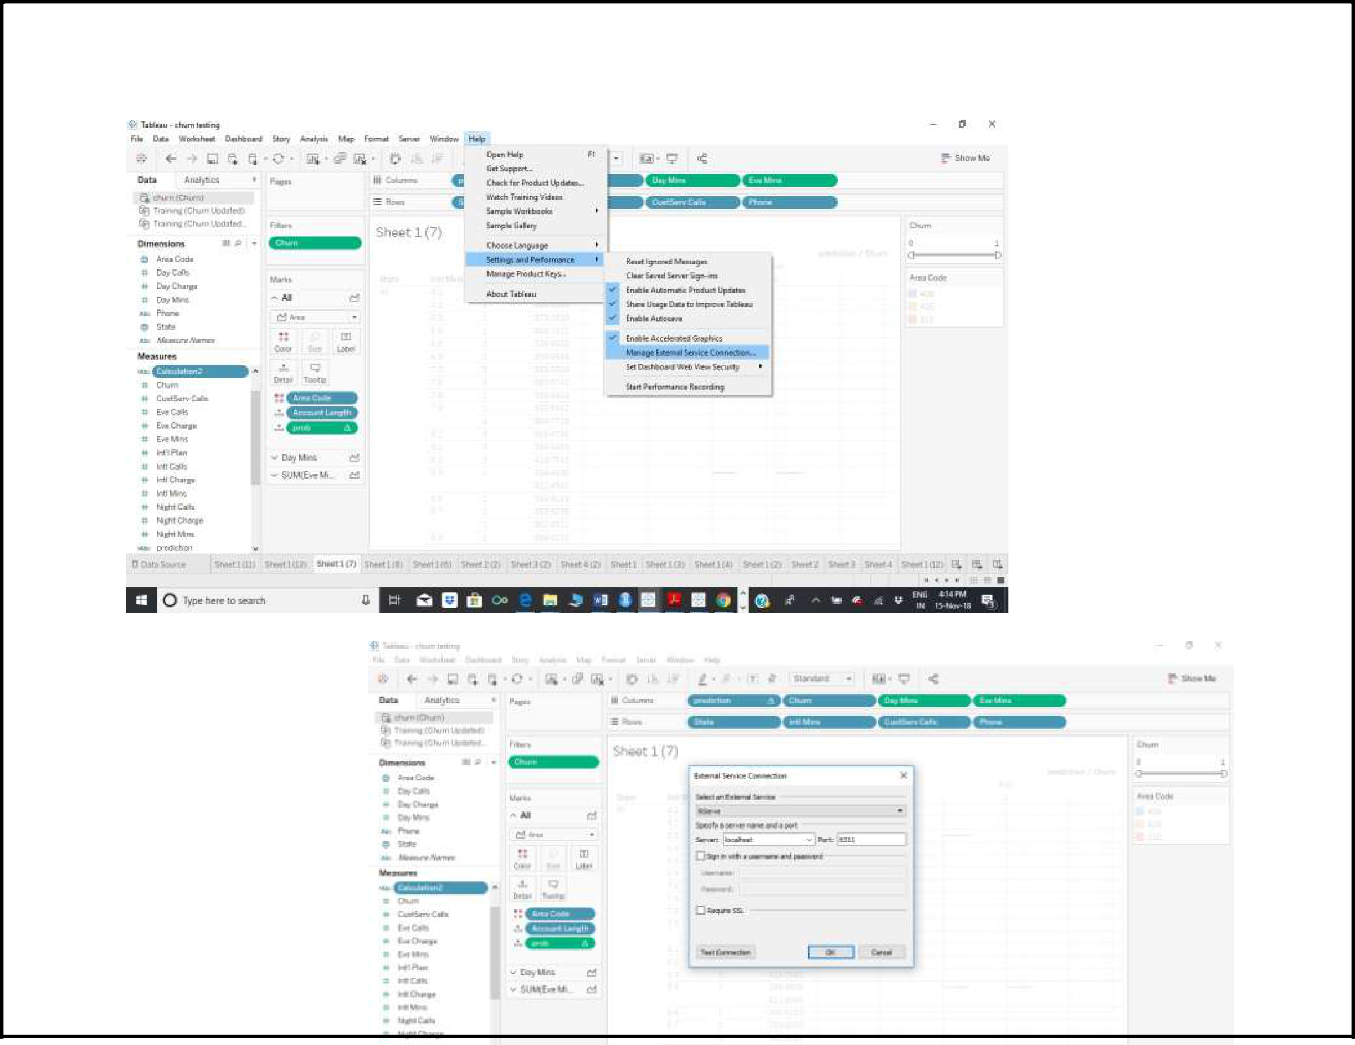

)

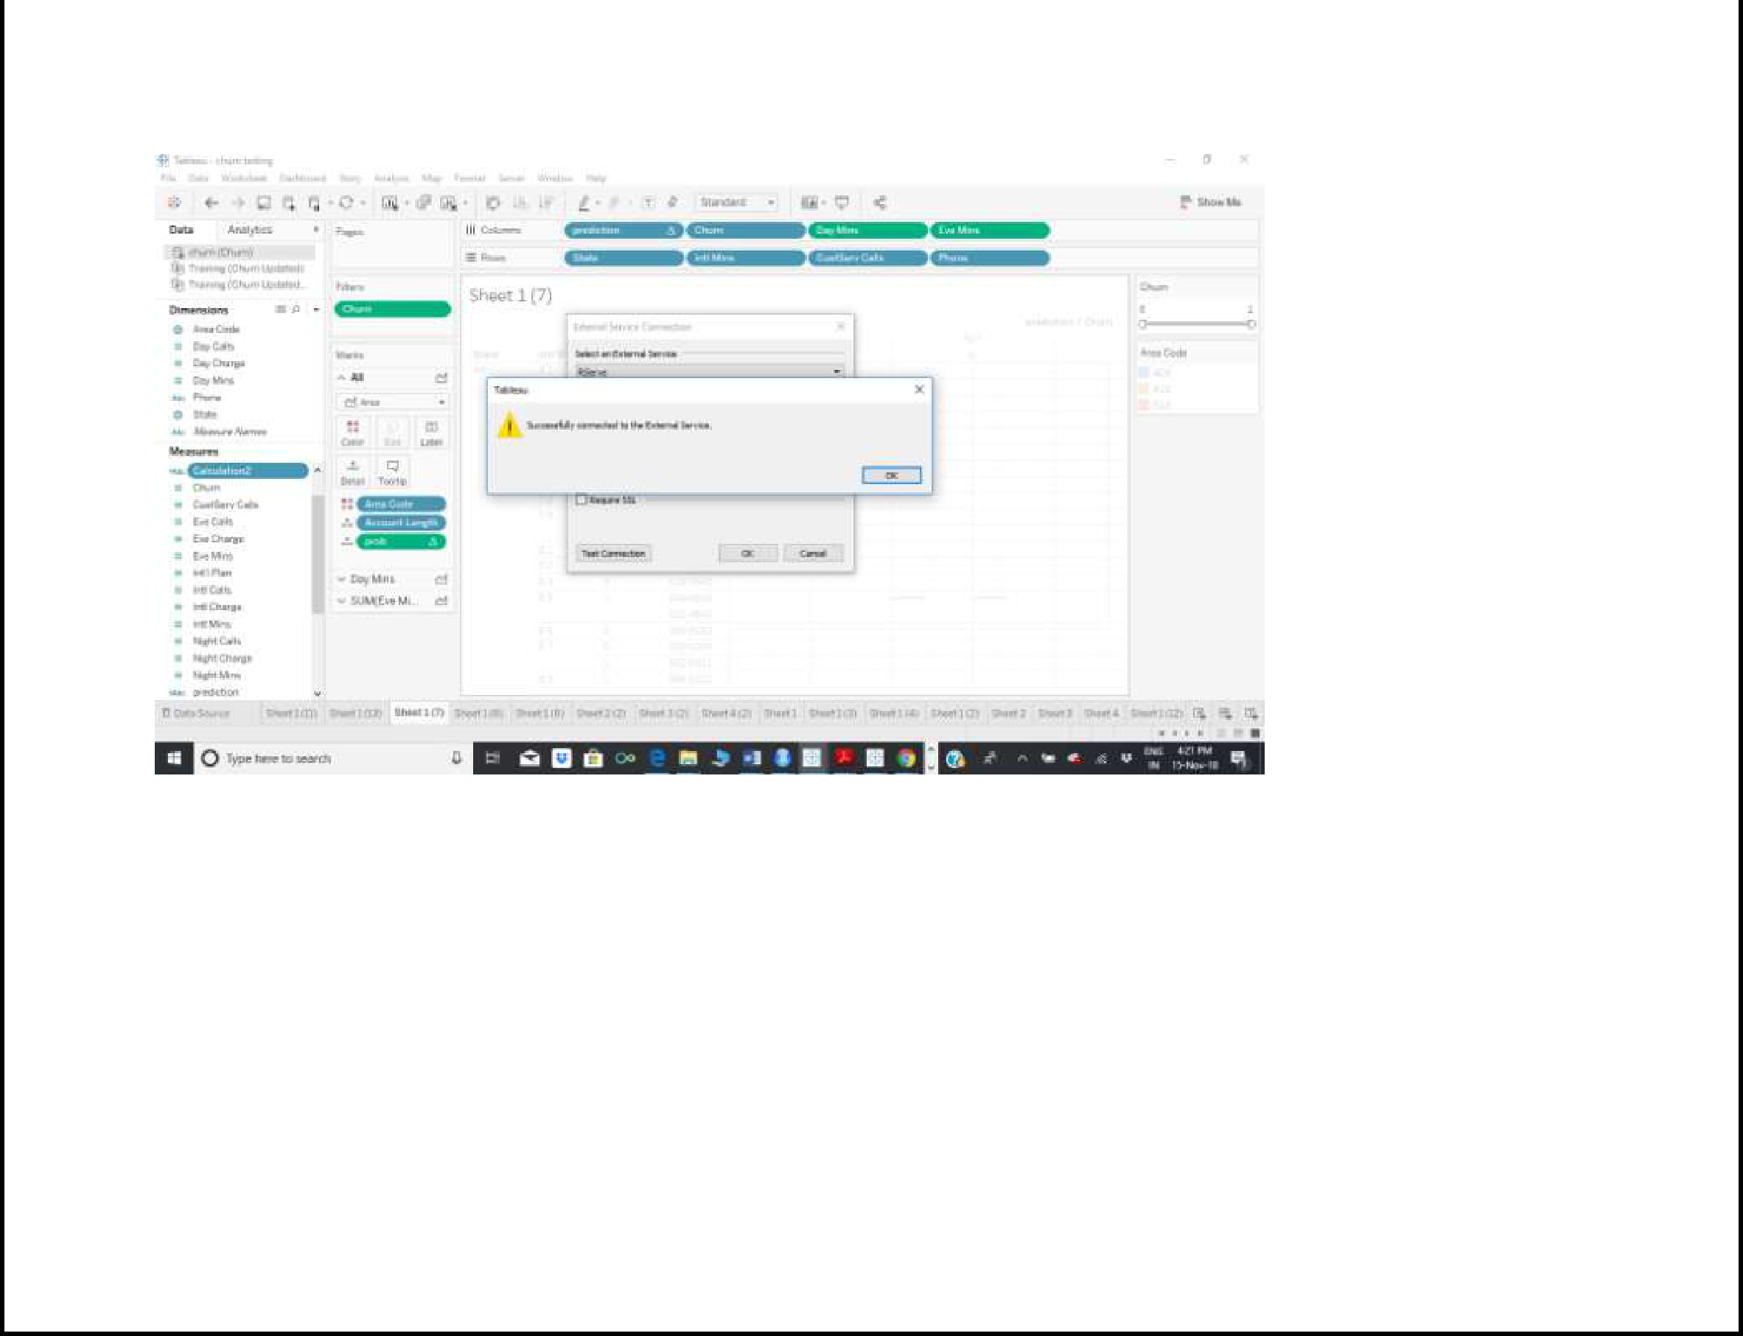

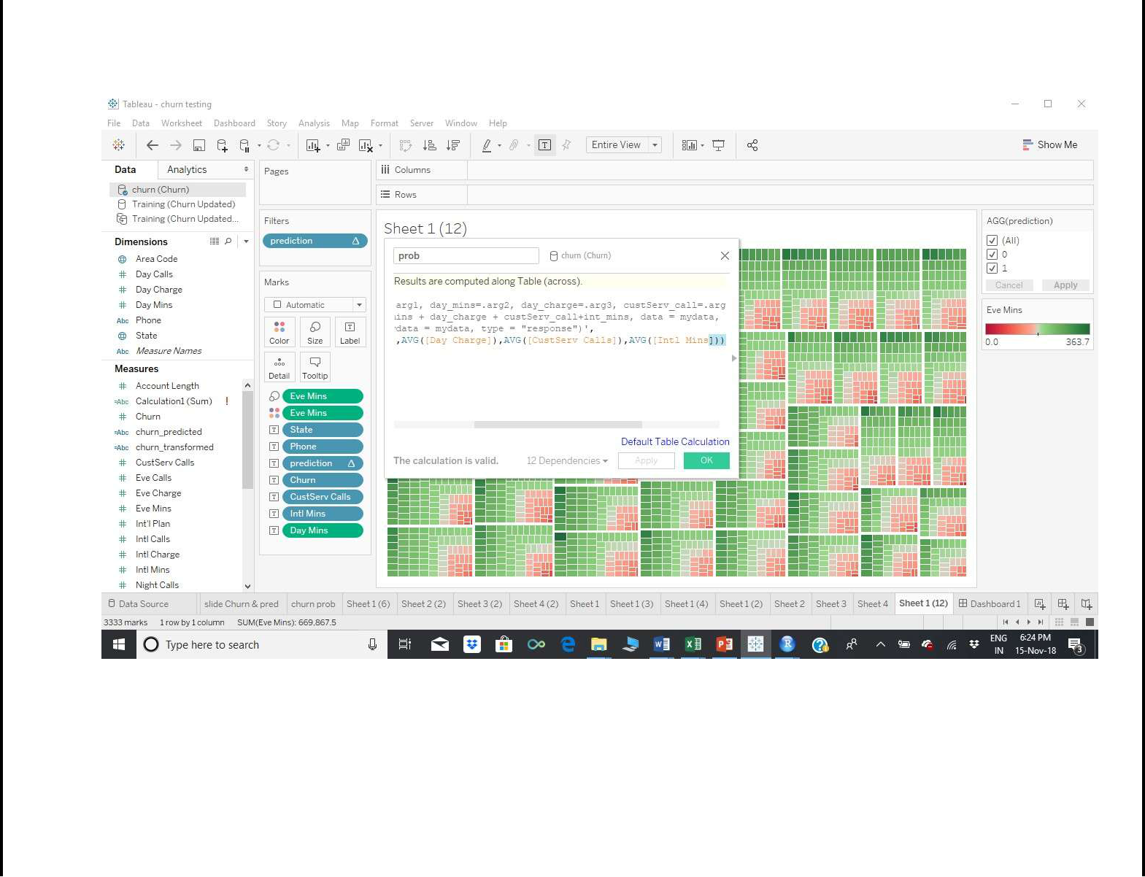

Calculated field (prob)

SCRIPT_REAL('library(dplyr);

mydata <- data.frame(churn=.arg1, day_mins=.arg2, day_charge=.arg3, custServ_call=.arg4, int_mins=.arg5);

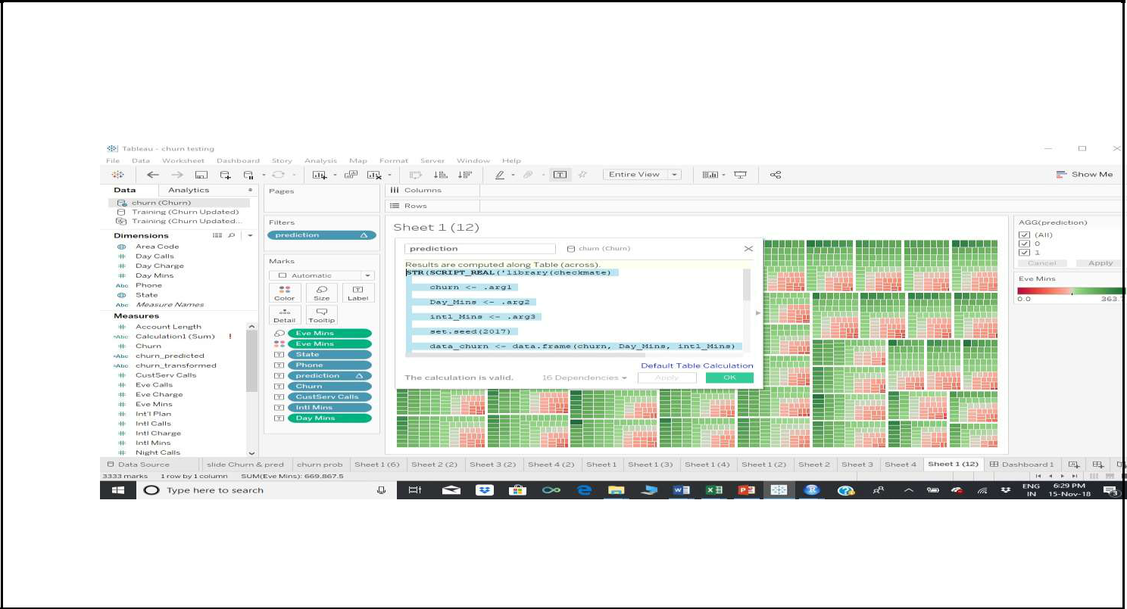

lrmodel <- glm(churn ~ day_mins + day_charge + custServ_call+int_mins, data = mydata, family = "binomial"); prob <- predict(lrmodel, newdata = mydata, type = "response")',

AVG([Churn]),AVG([Day Mins]),AVG([Day Charge]),AVG([CustServ Calls]),AVG([Intl Mins]))

STR(SCRIPT_REAL('library(checkmate)

churn <- .arg1

Day_Mins <- .arg2

intl_Mins <- .arg3

set.seed(2017)

data_churn <- data.frame(churn, Day_Mins, intl_Mins)

intrain<-sample(1:nrow(data_churn),.7*nrow(data_churn))

training<- data_churn[intrain,]

testing<- data_churn[-intrain,]

new_data<-rbind(training,testing)

LogModel <- glm(churn ~ .,family=binomial(link="logit"),data=training)

fitted.results <- predict(LogModel,newdata=new_data,type="response")

pred_val <- ifelse(fitted.results > 0.5,1,0)

pred_val

',ATTR([Churn]),SUM([Day Mins]),sum([Intl Mins])))

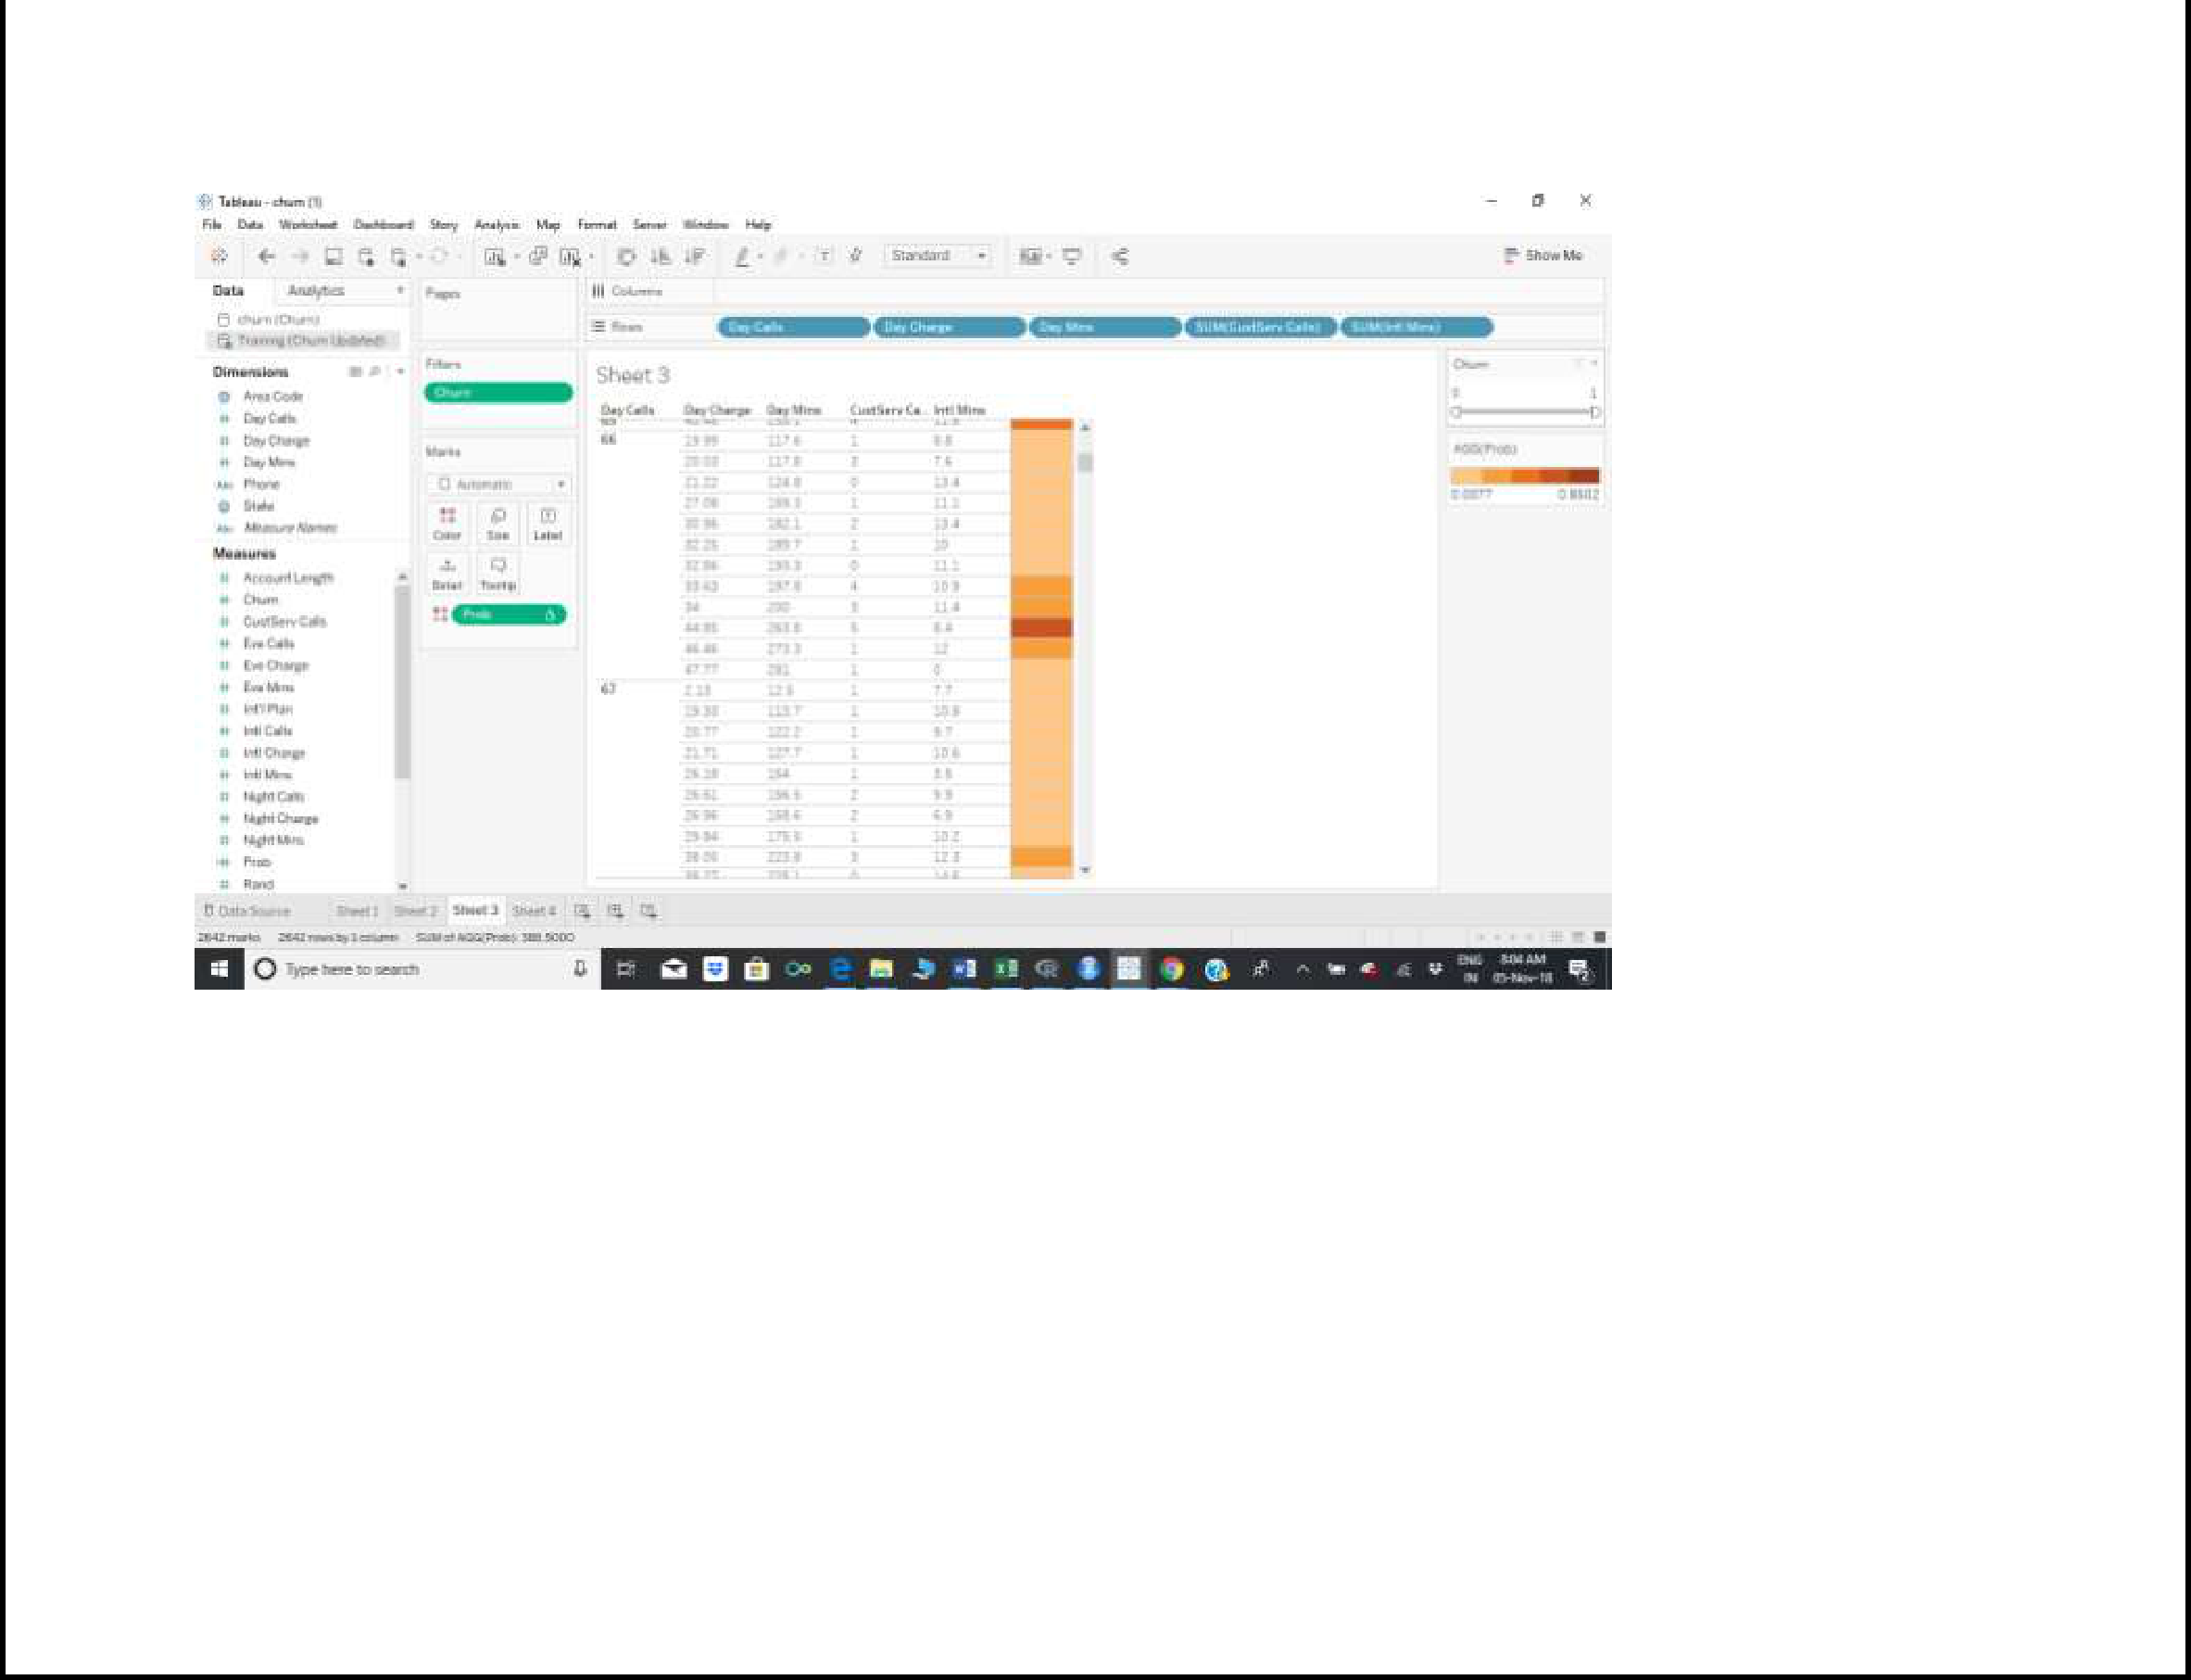

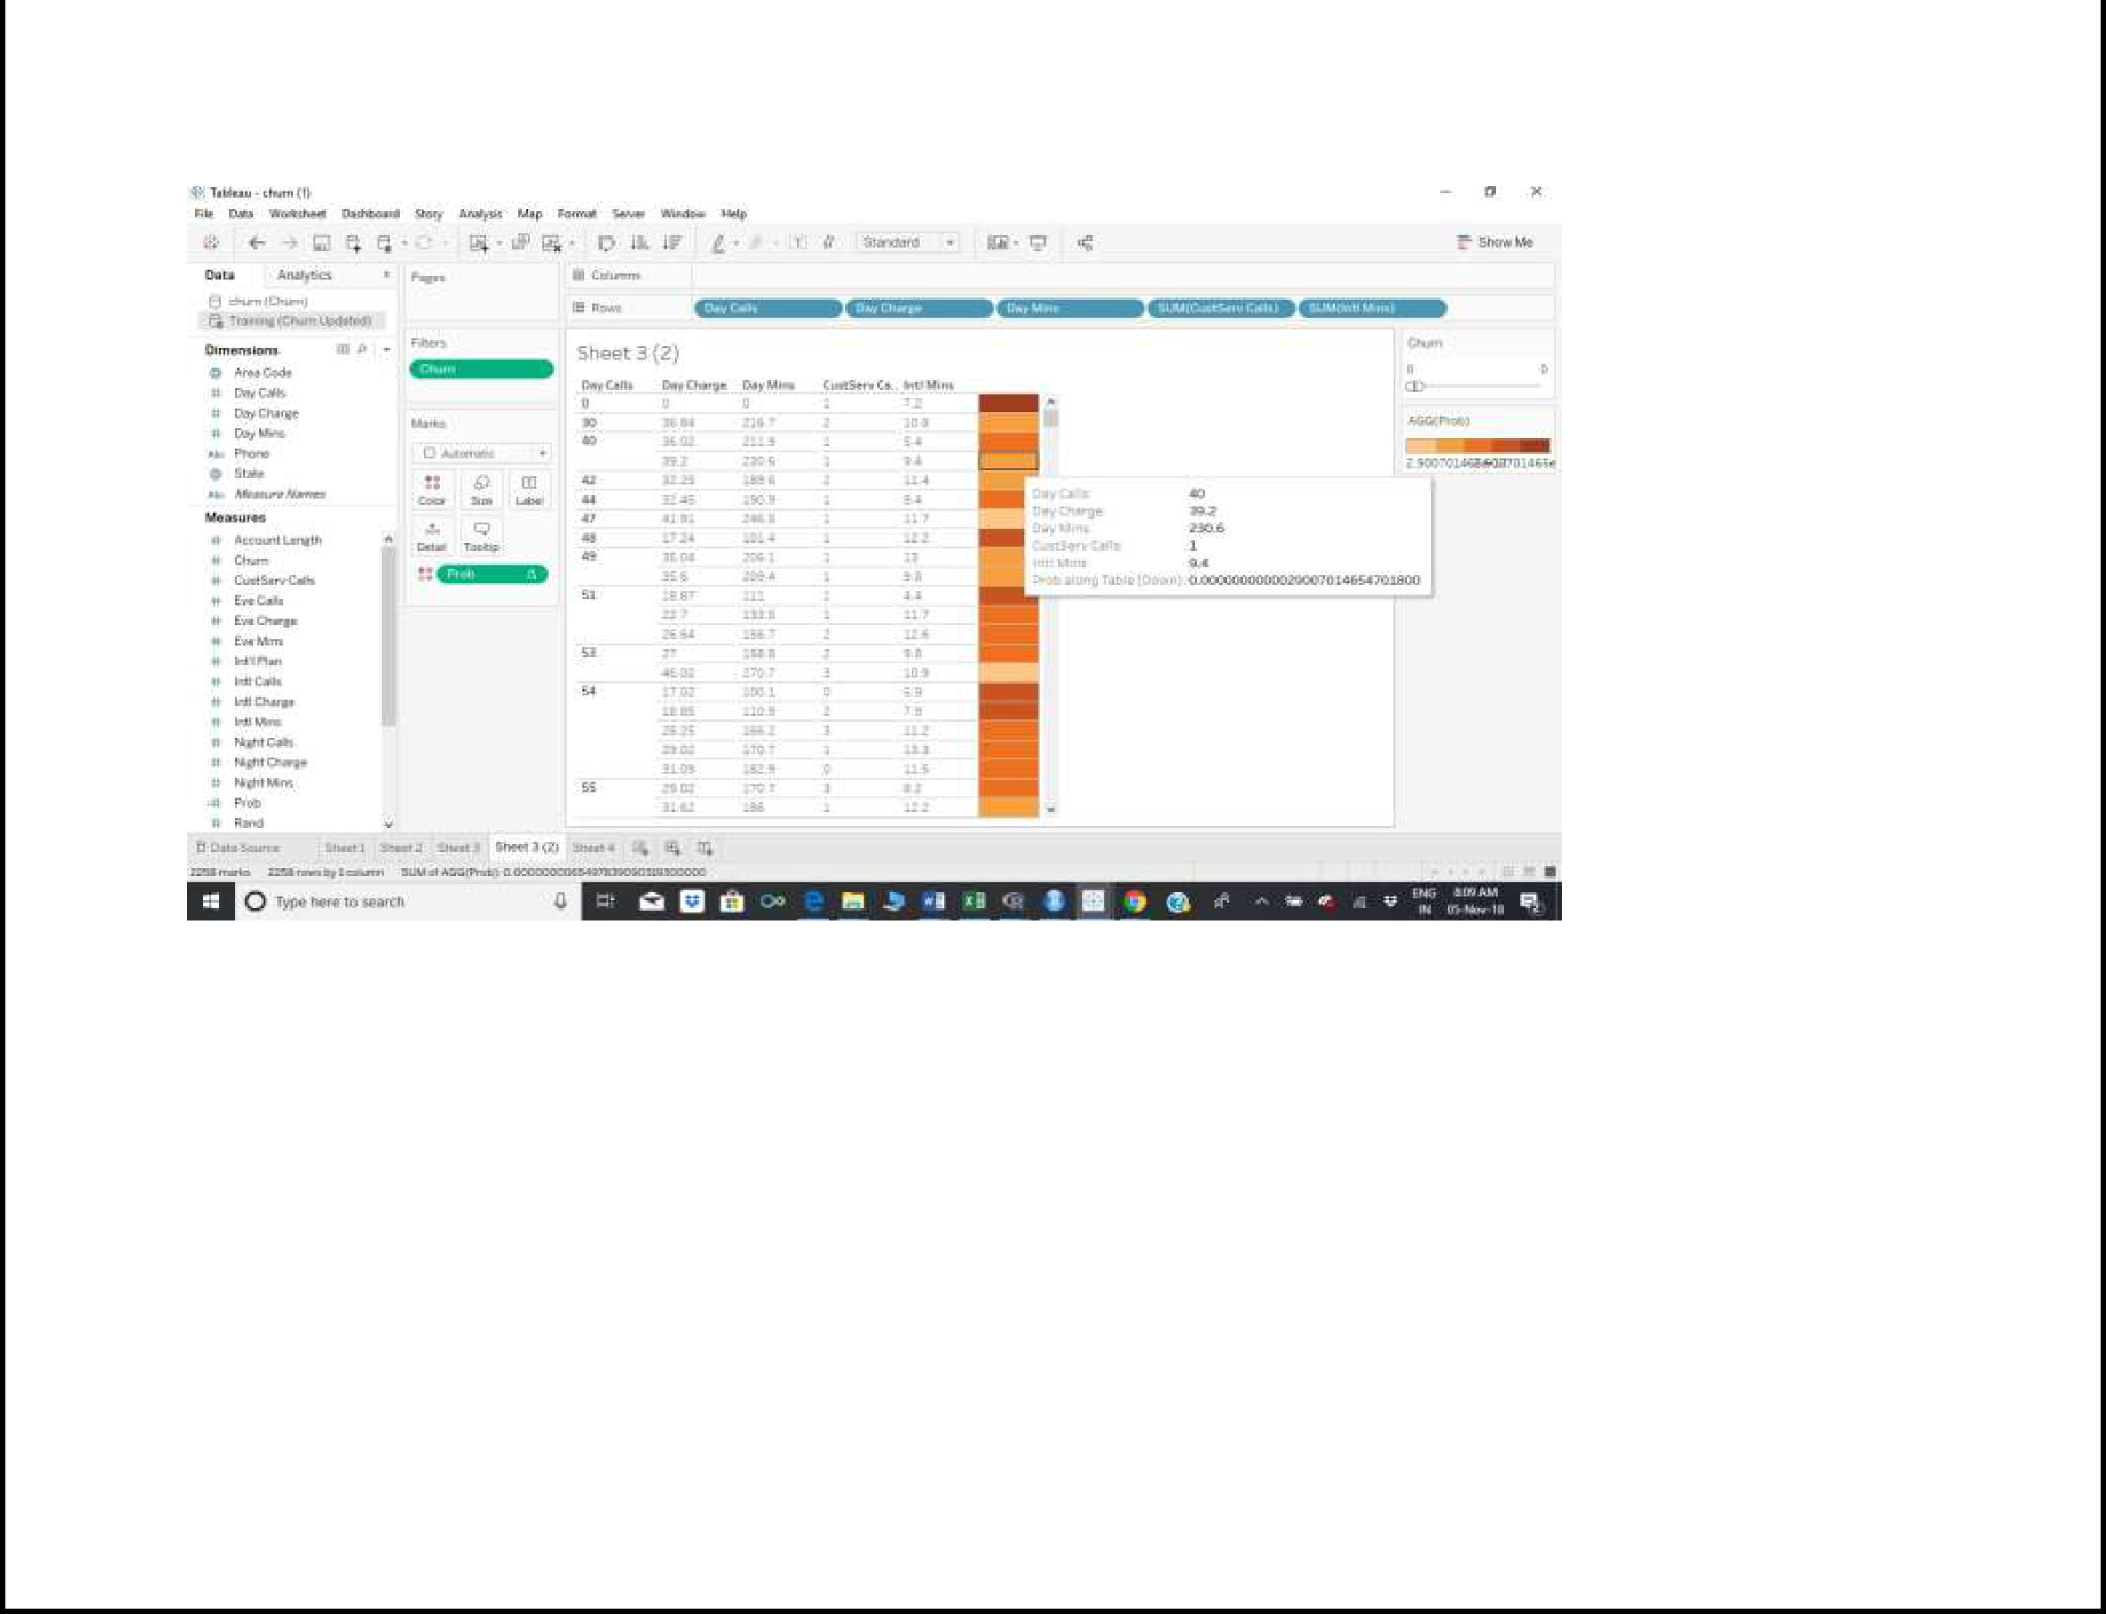

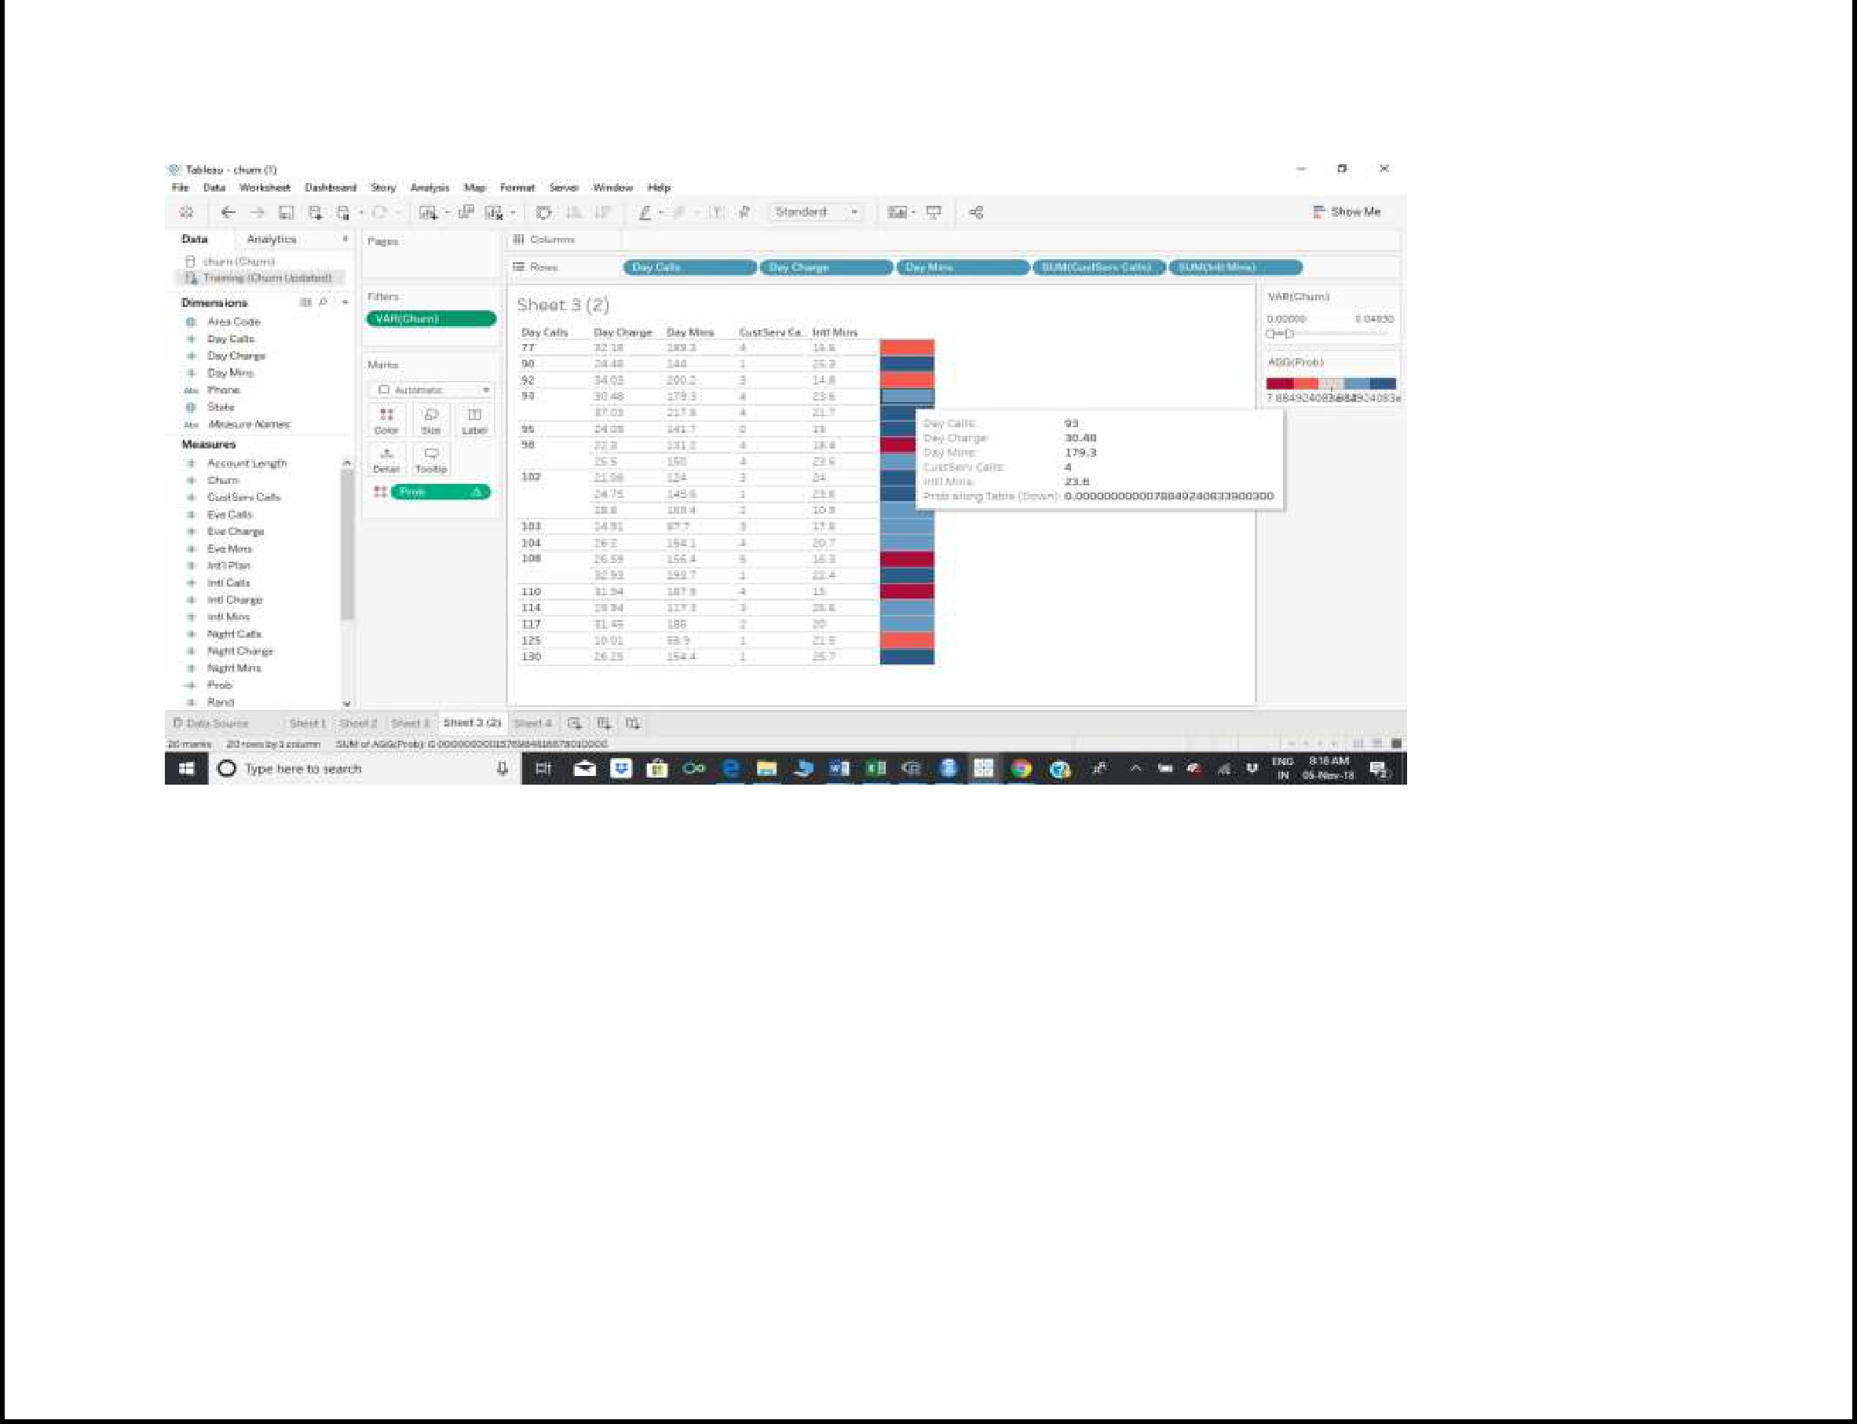

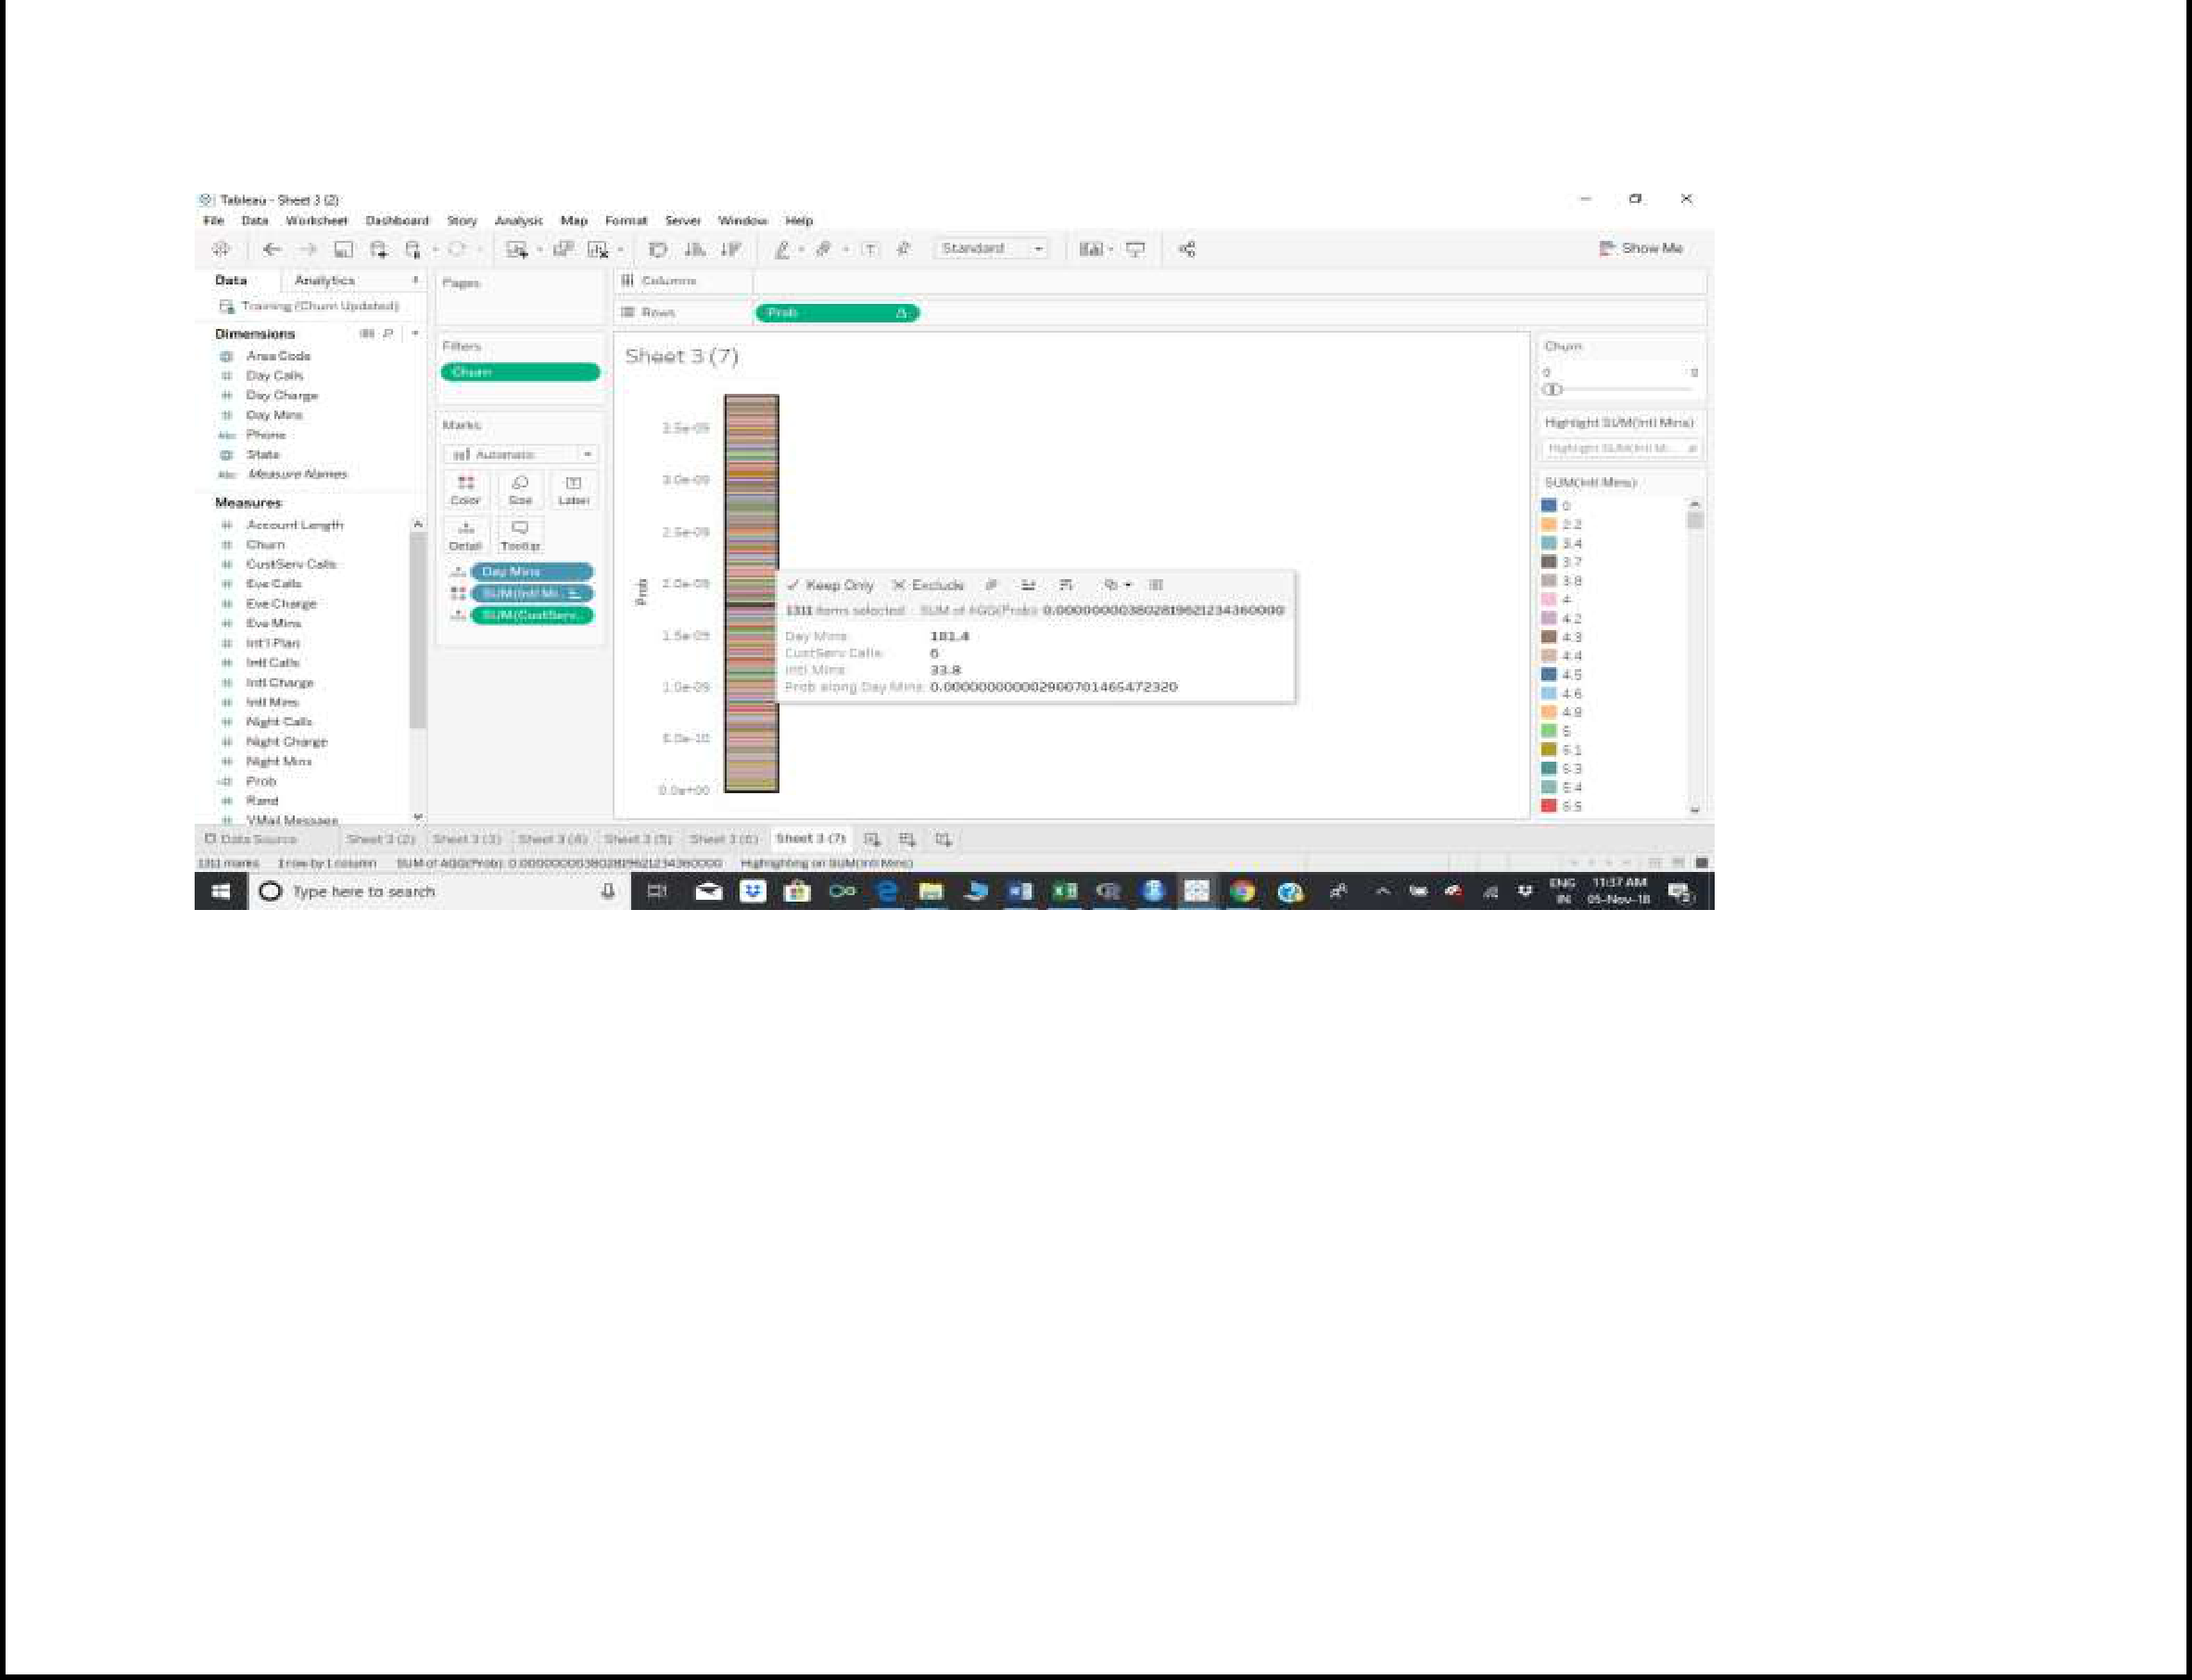

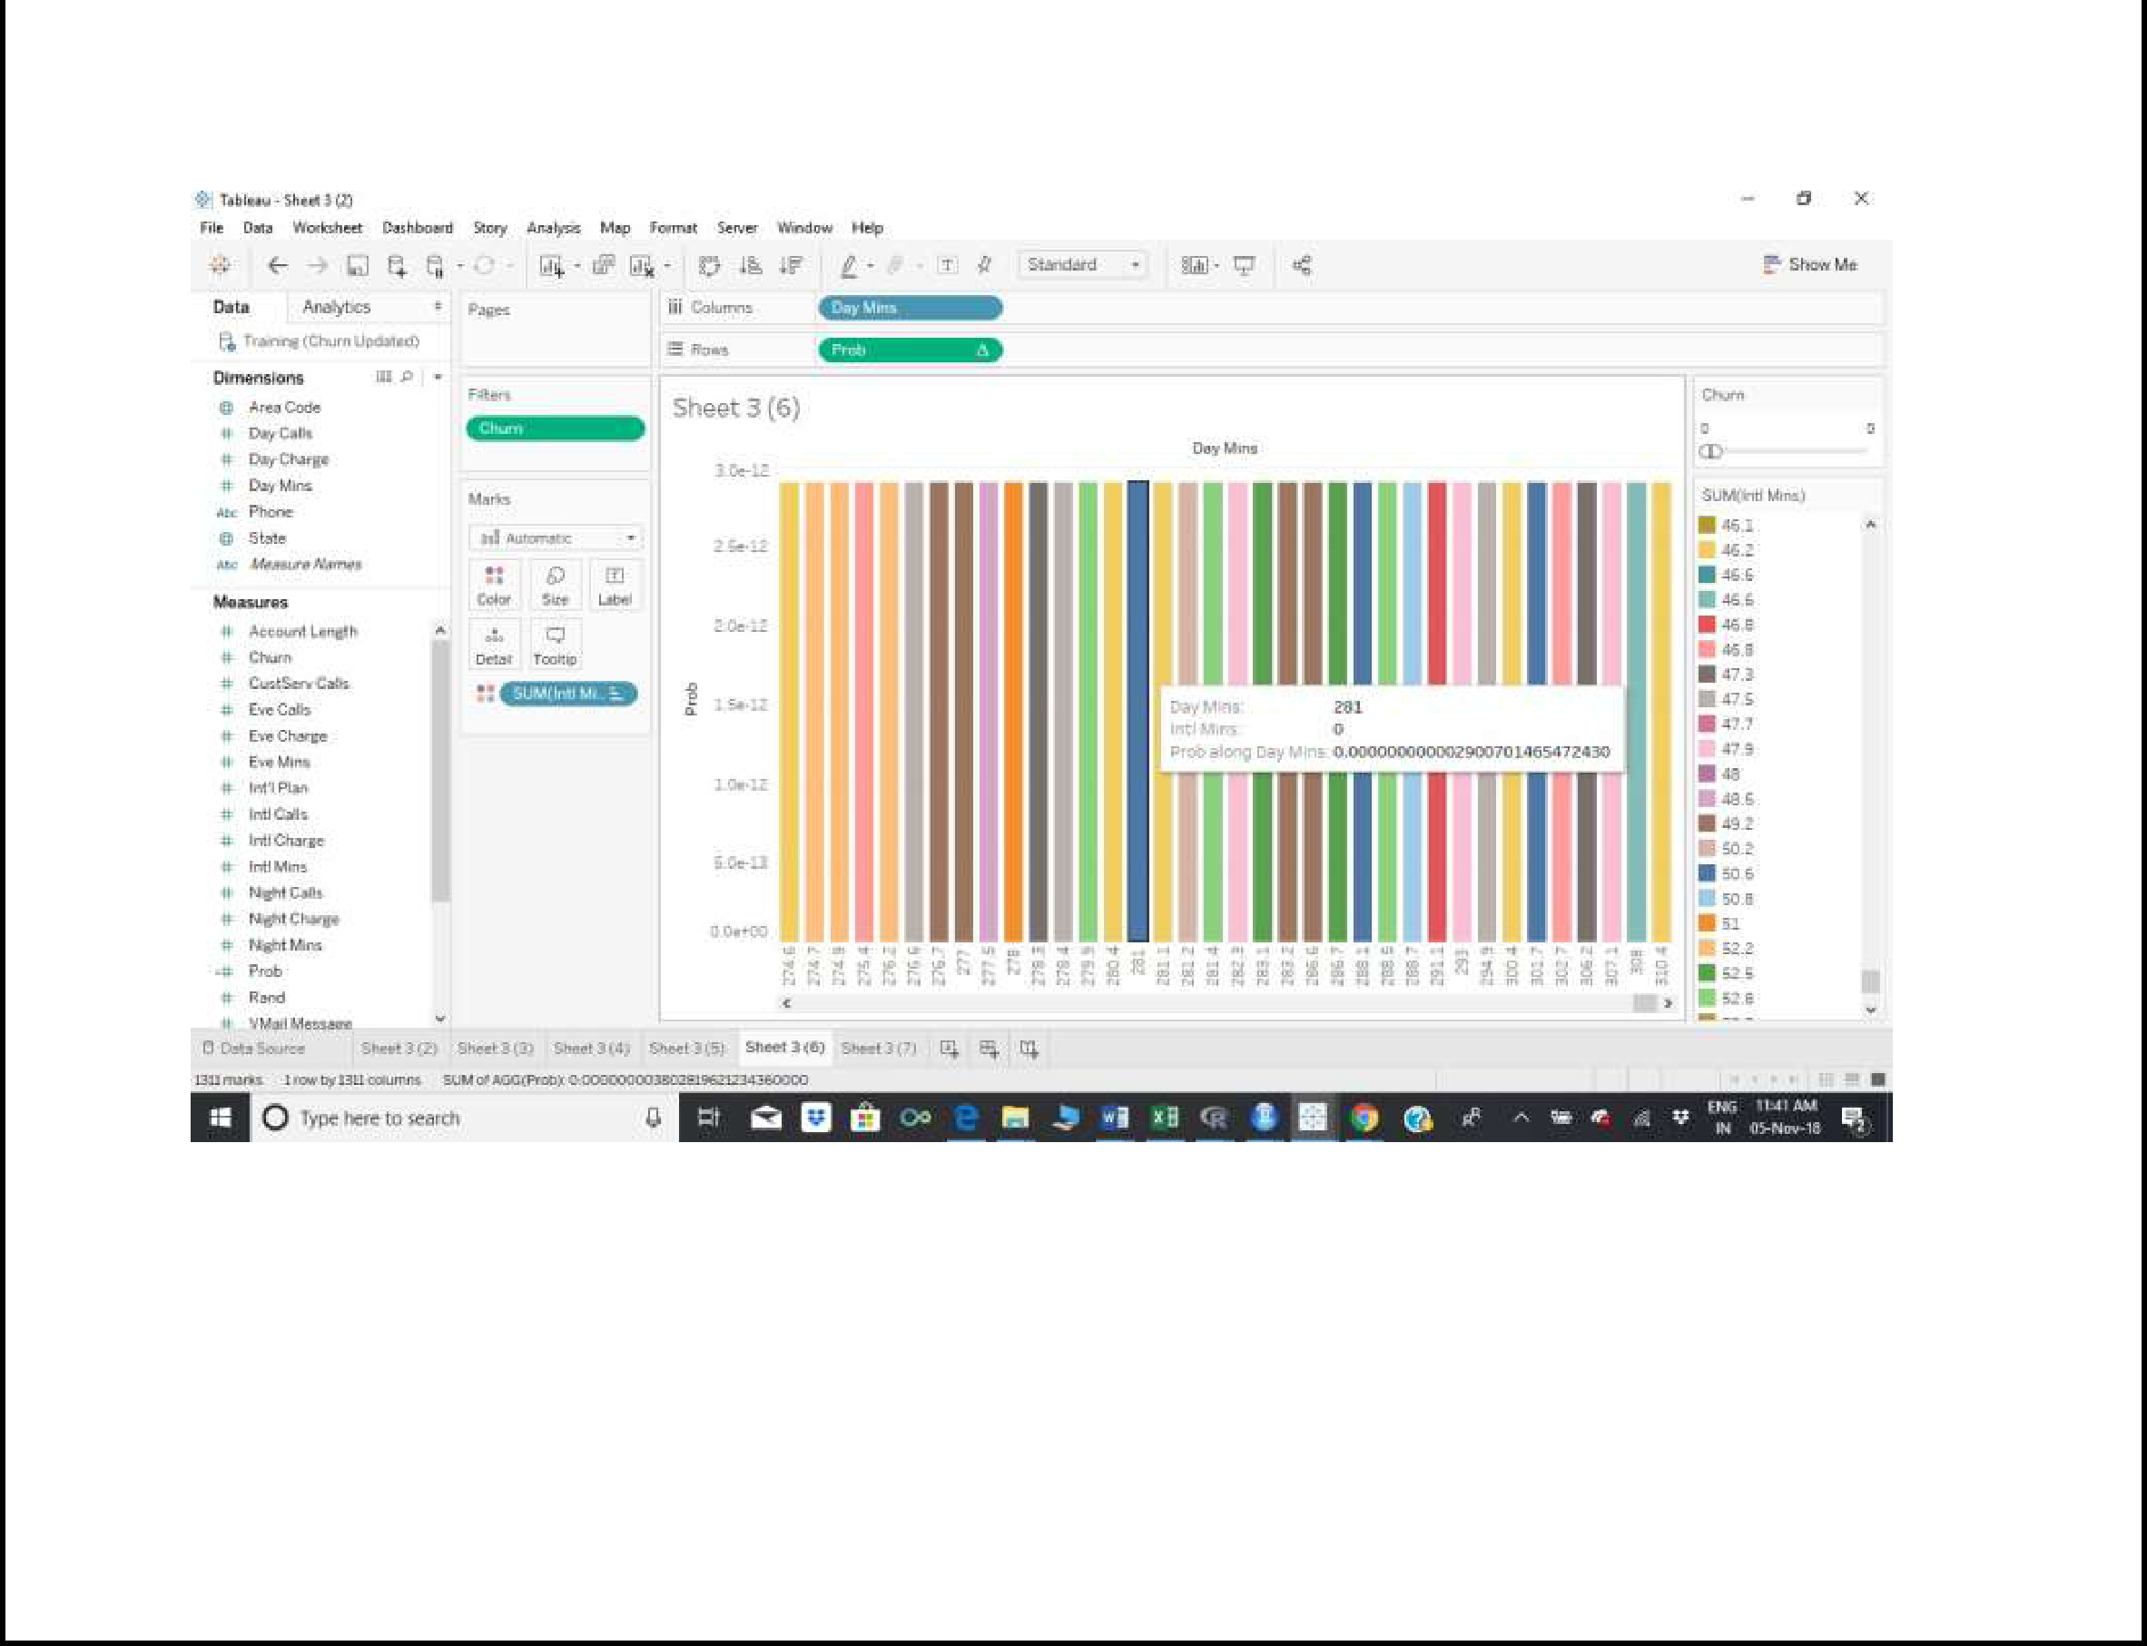

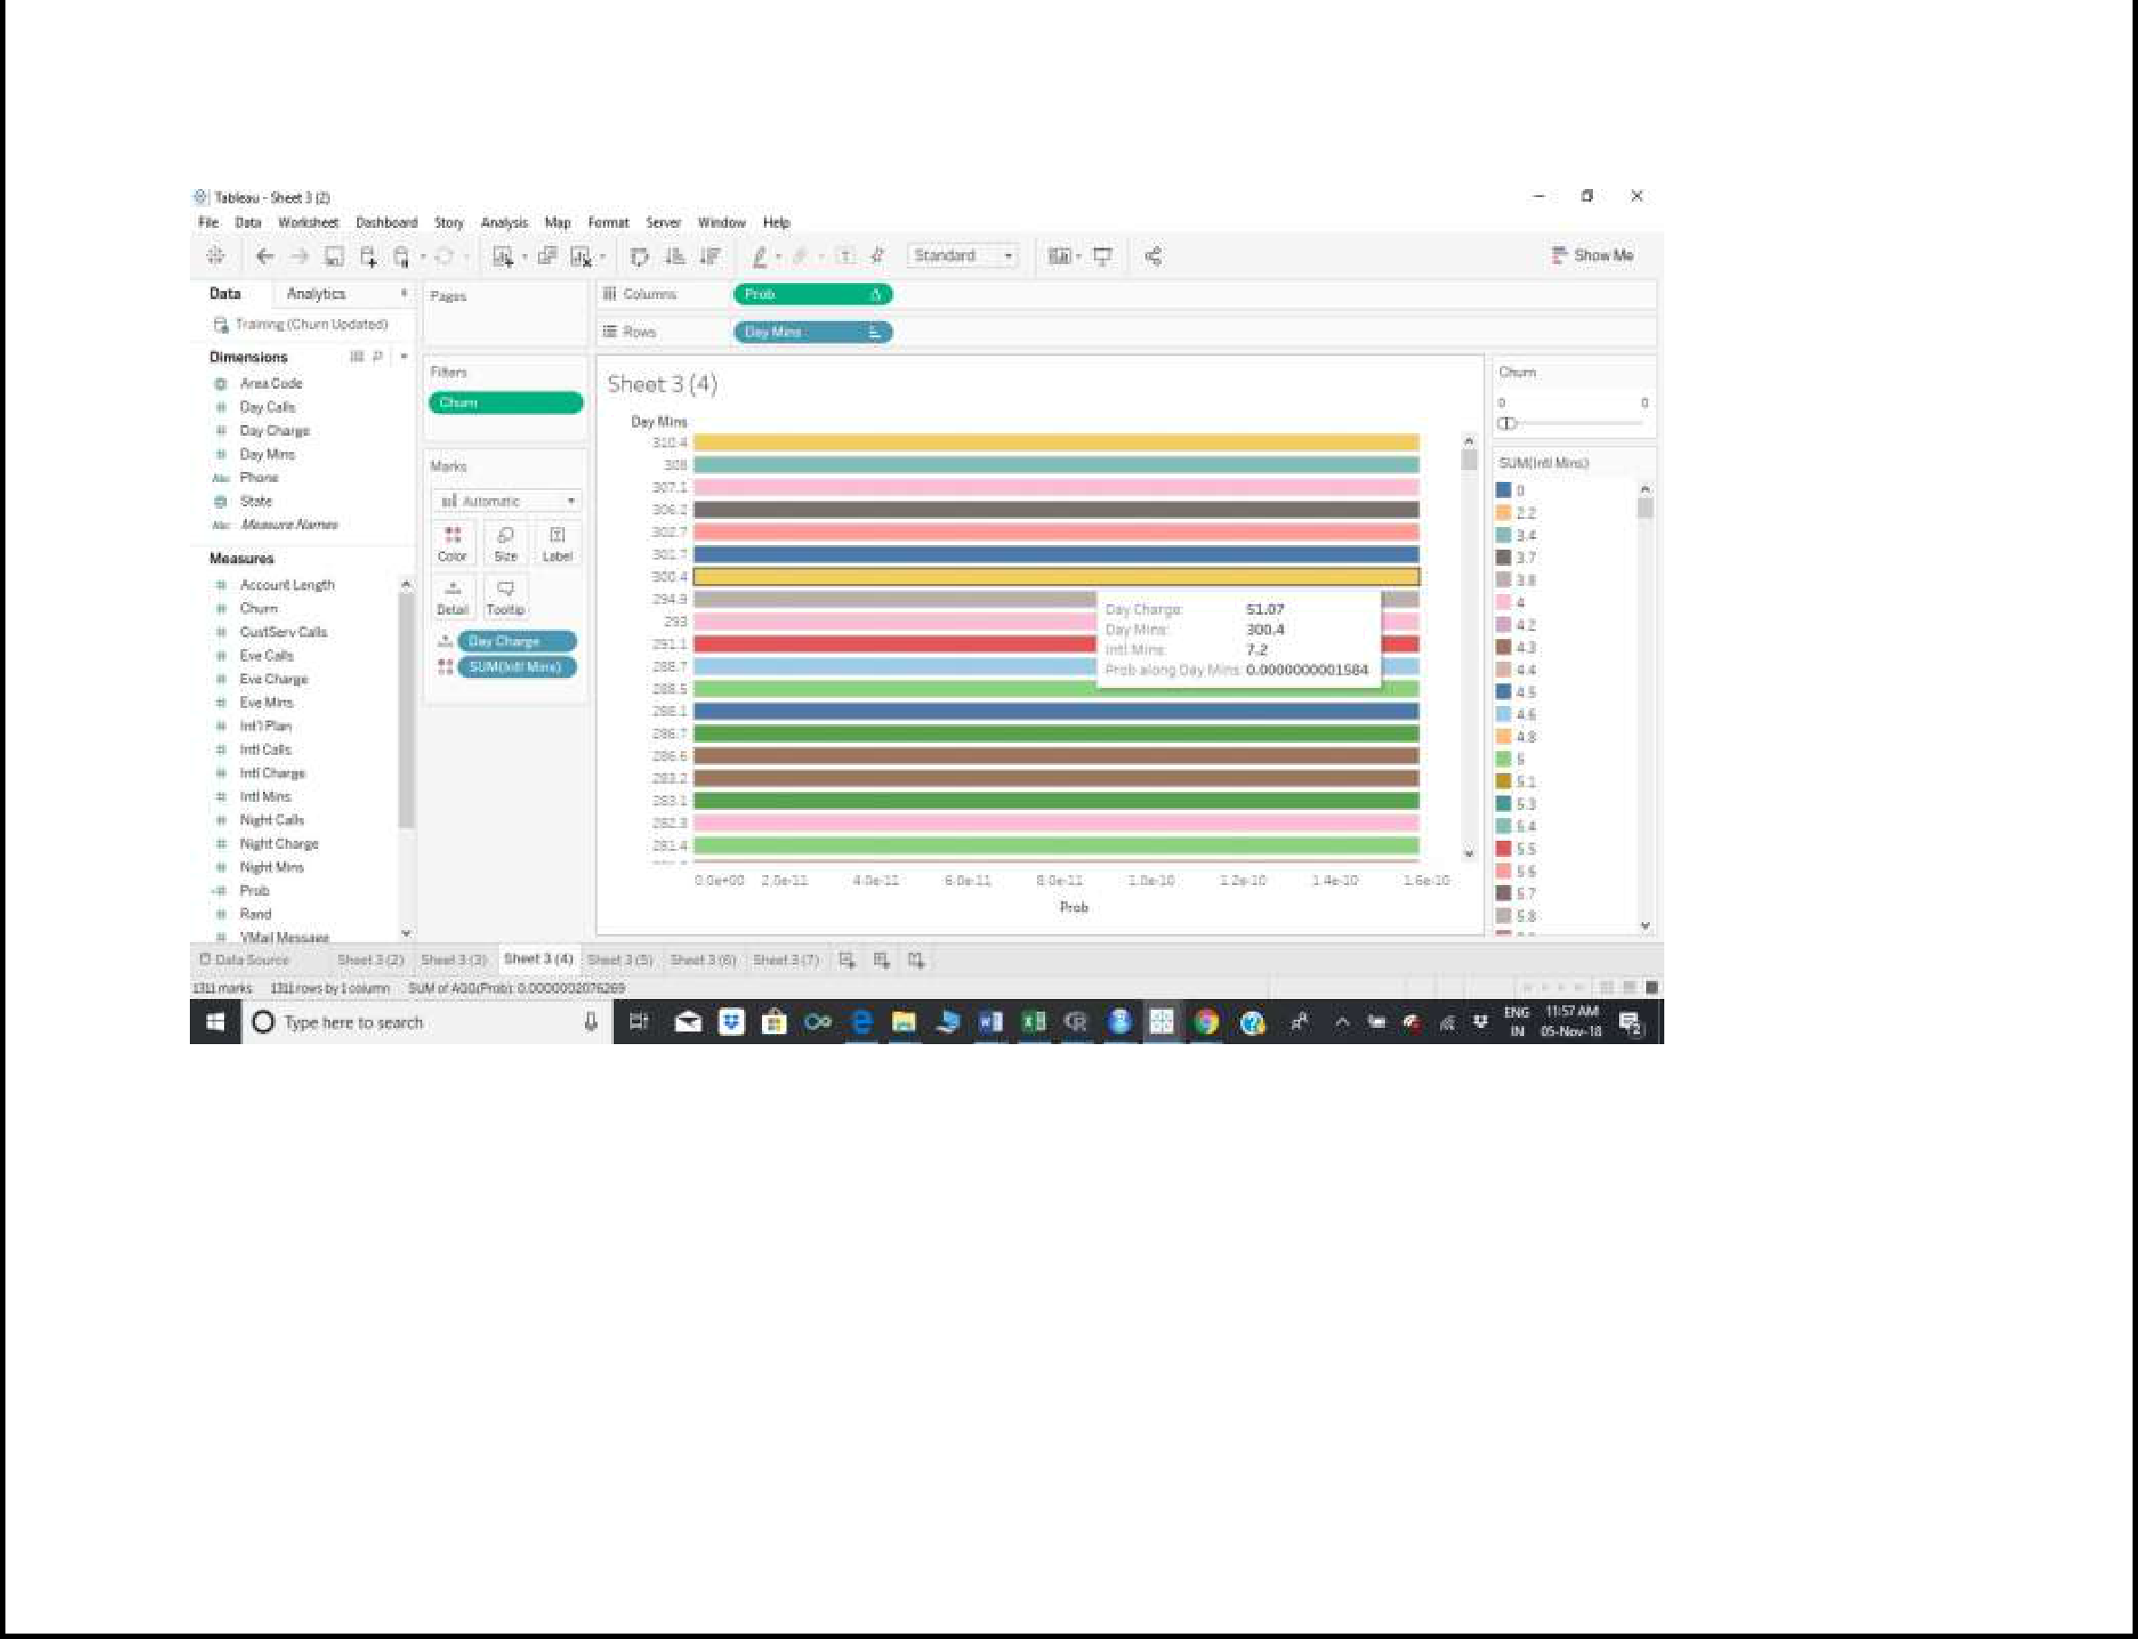

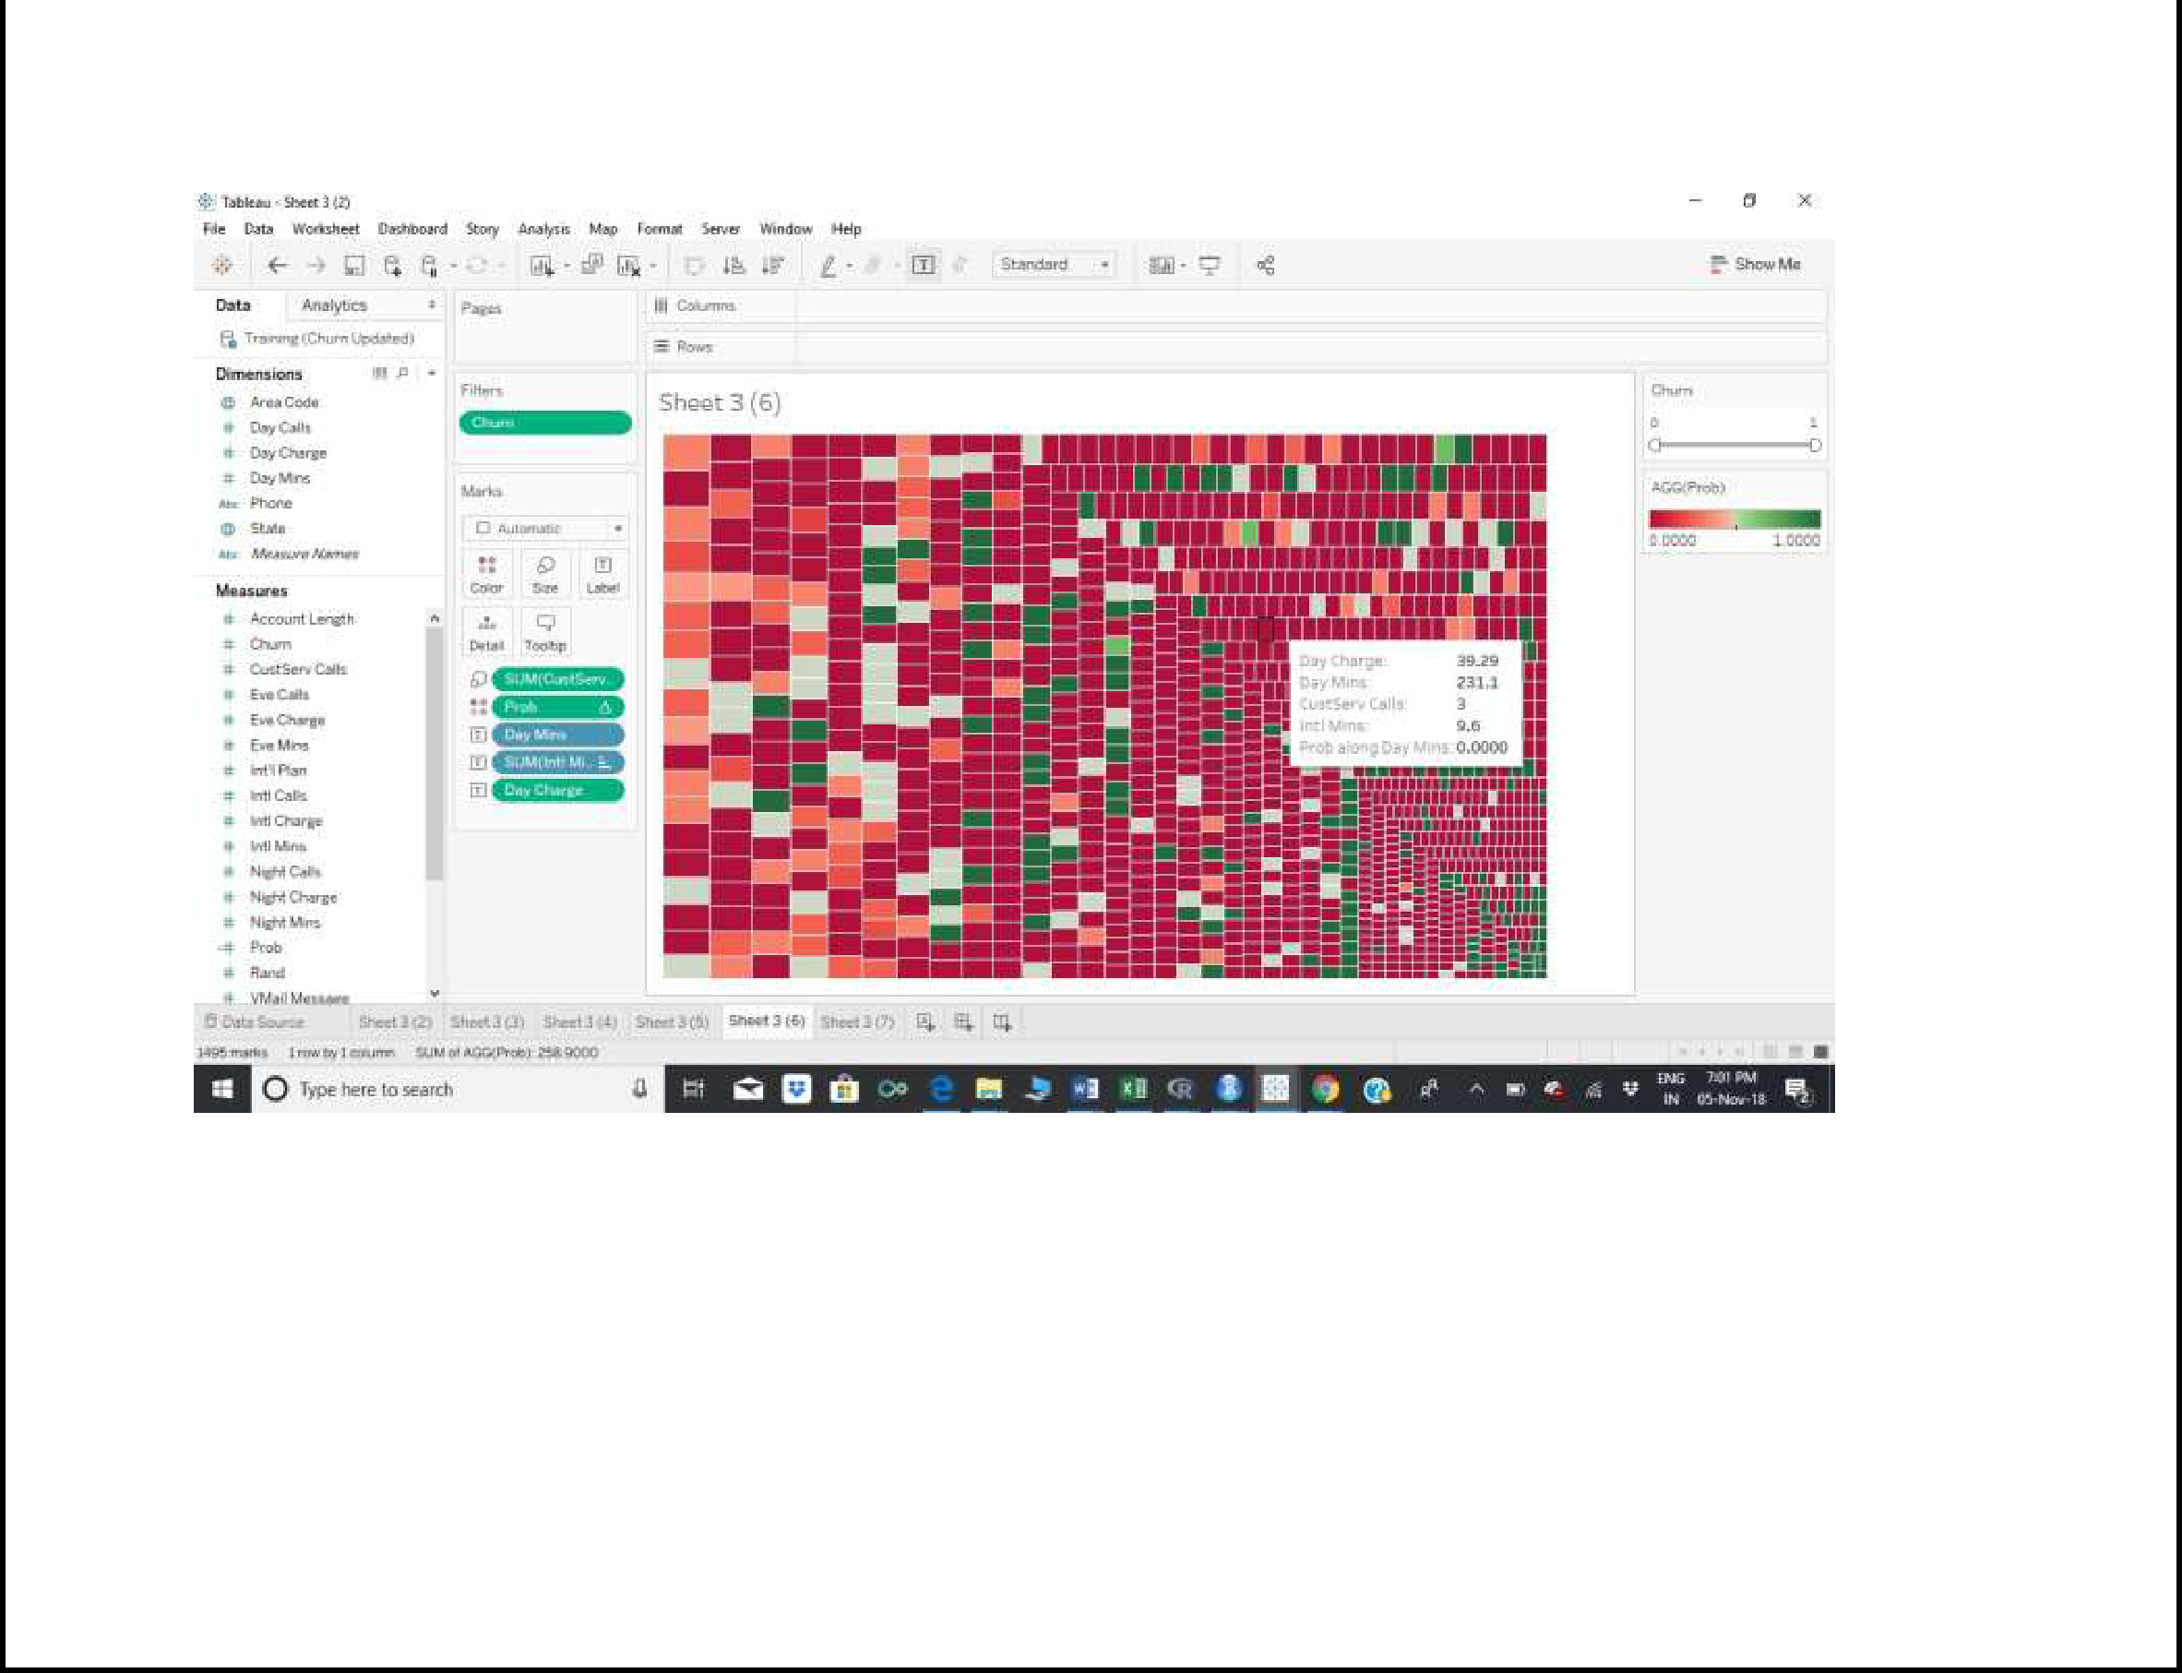

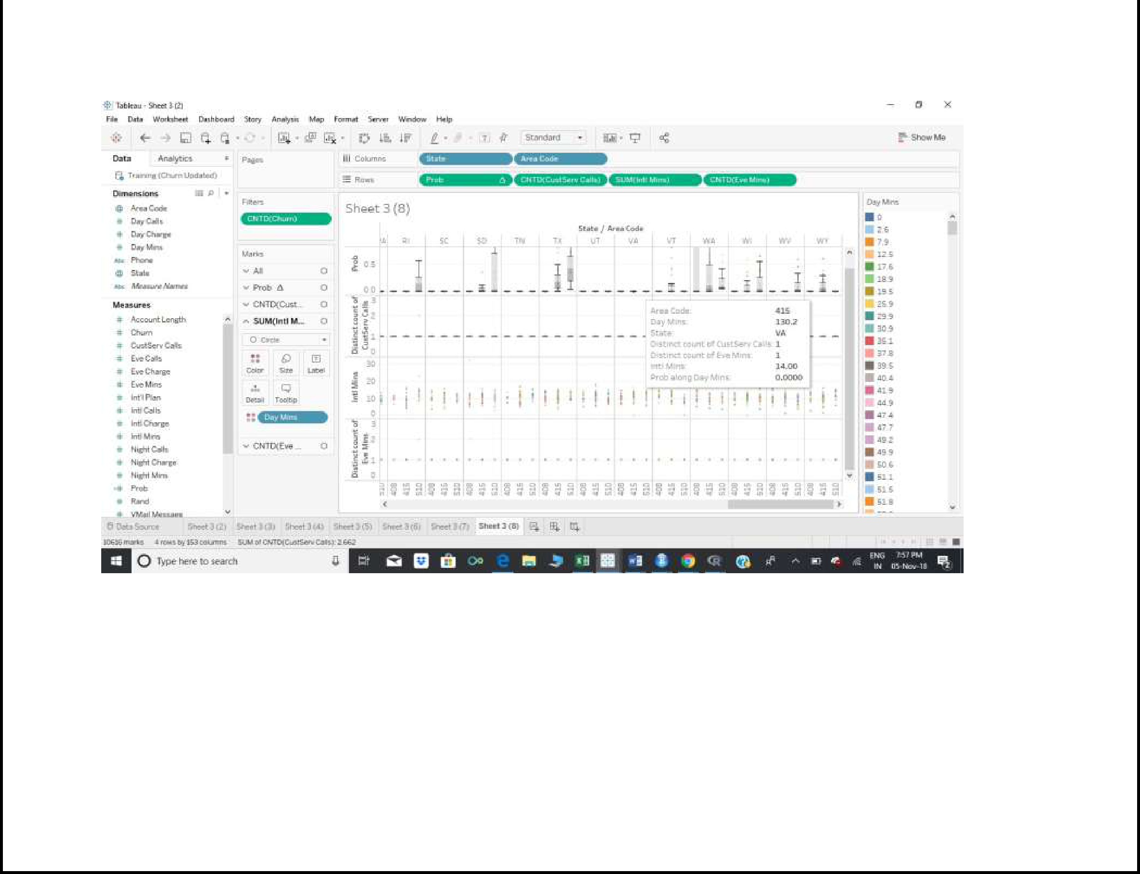

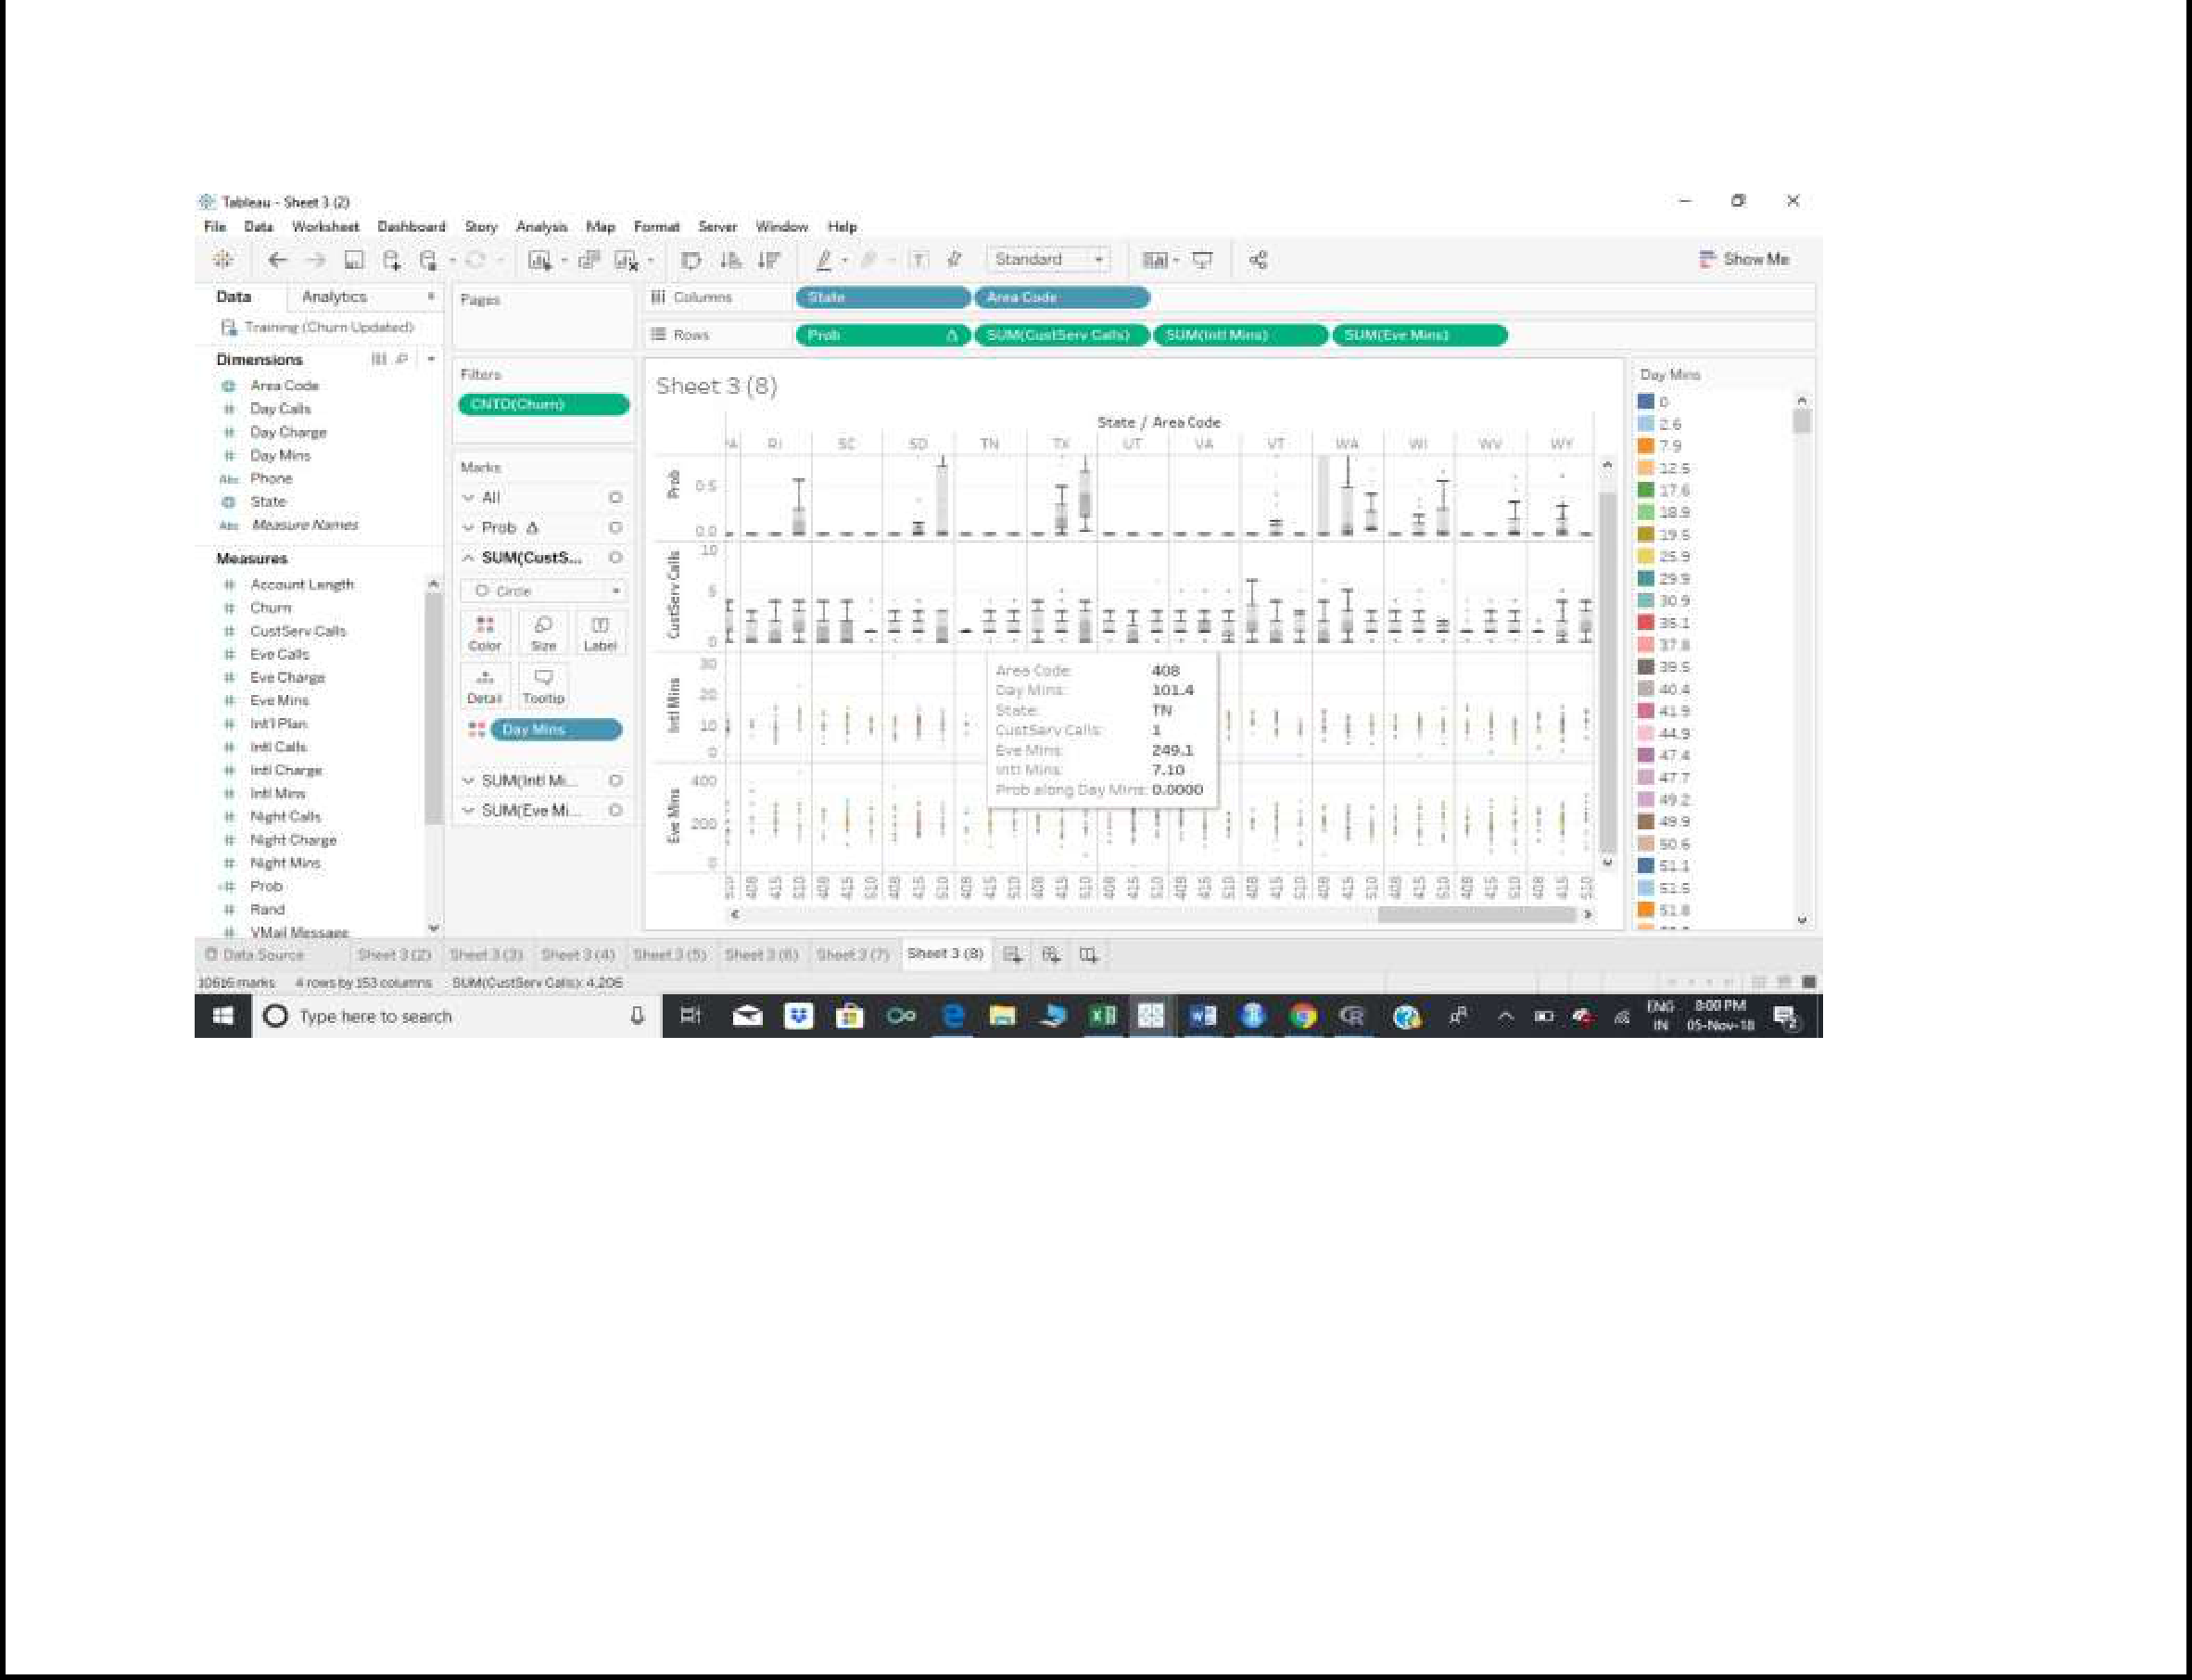

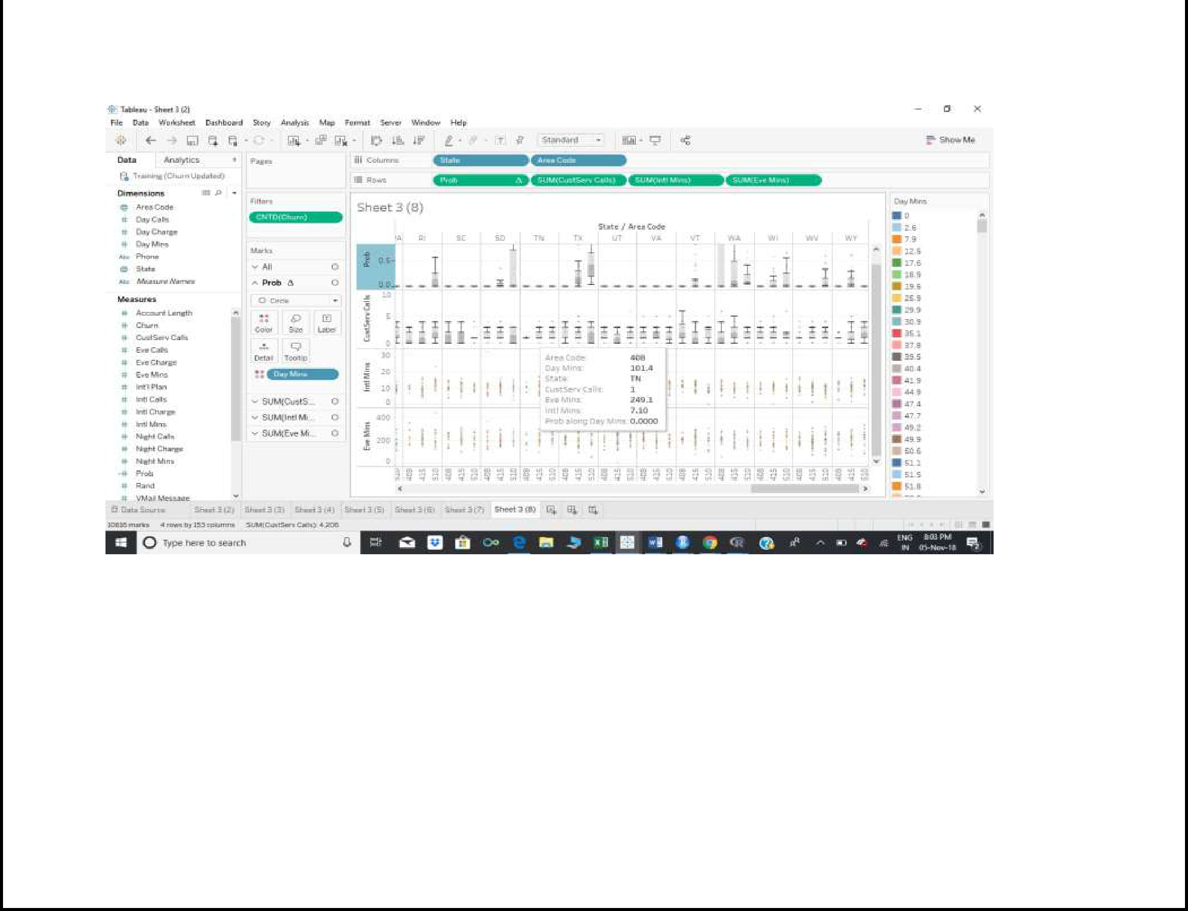

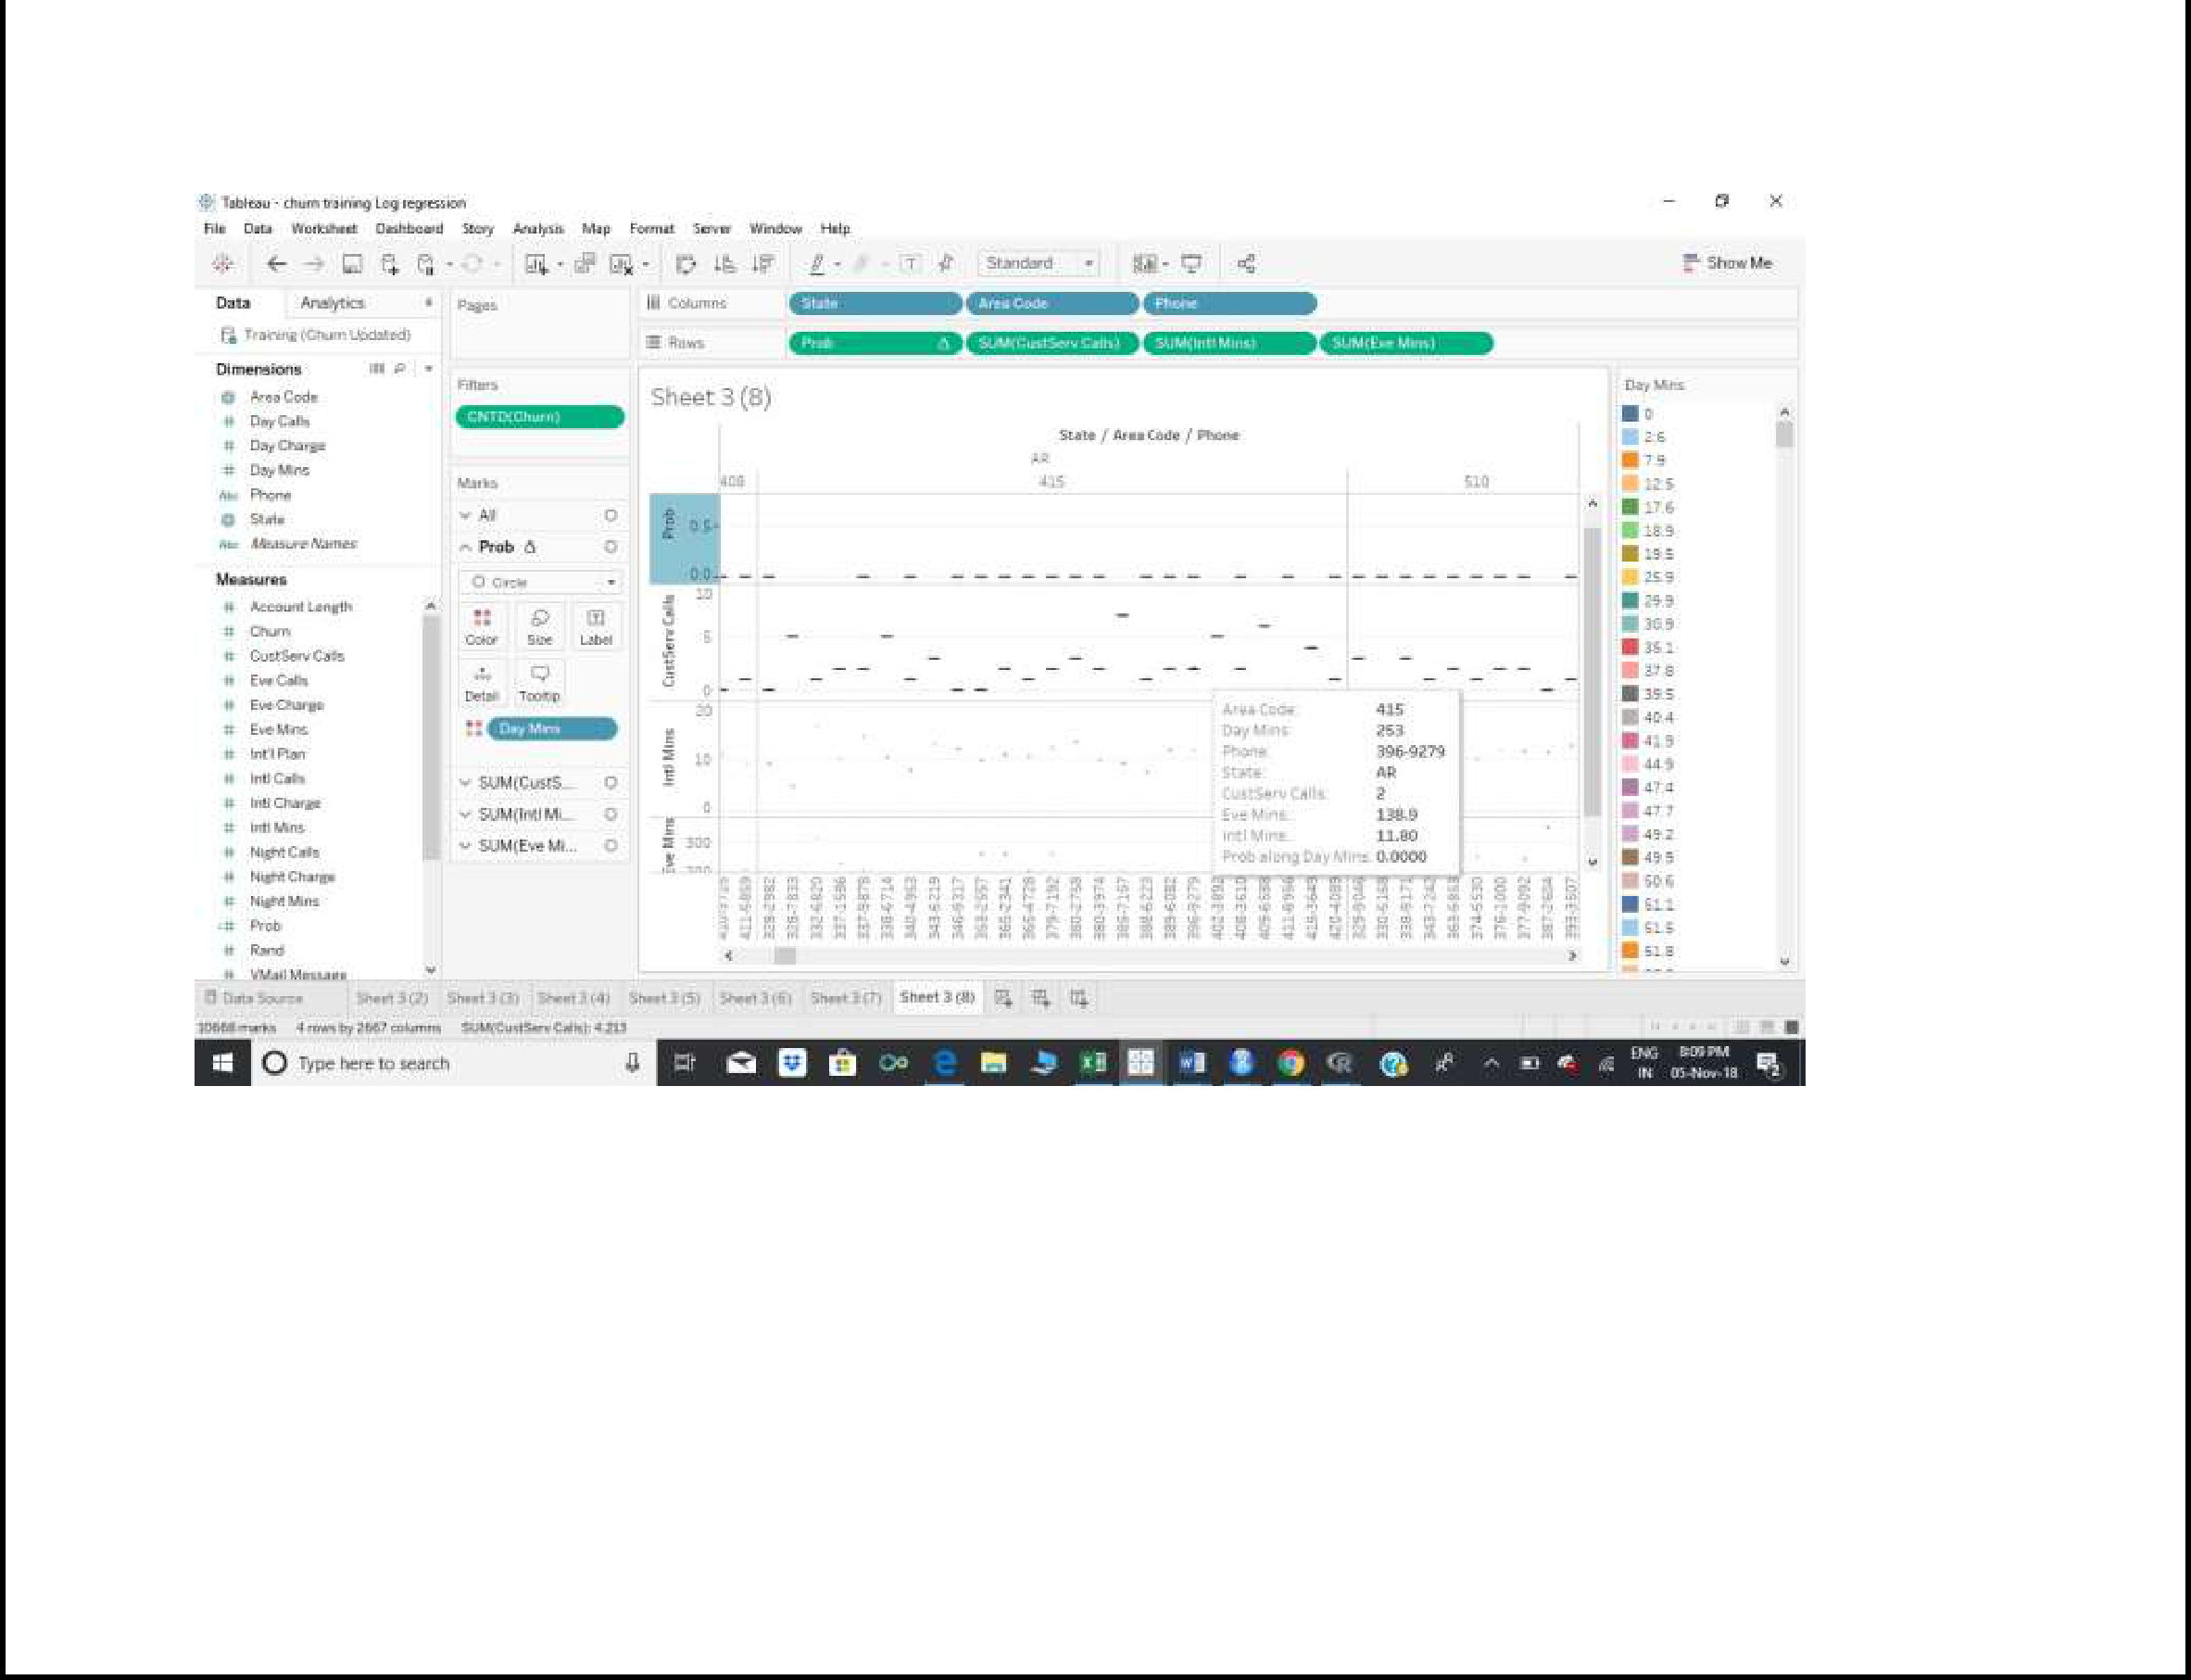

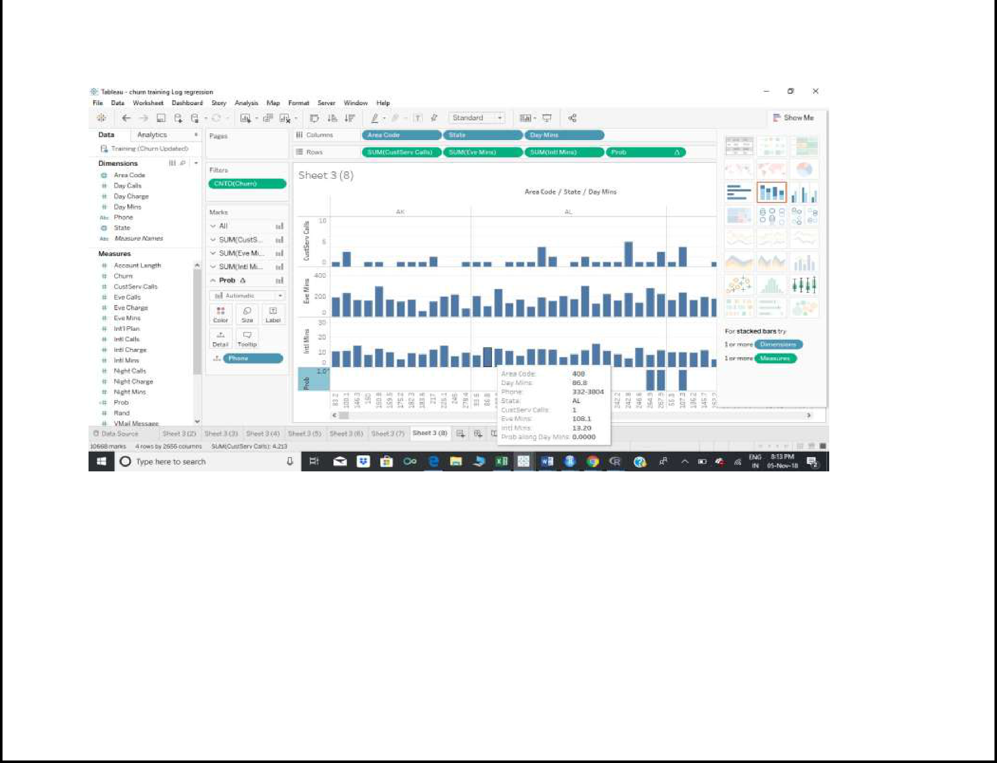

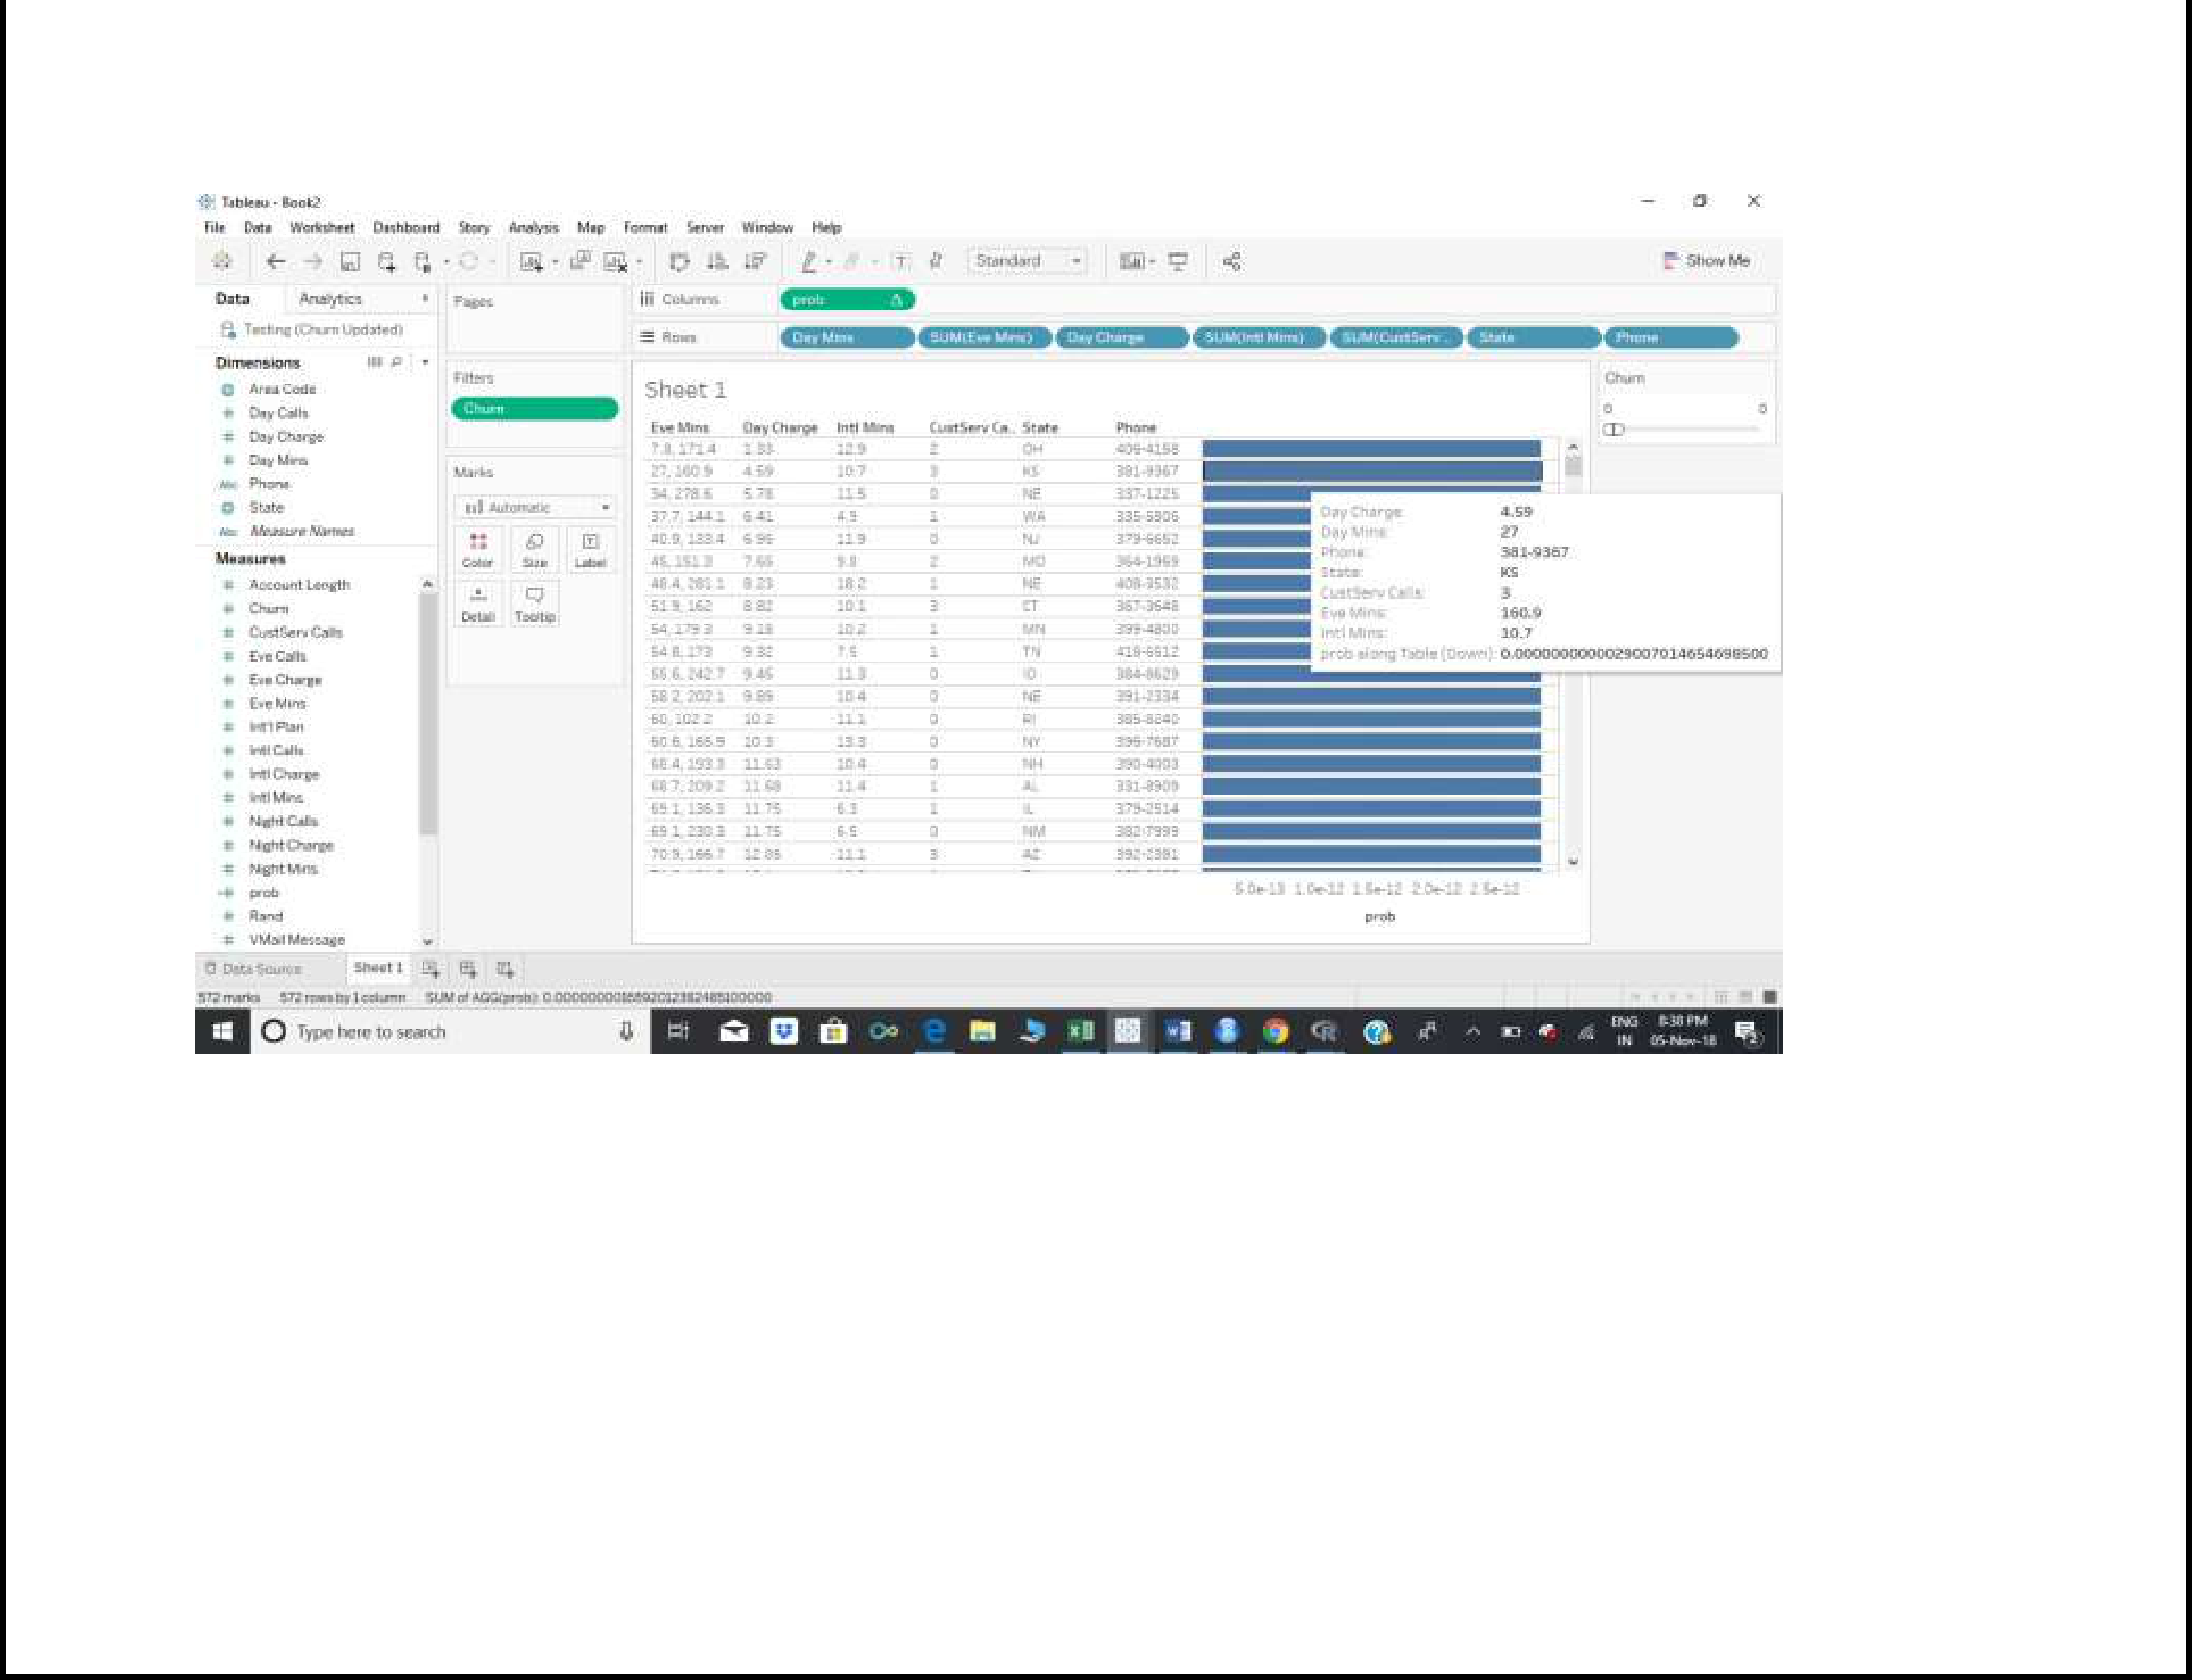

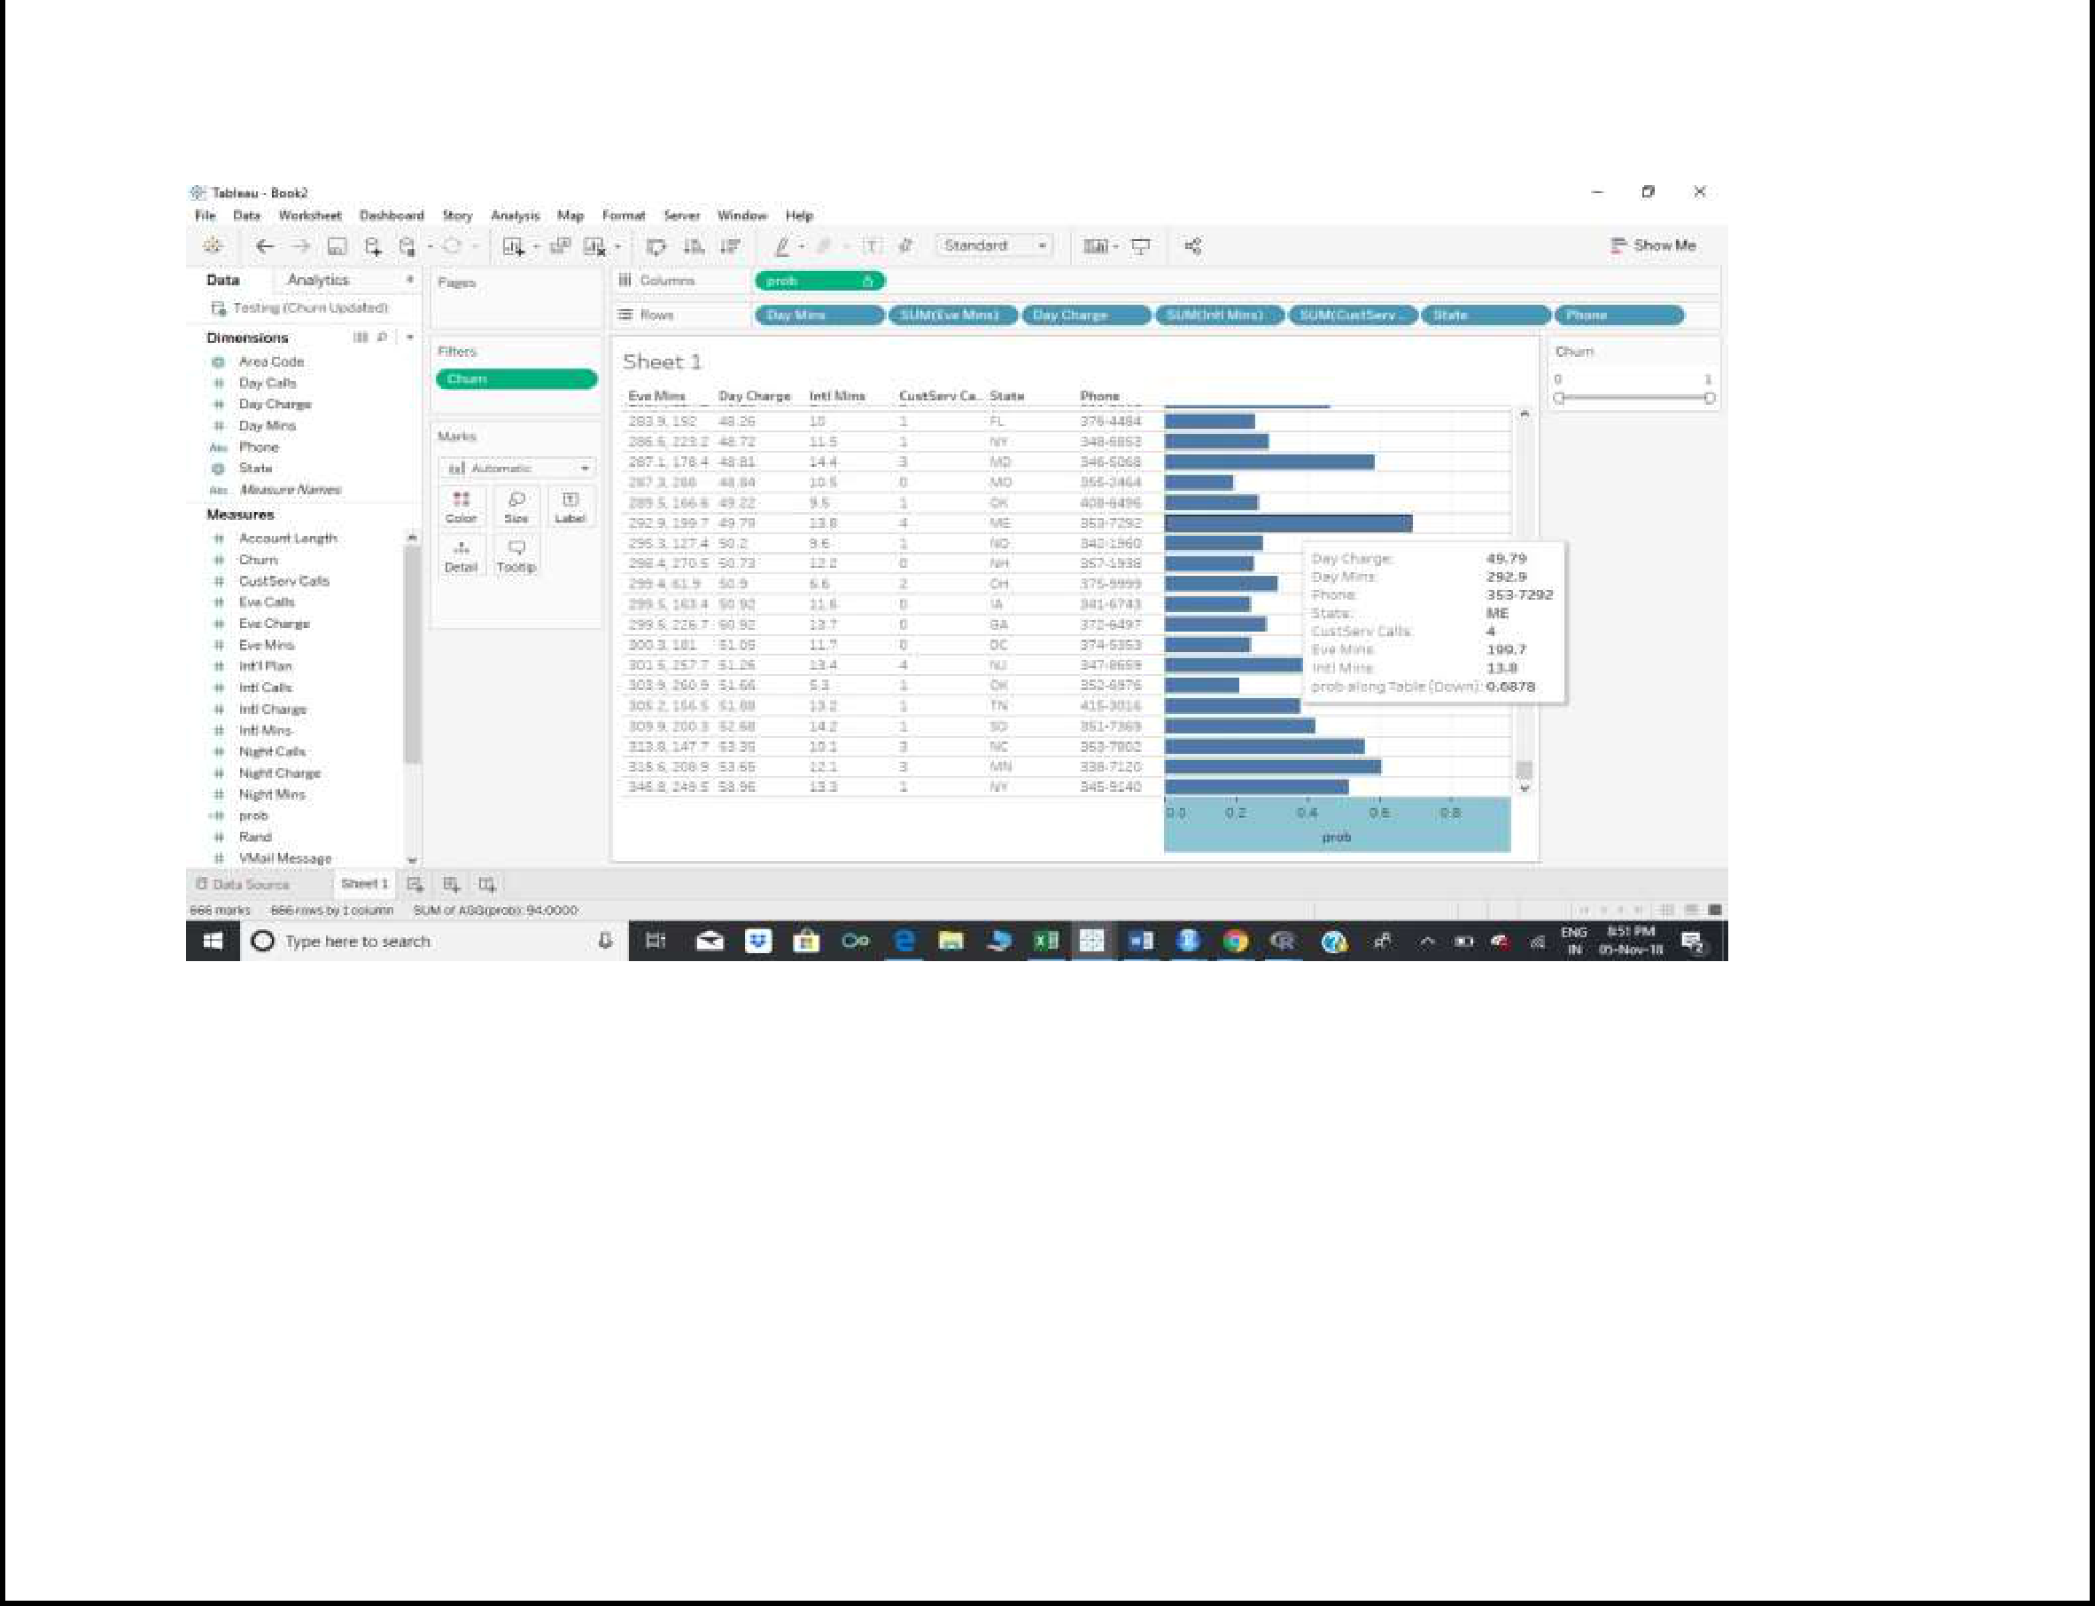

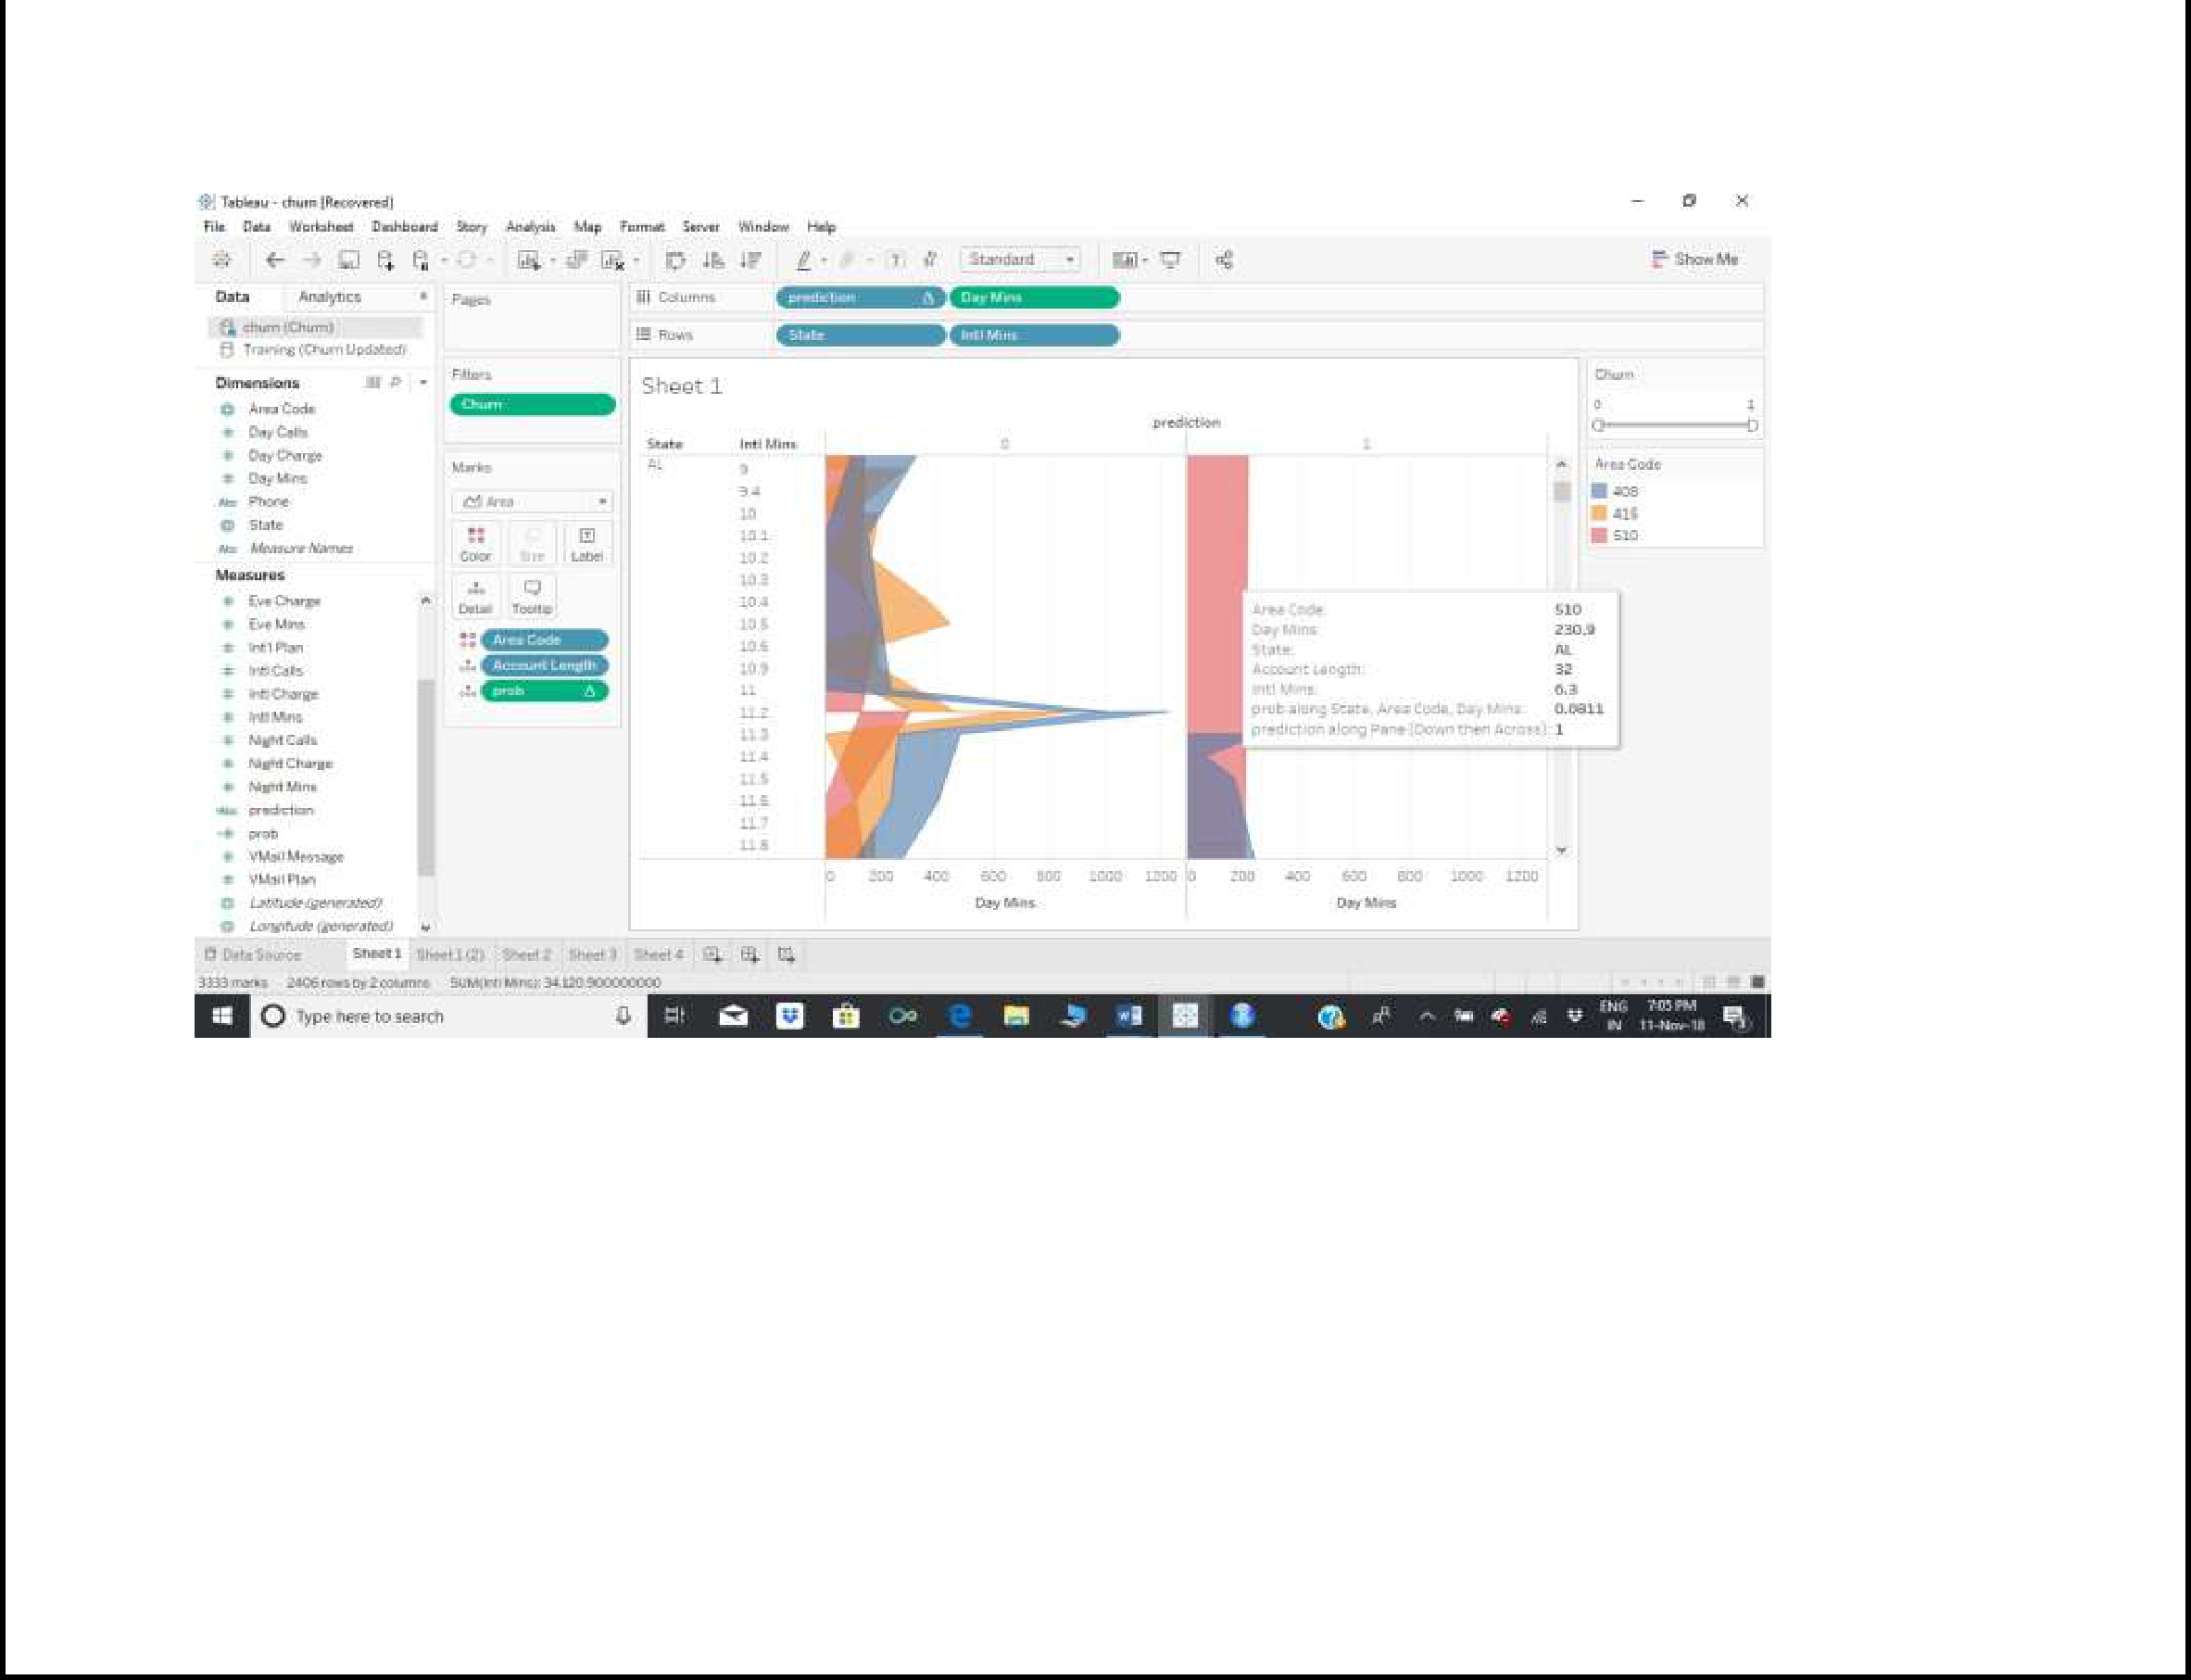

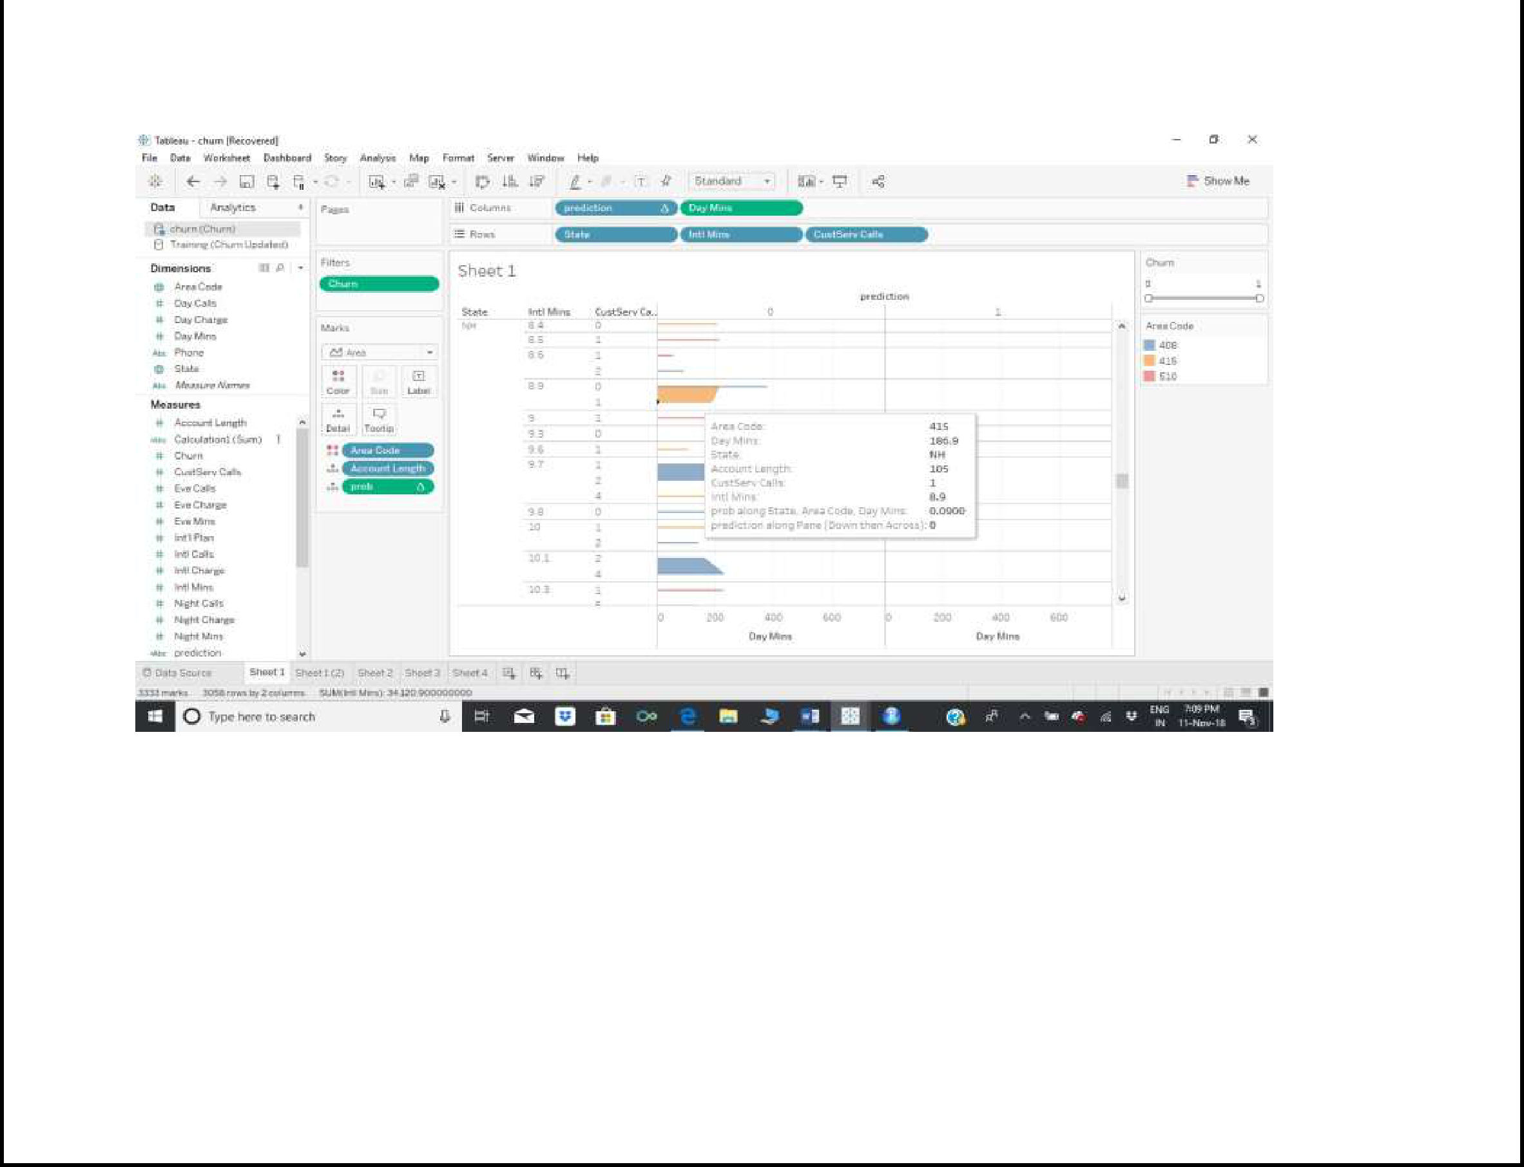

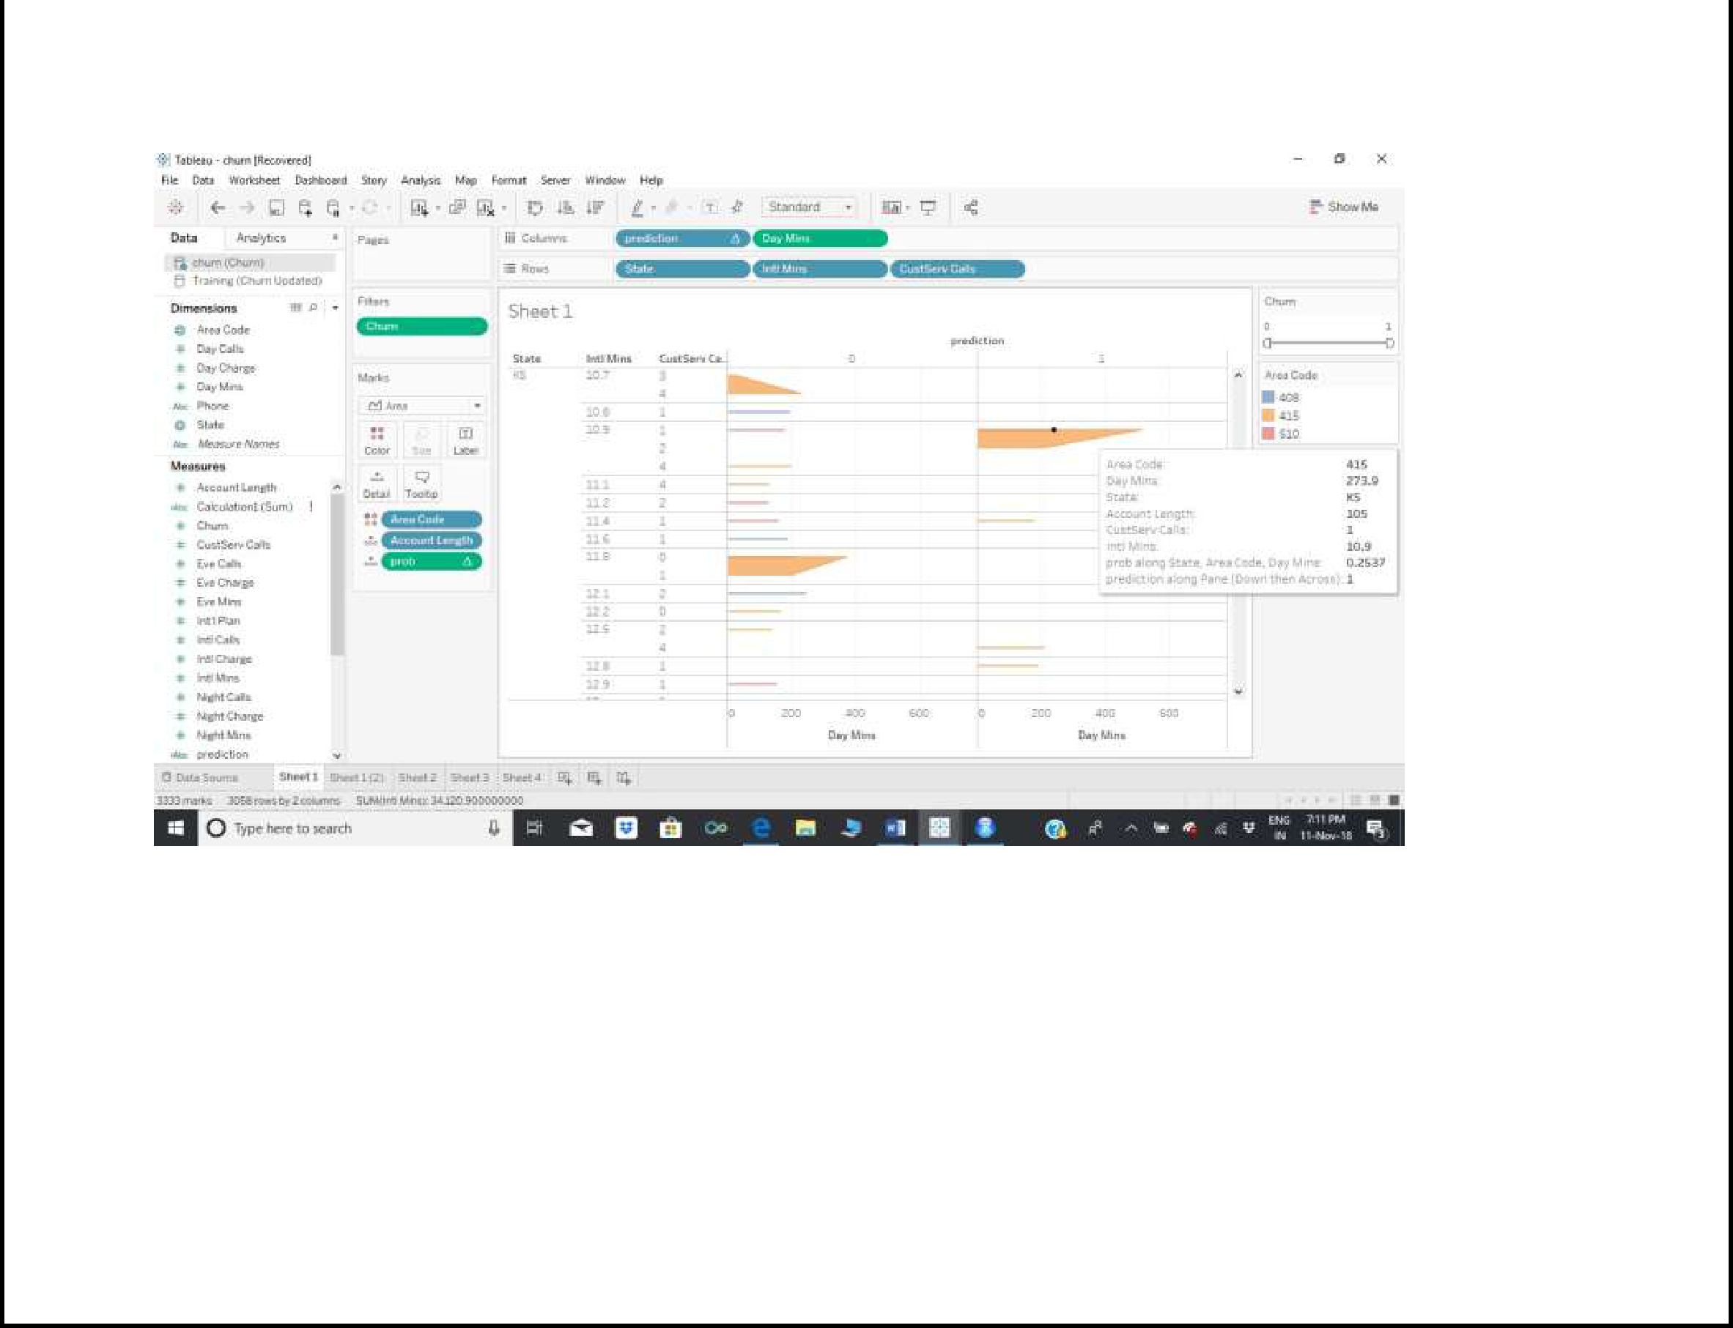

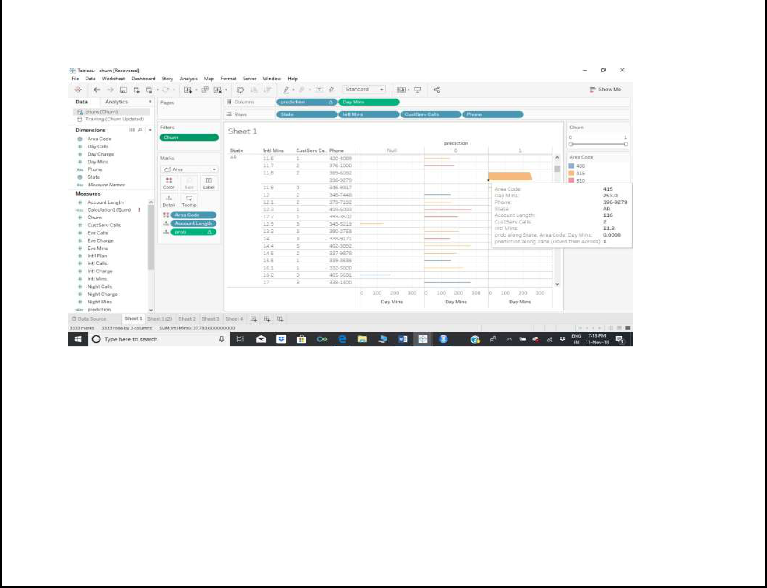

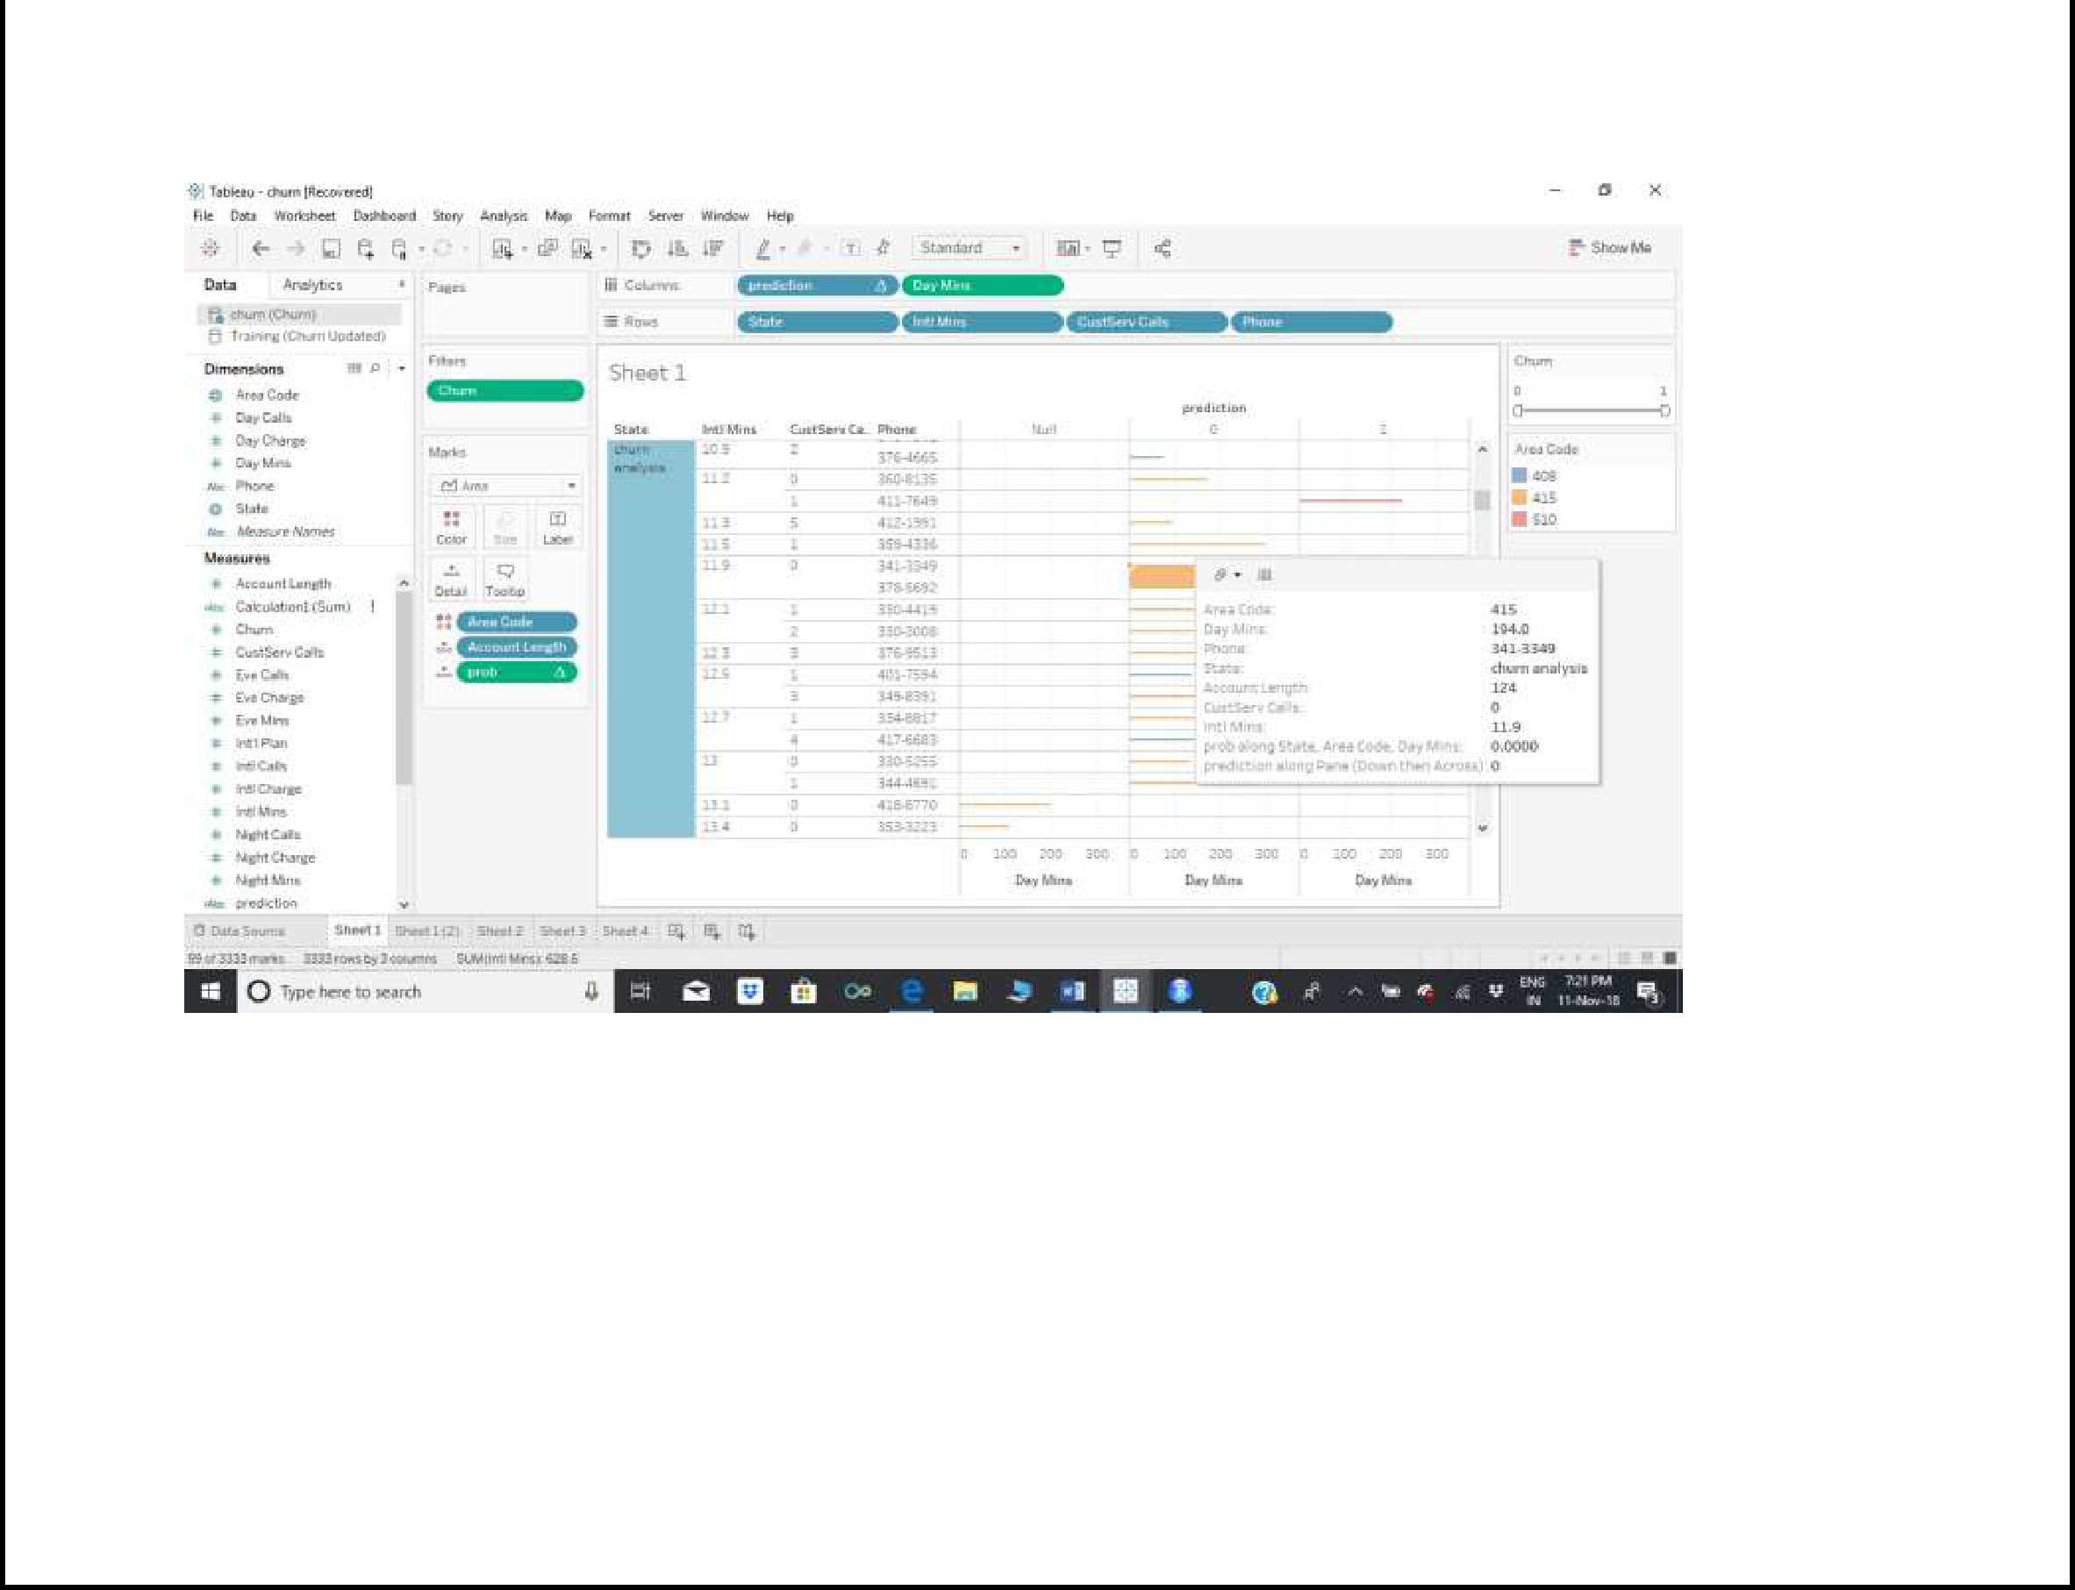

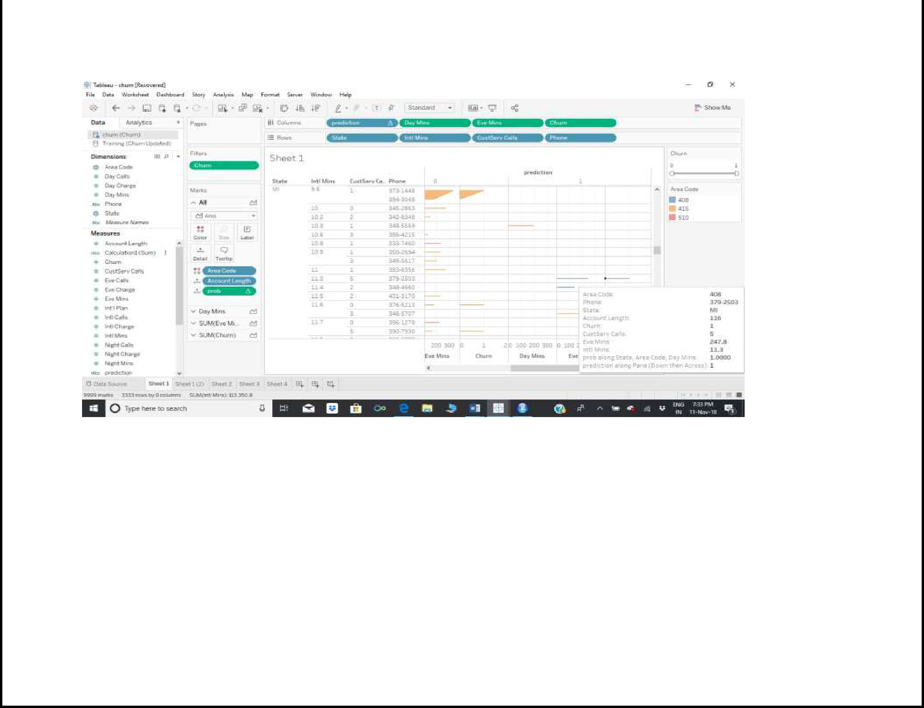

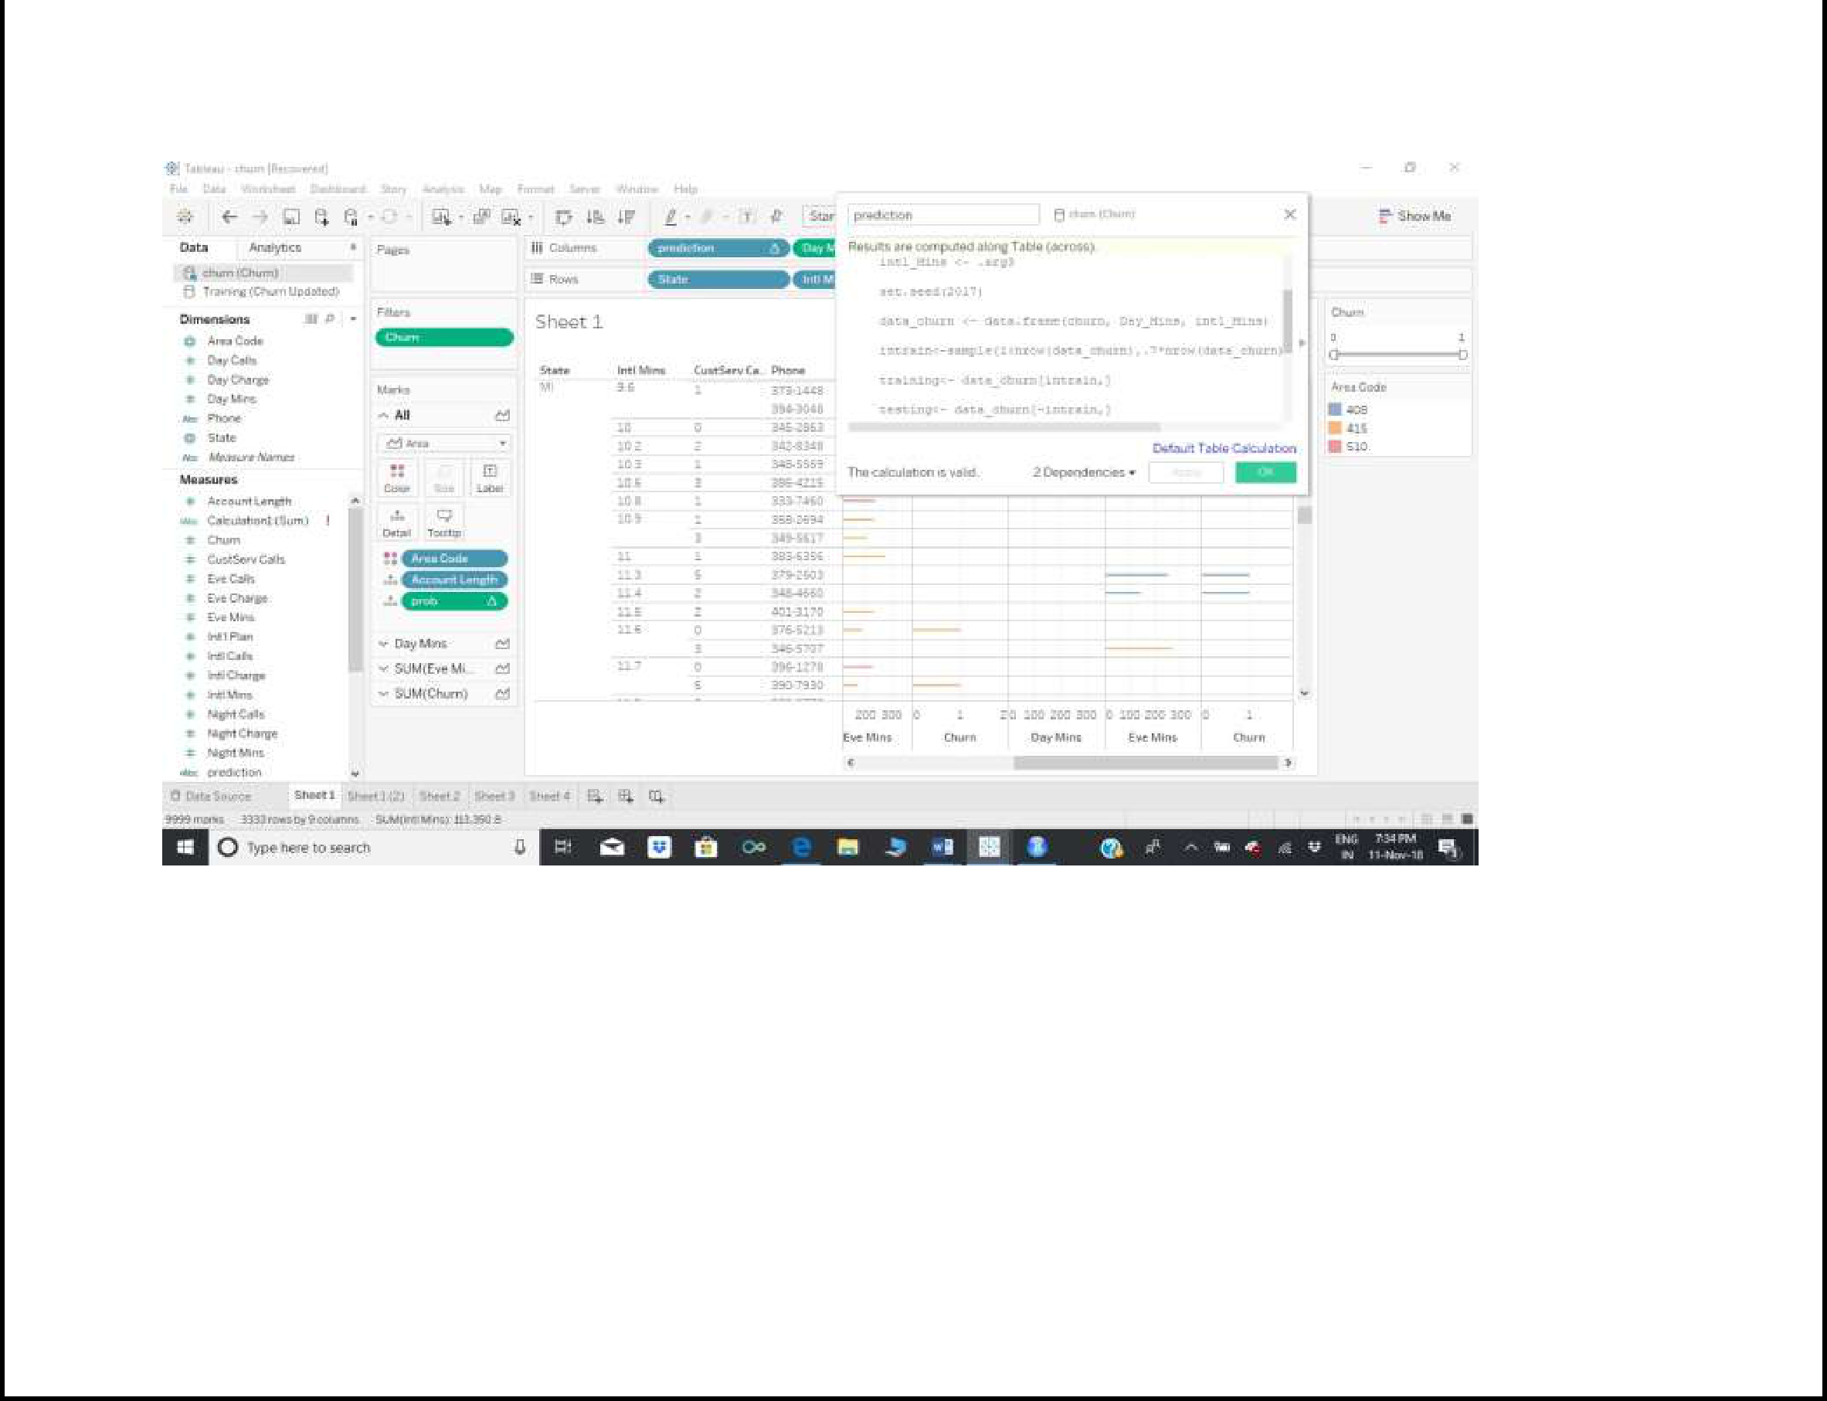

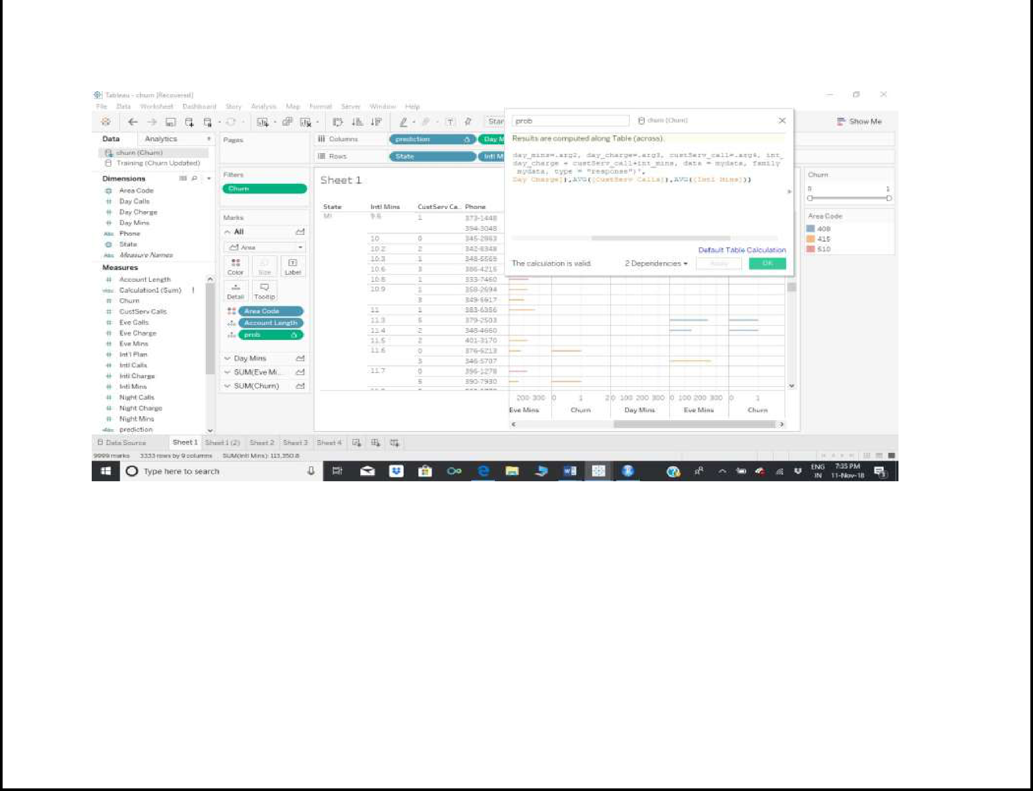

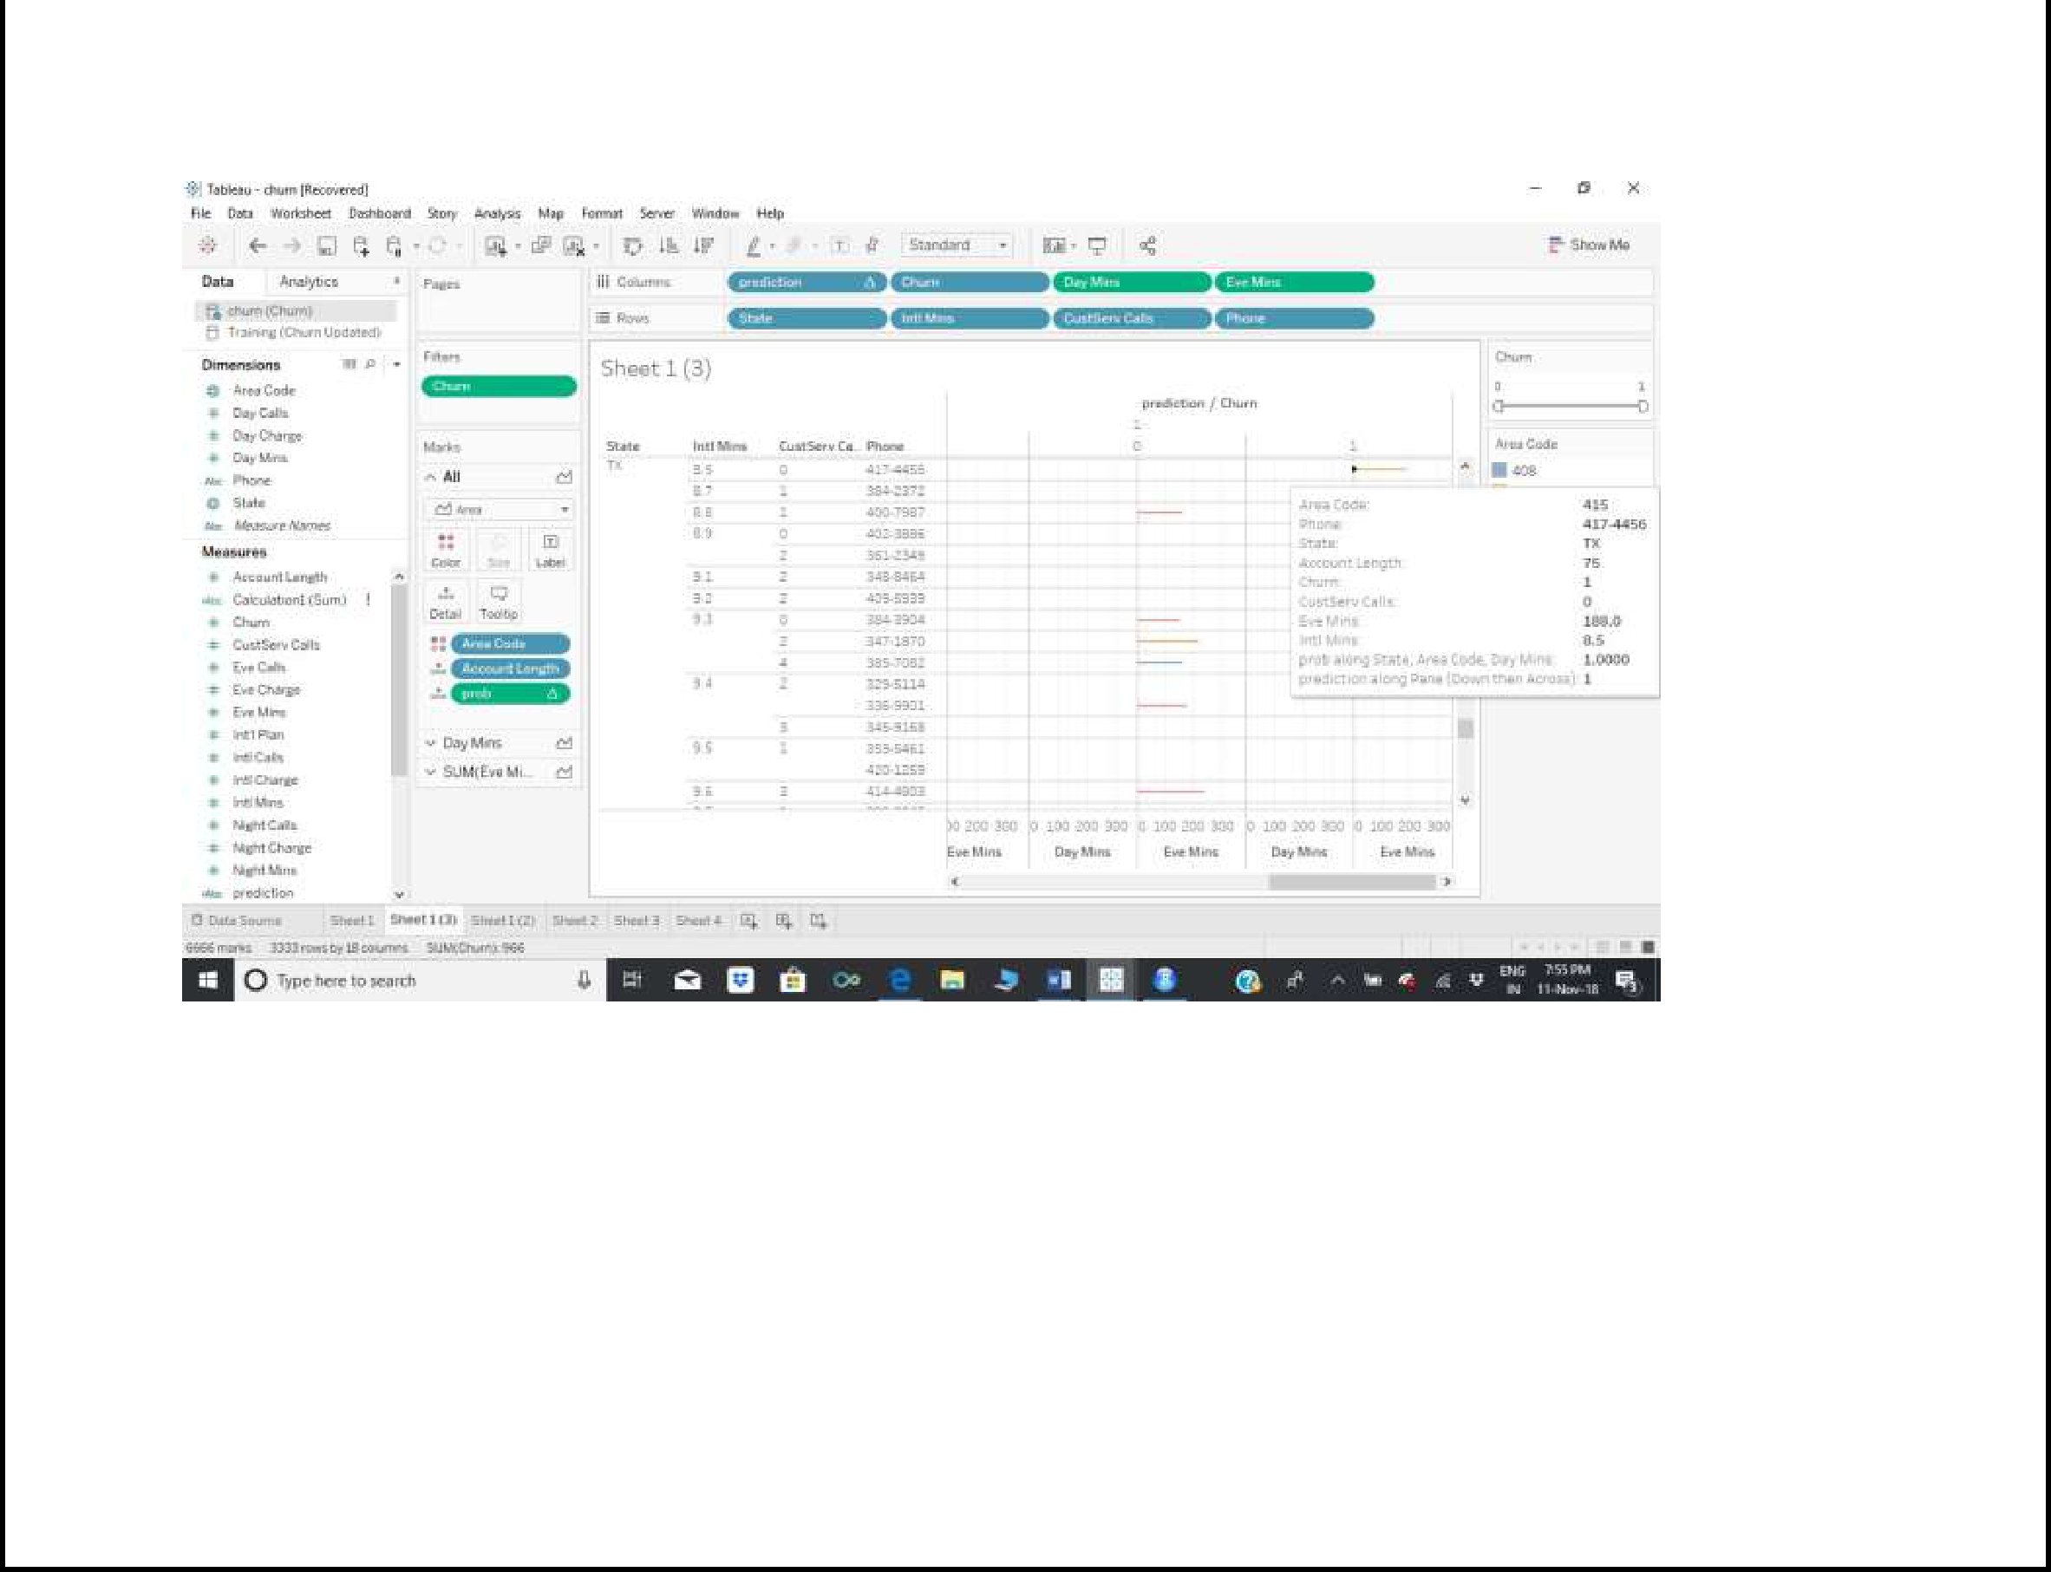

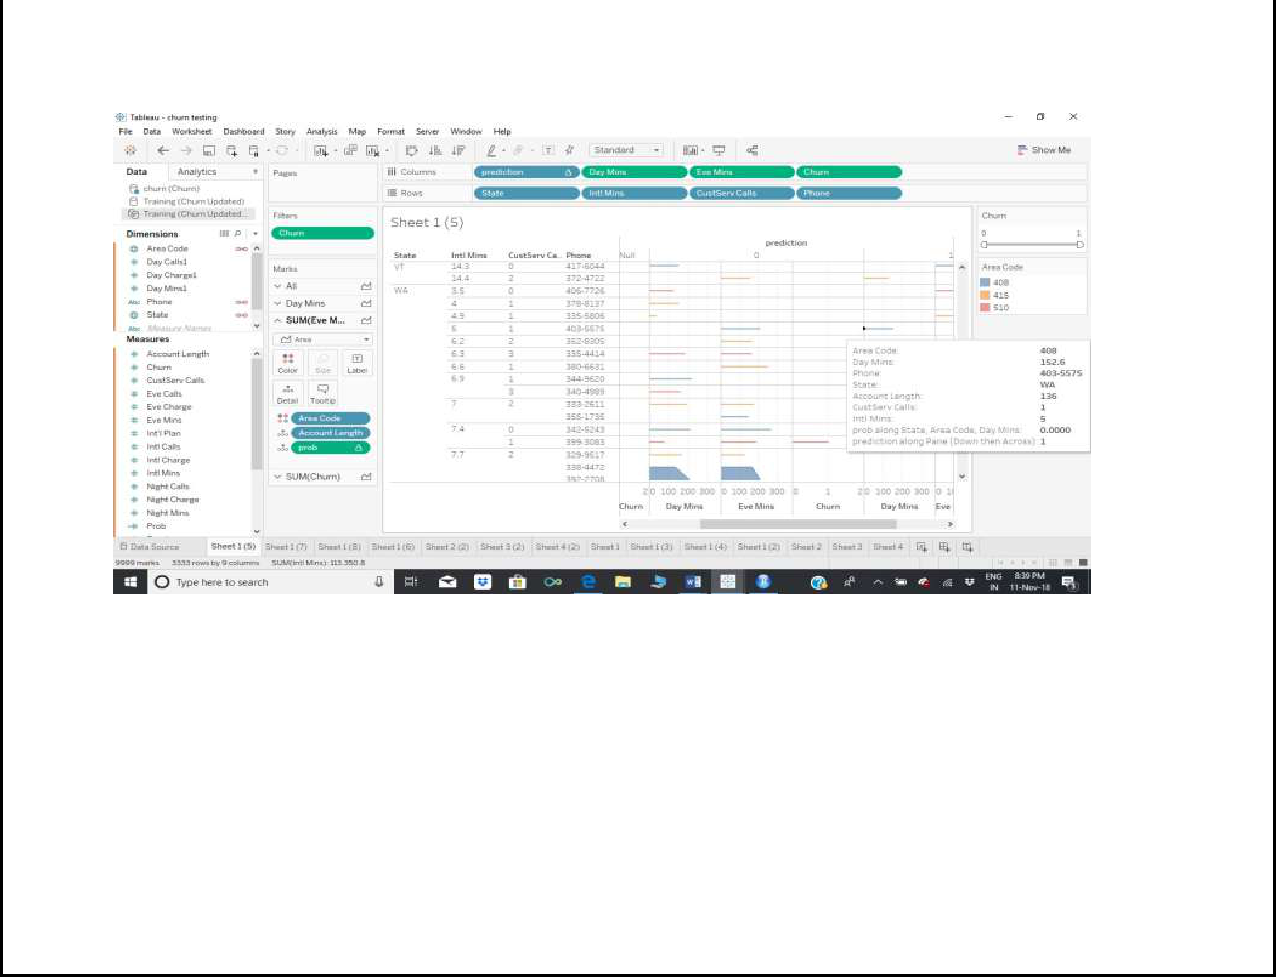

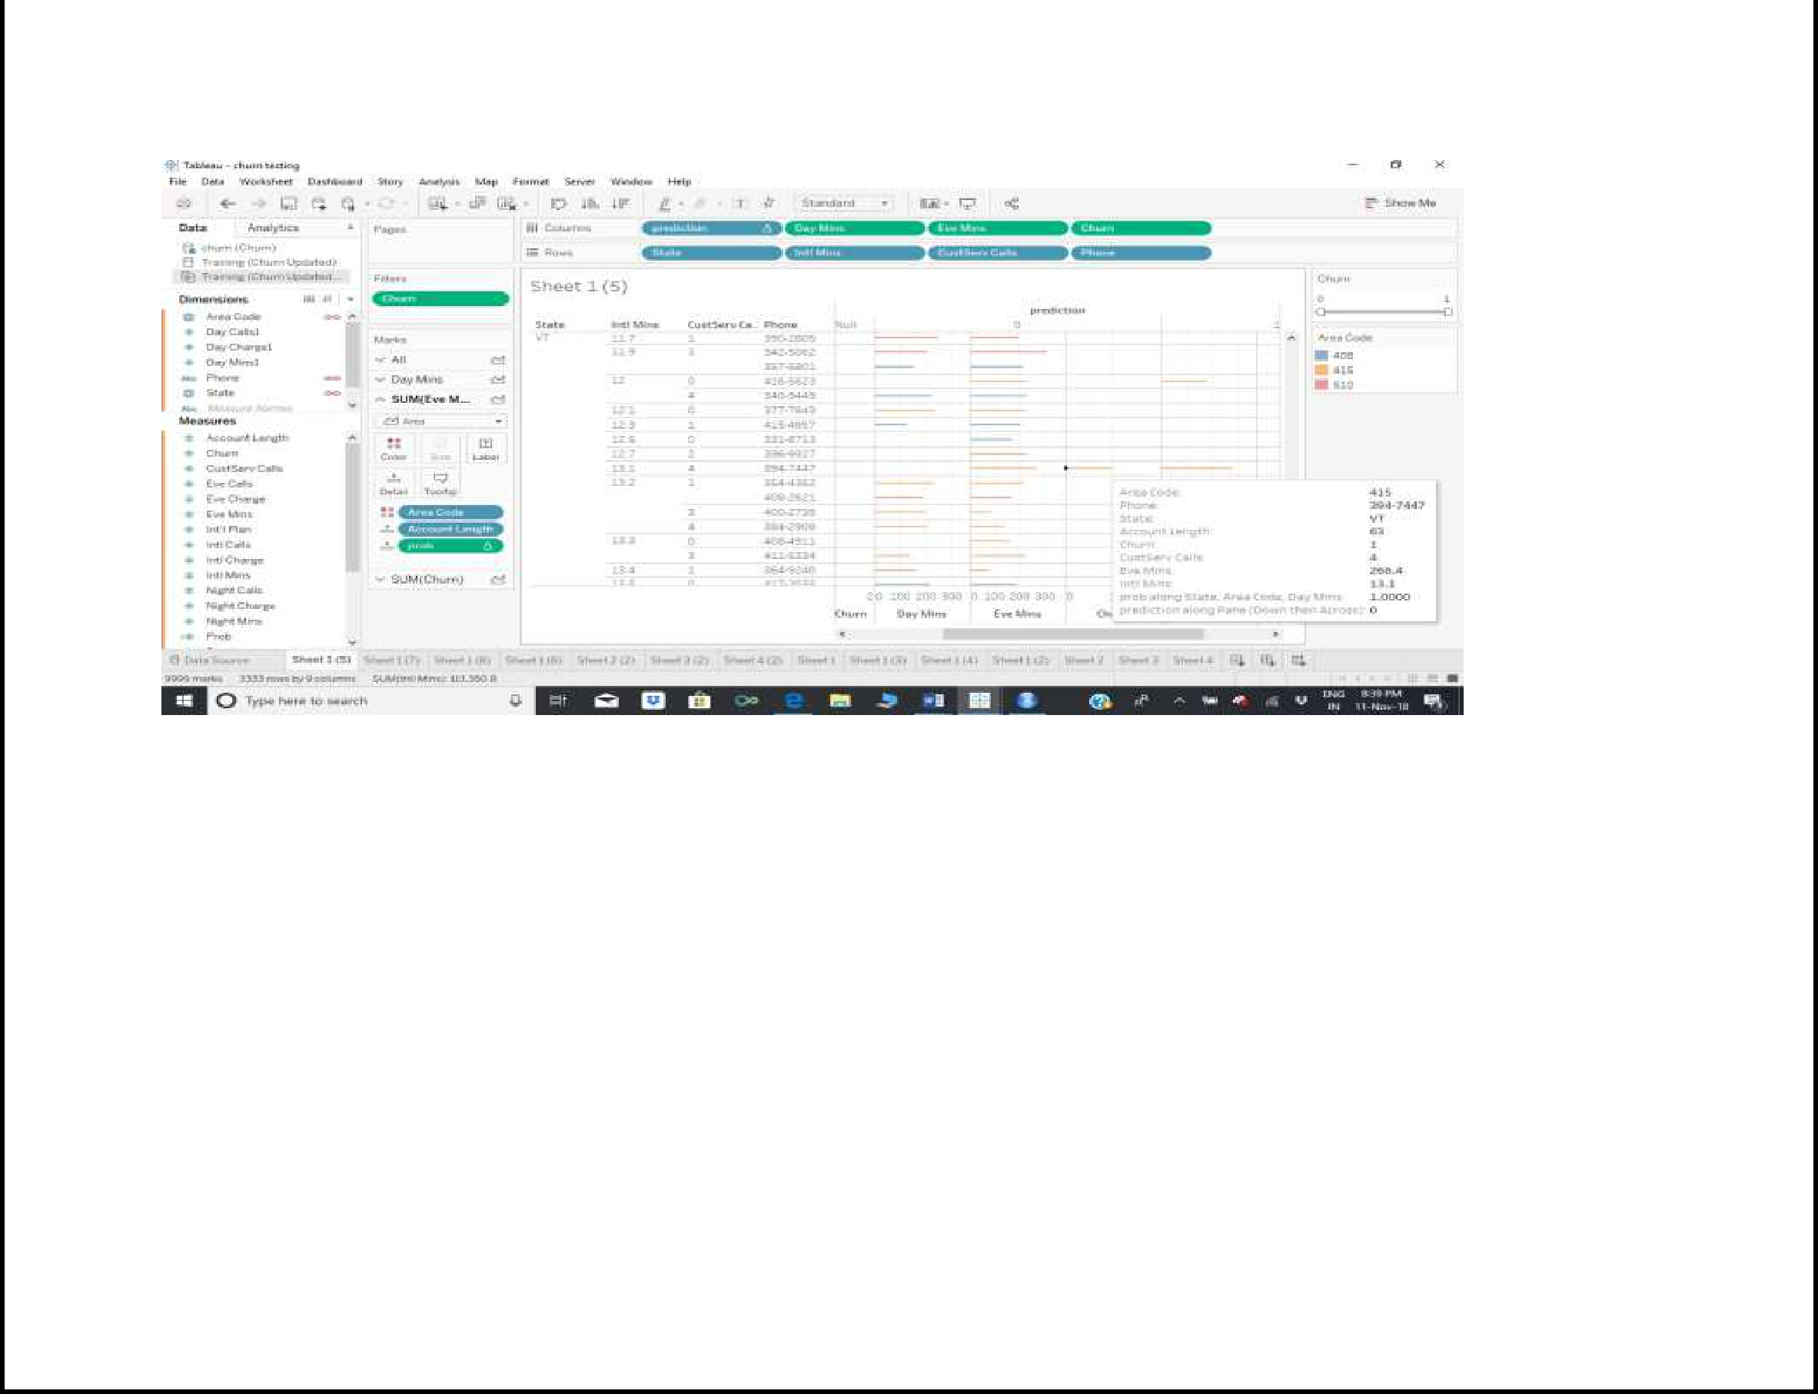

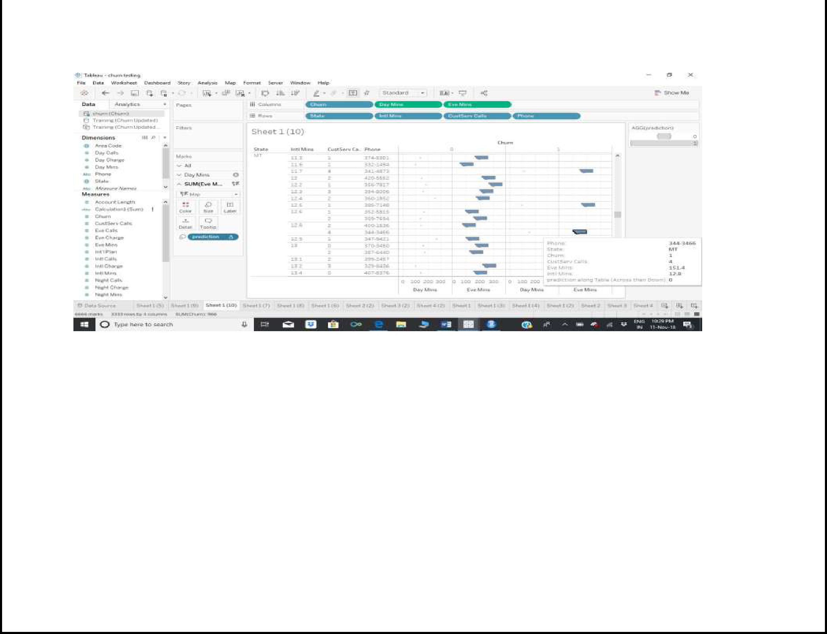

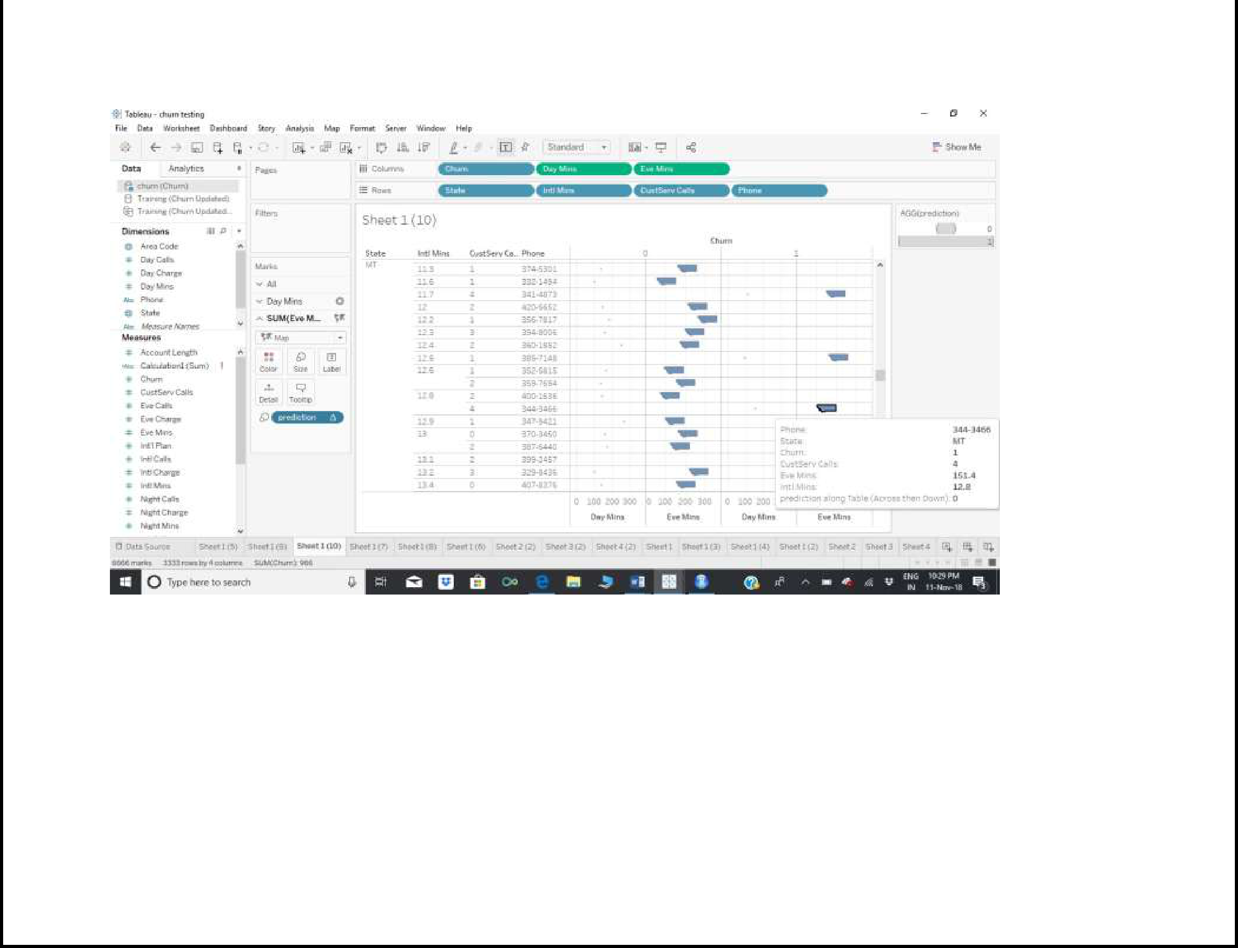

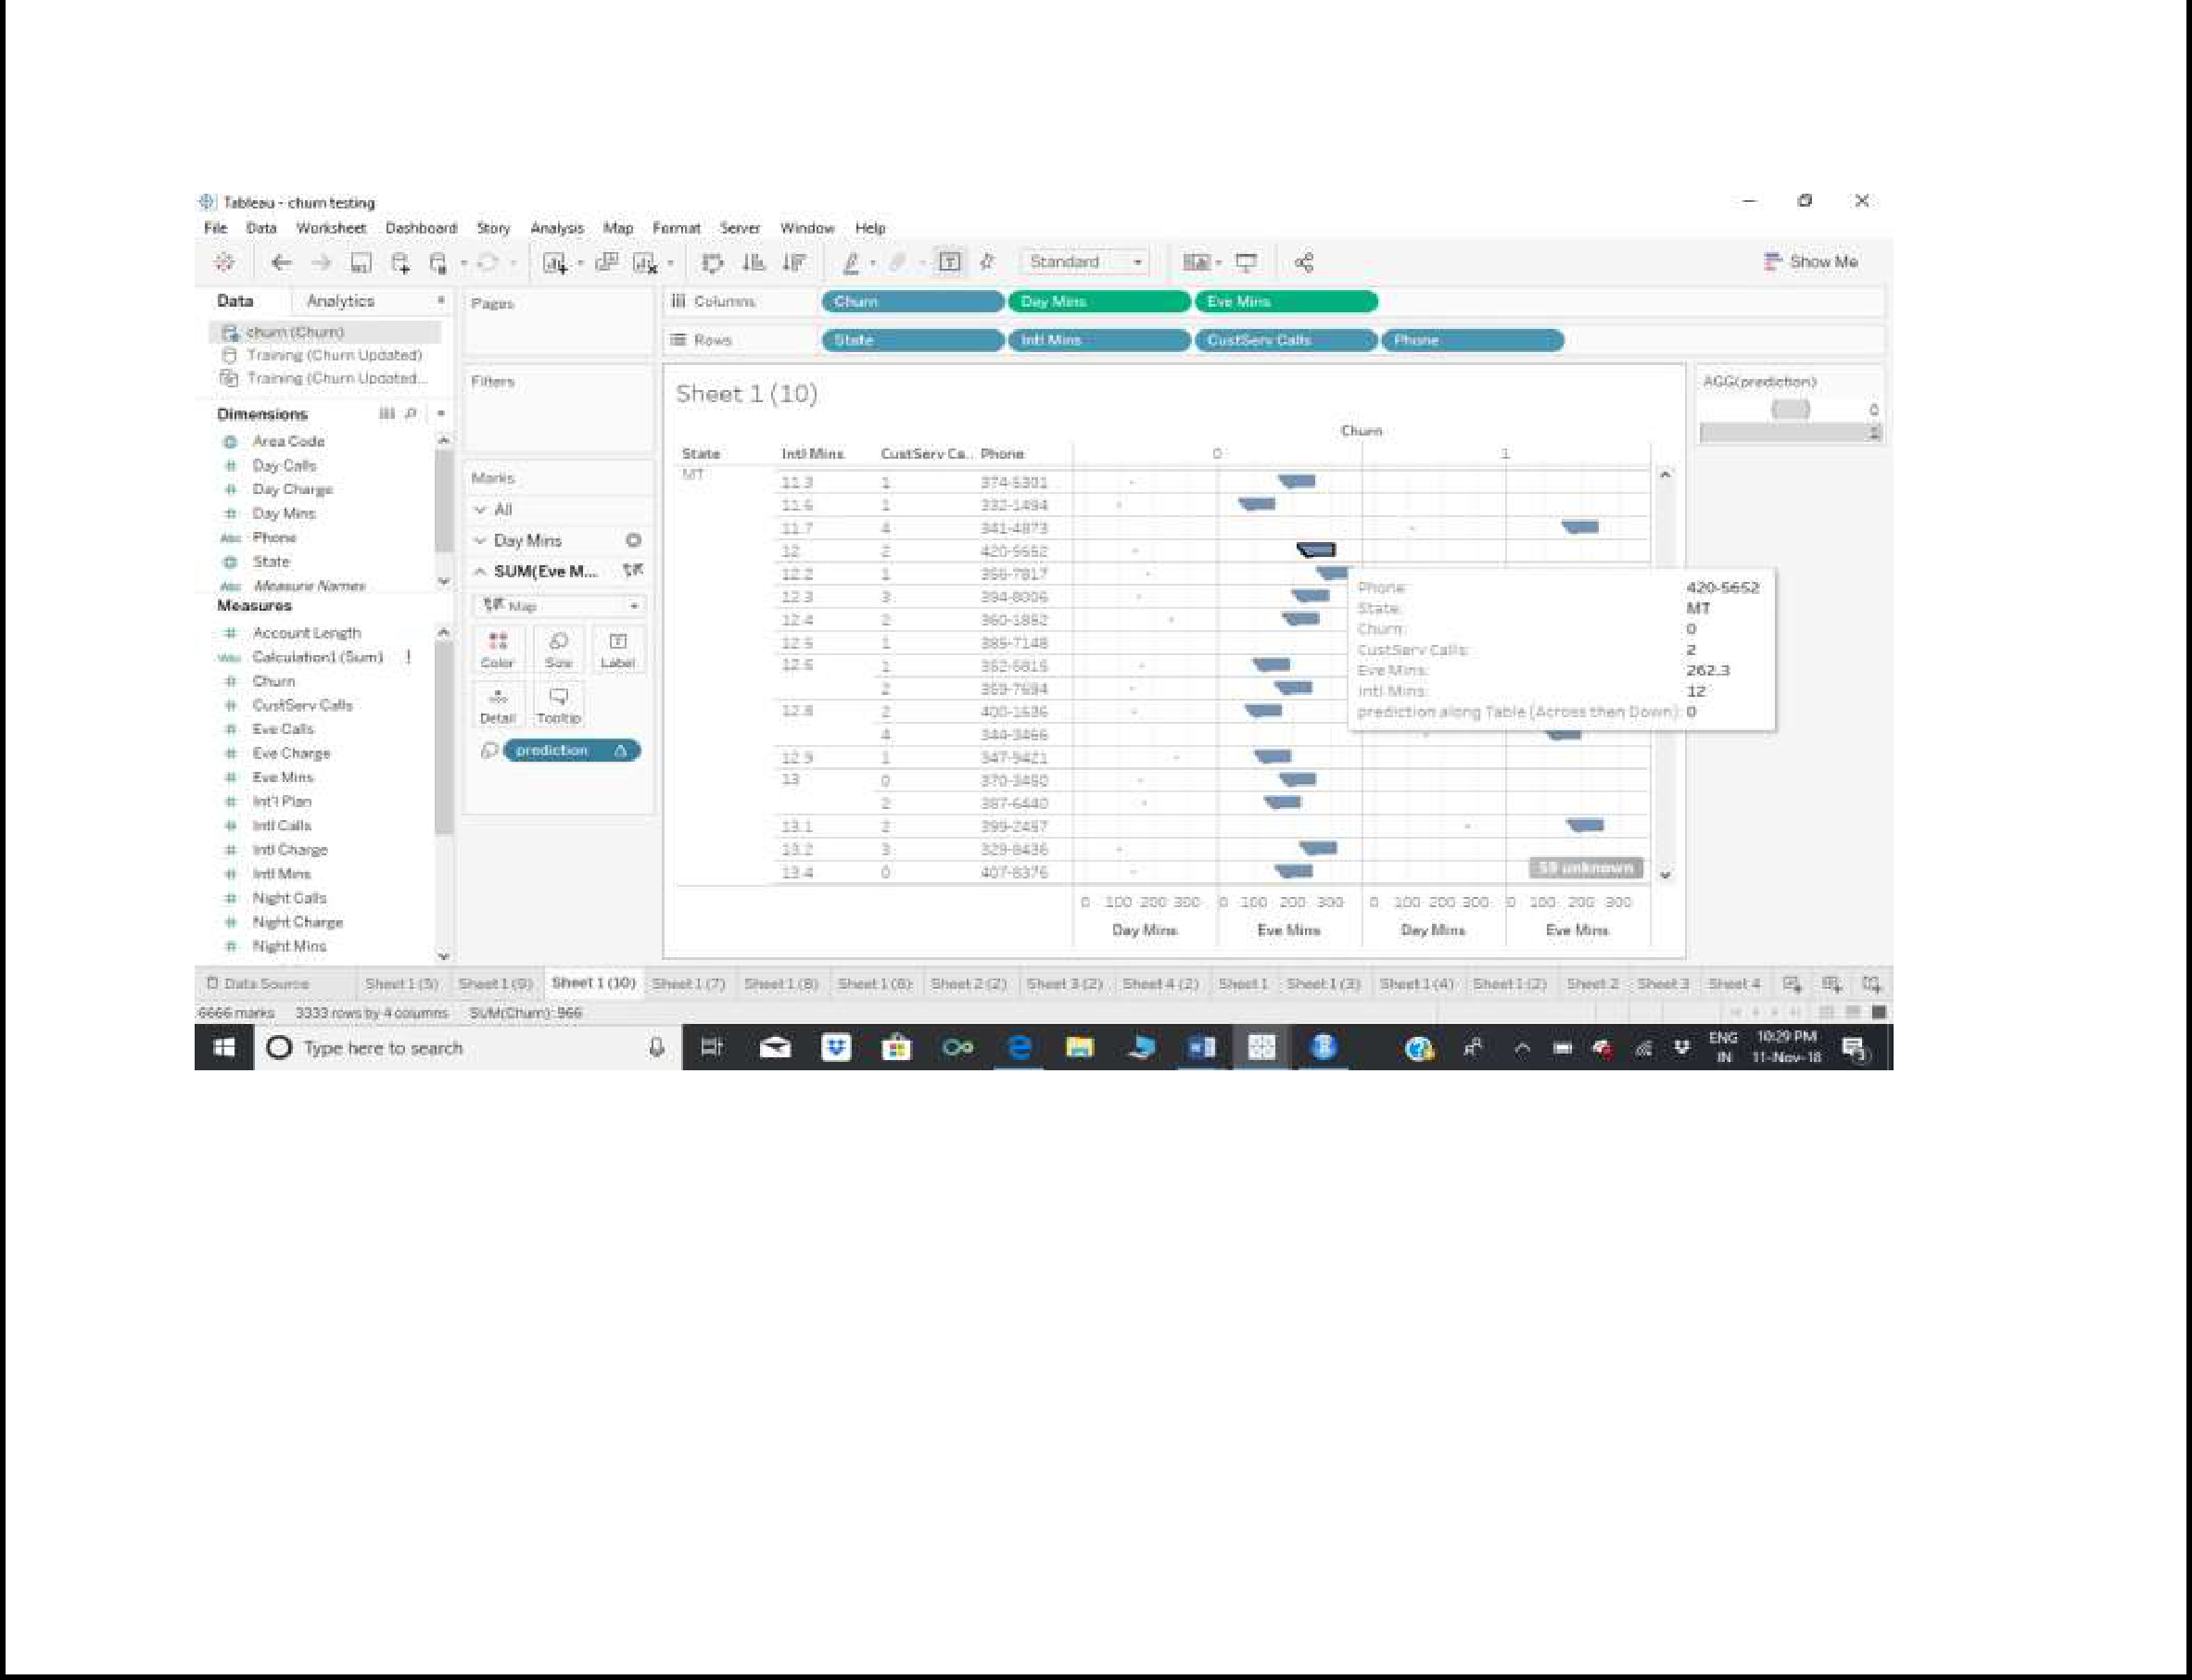

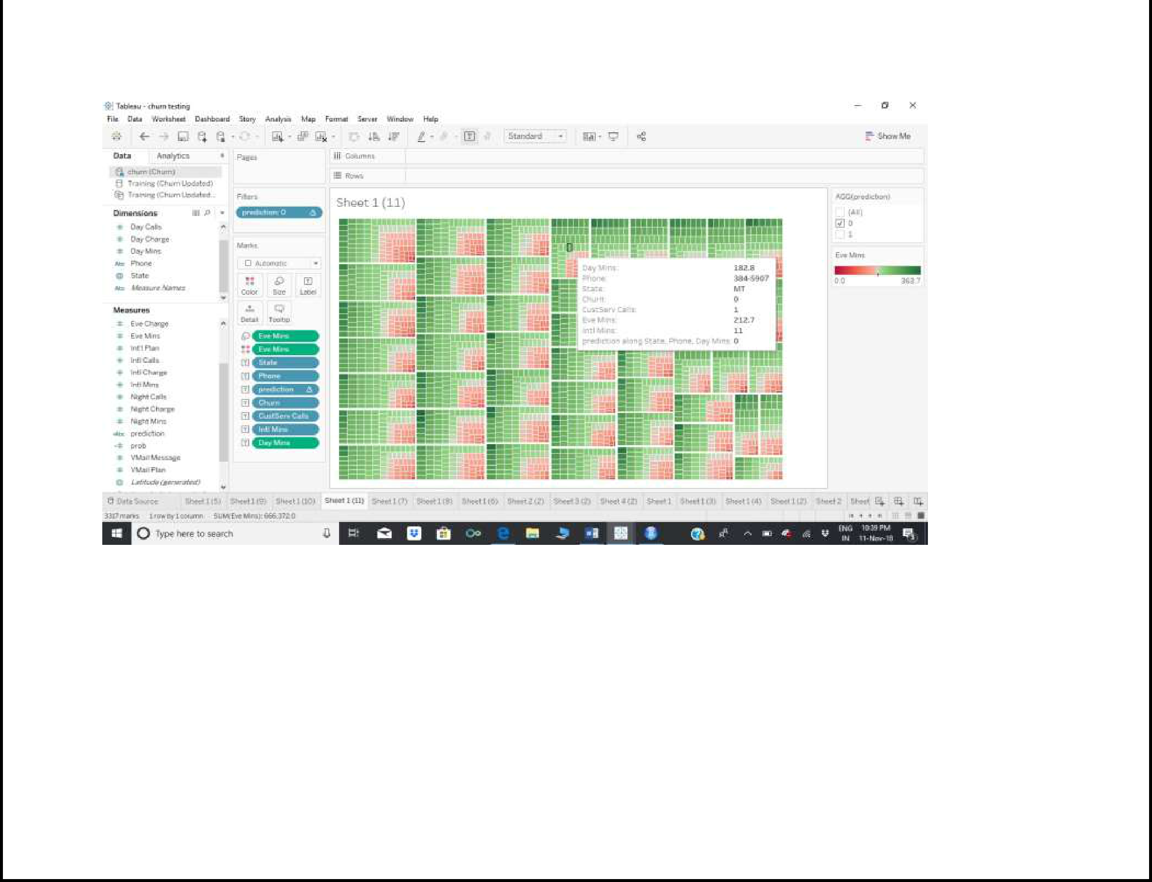

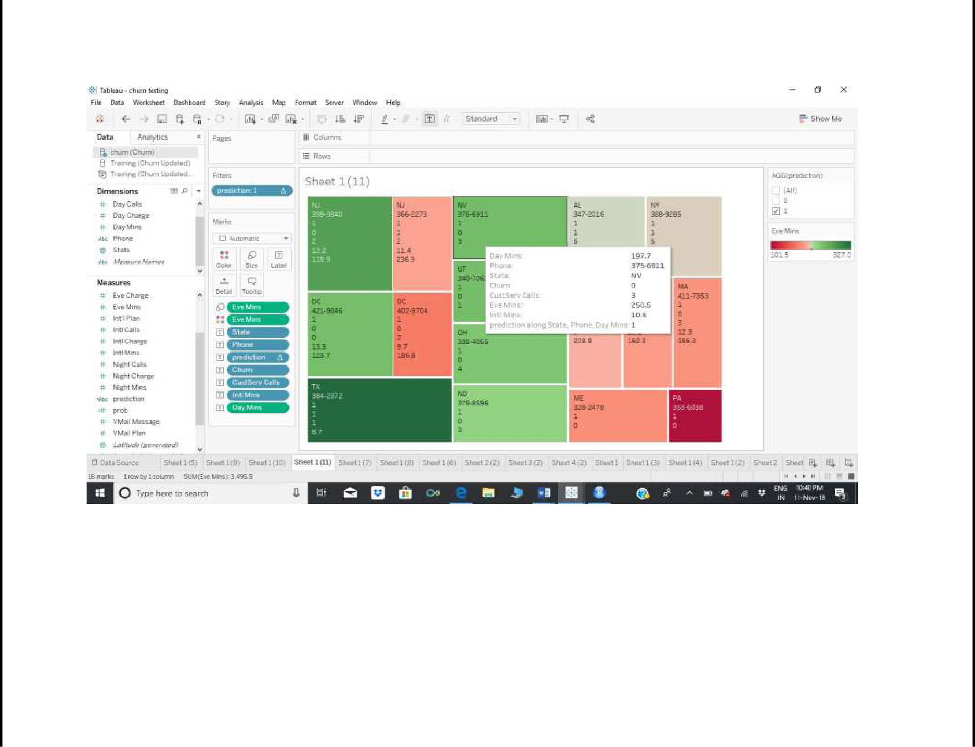

Prediction in slider

we can select 0,1 or All

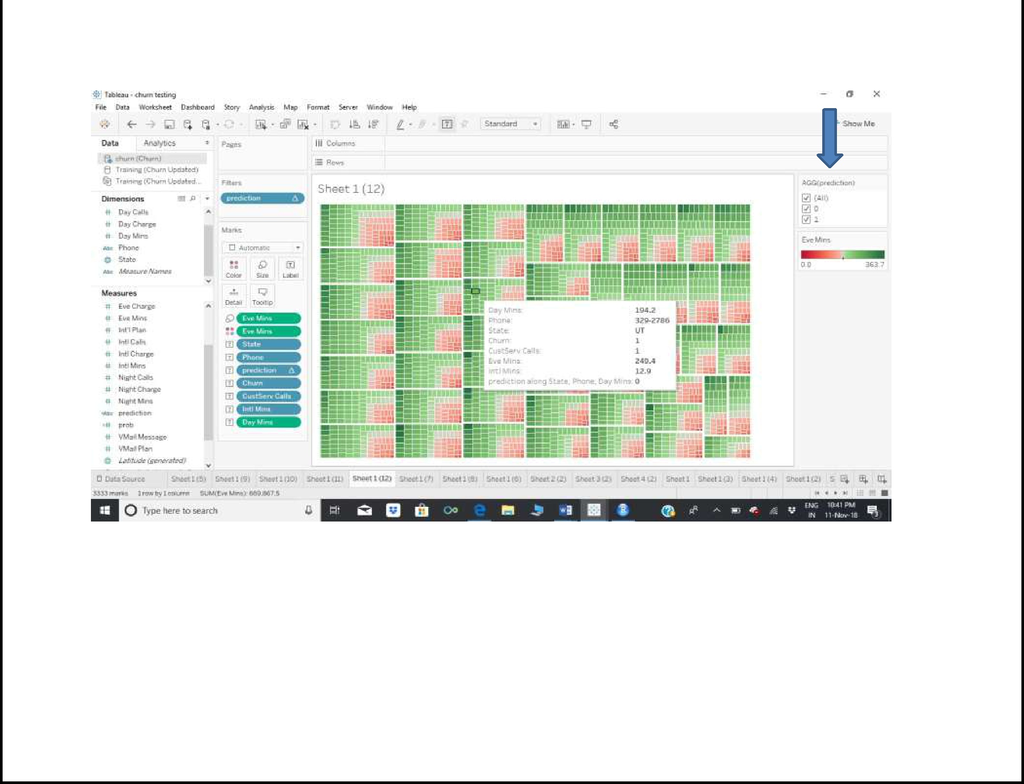

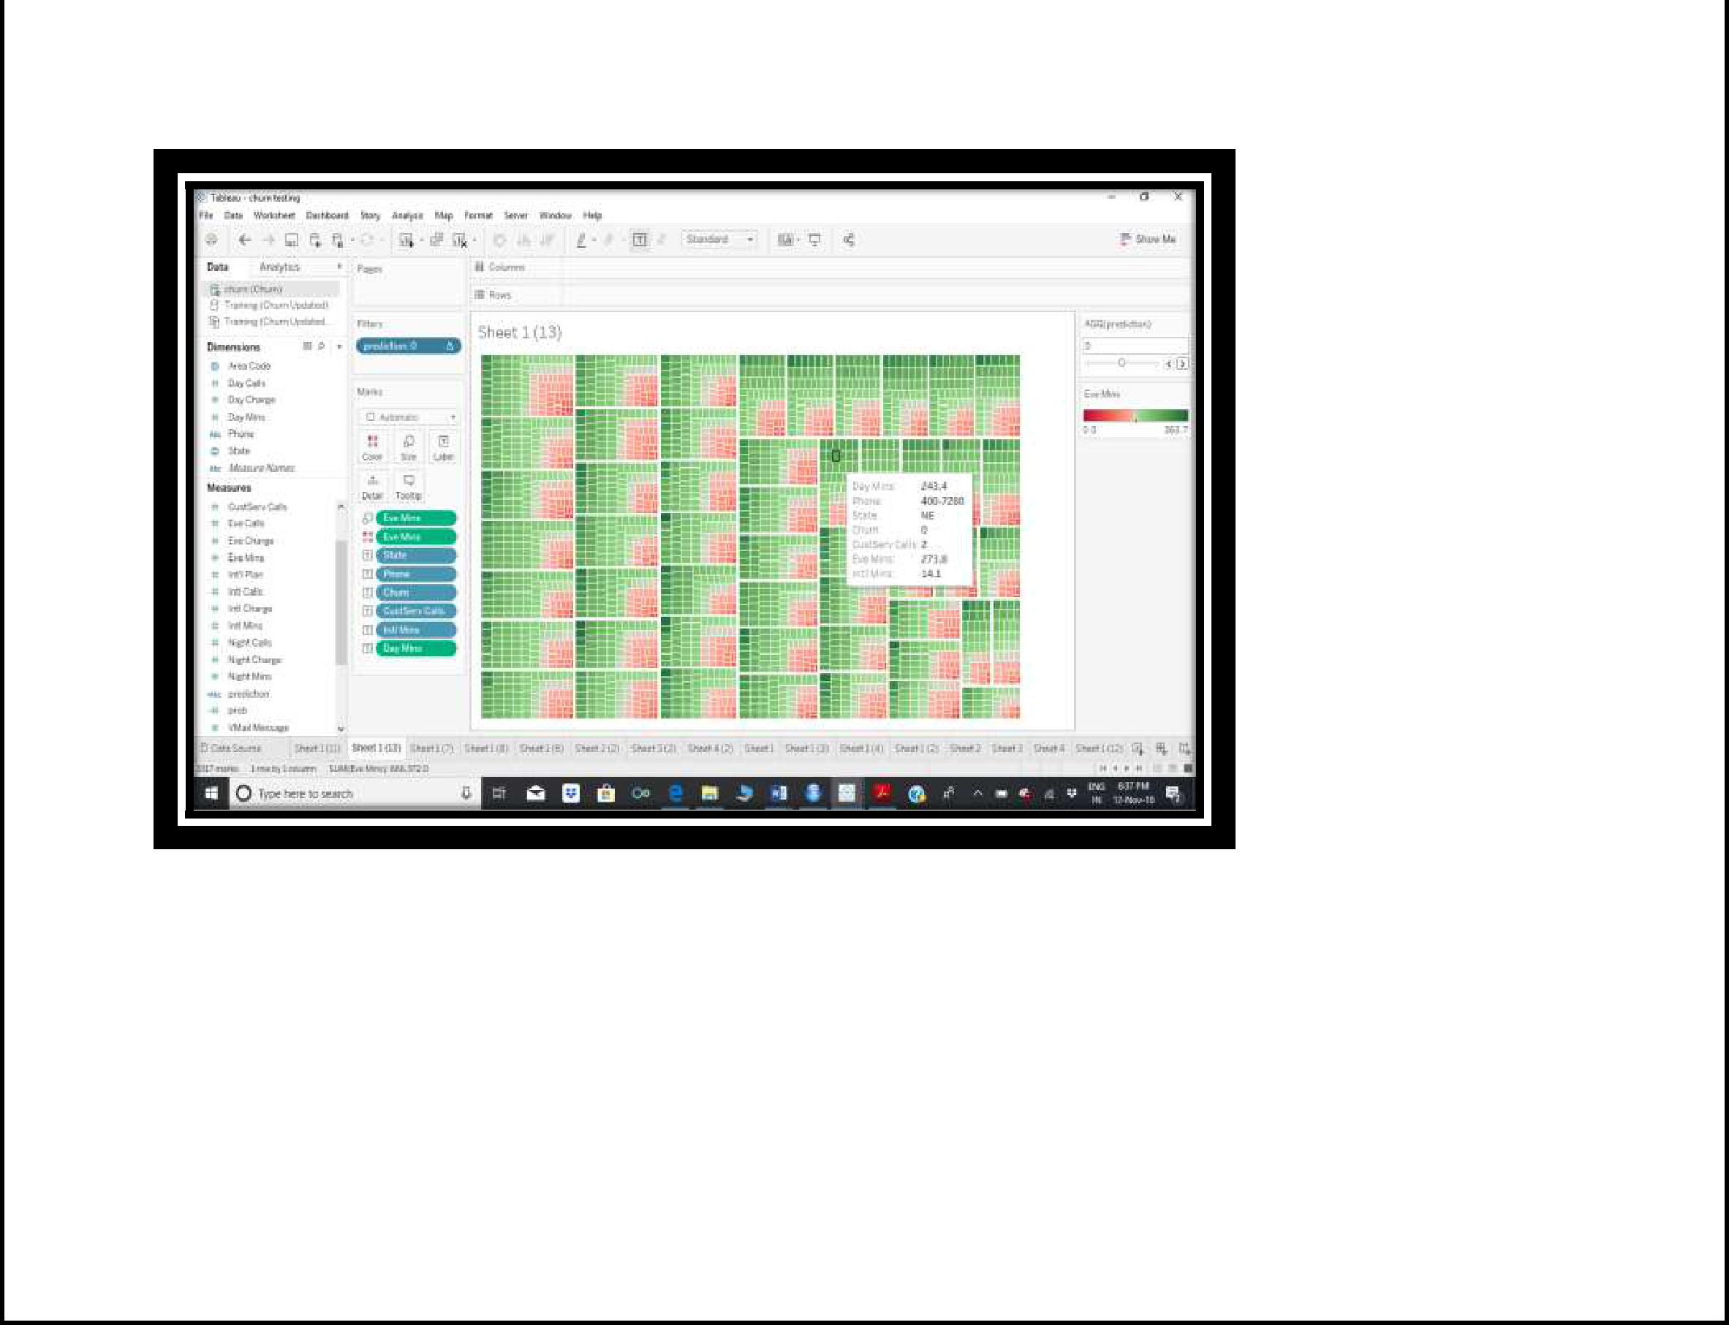

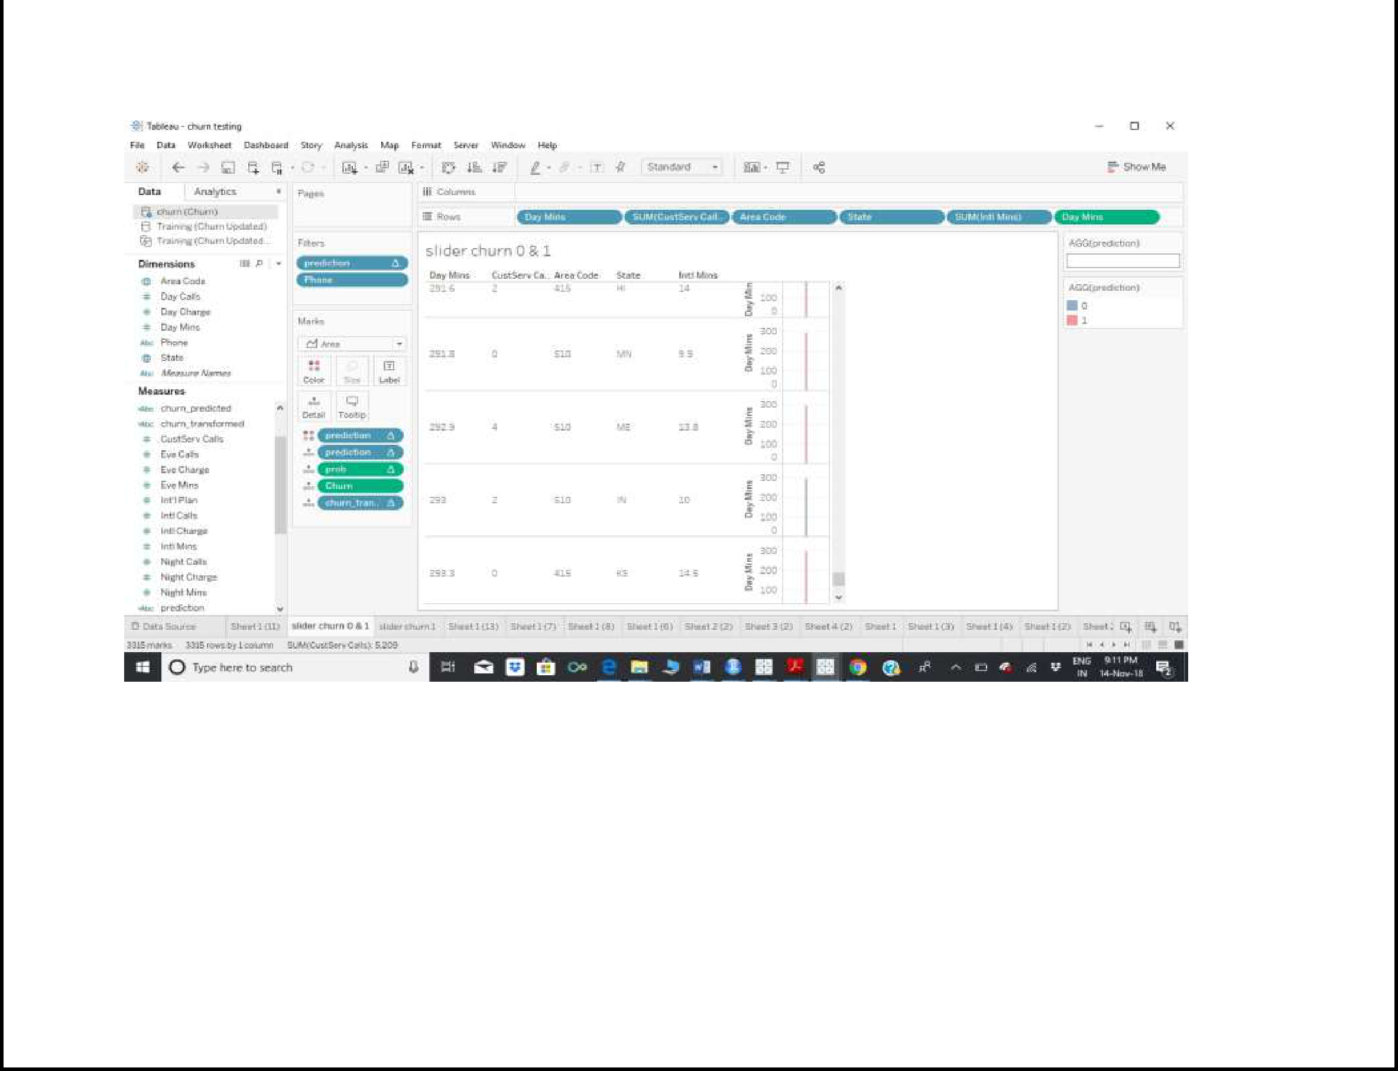

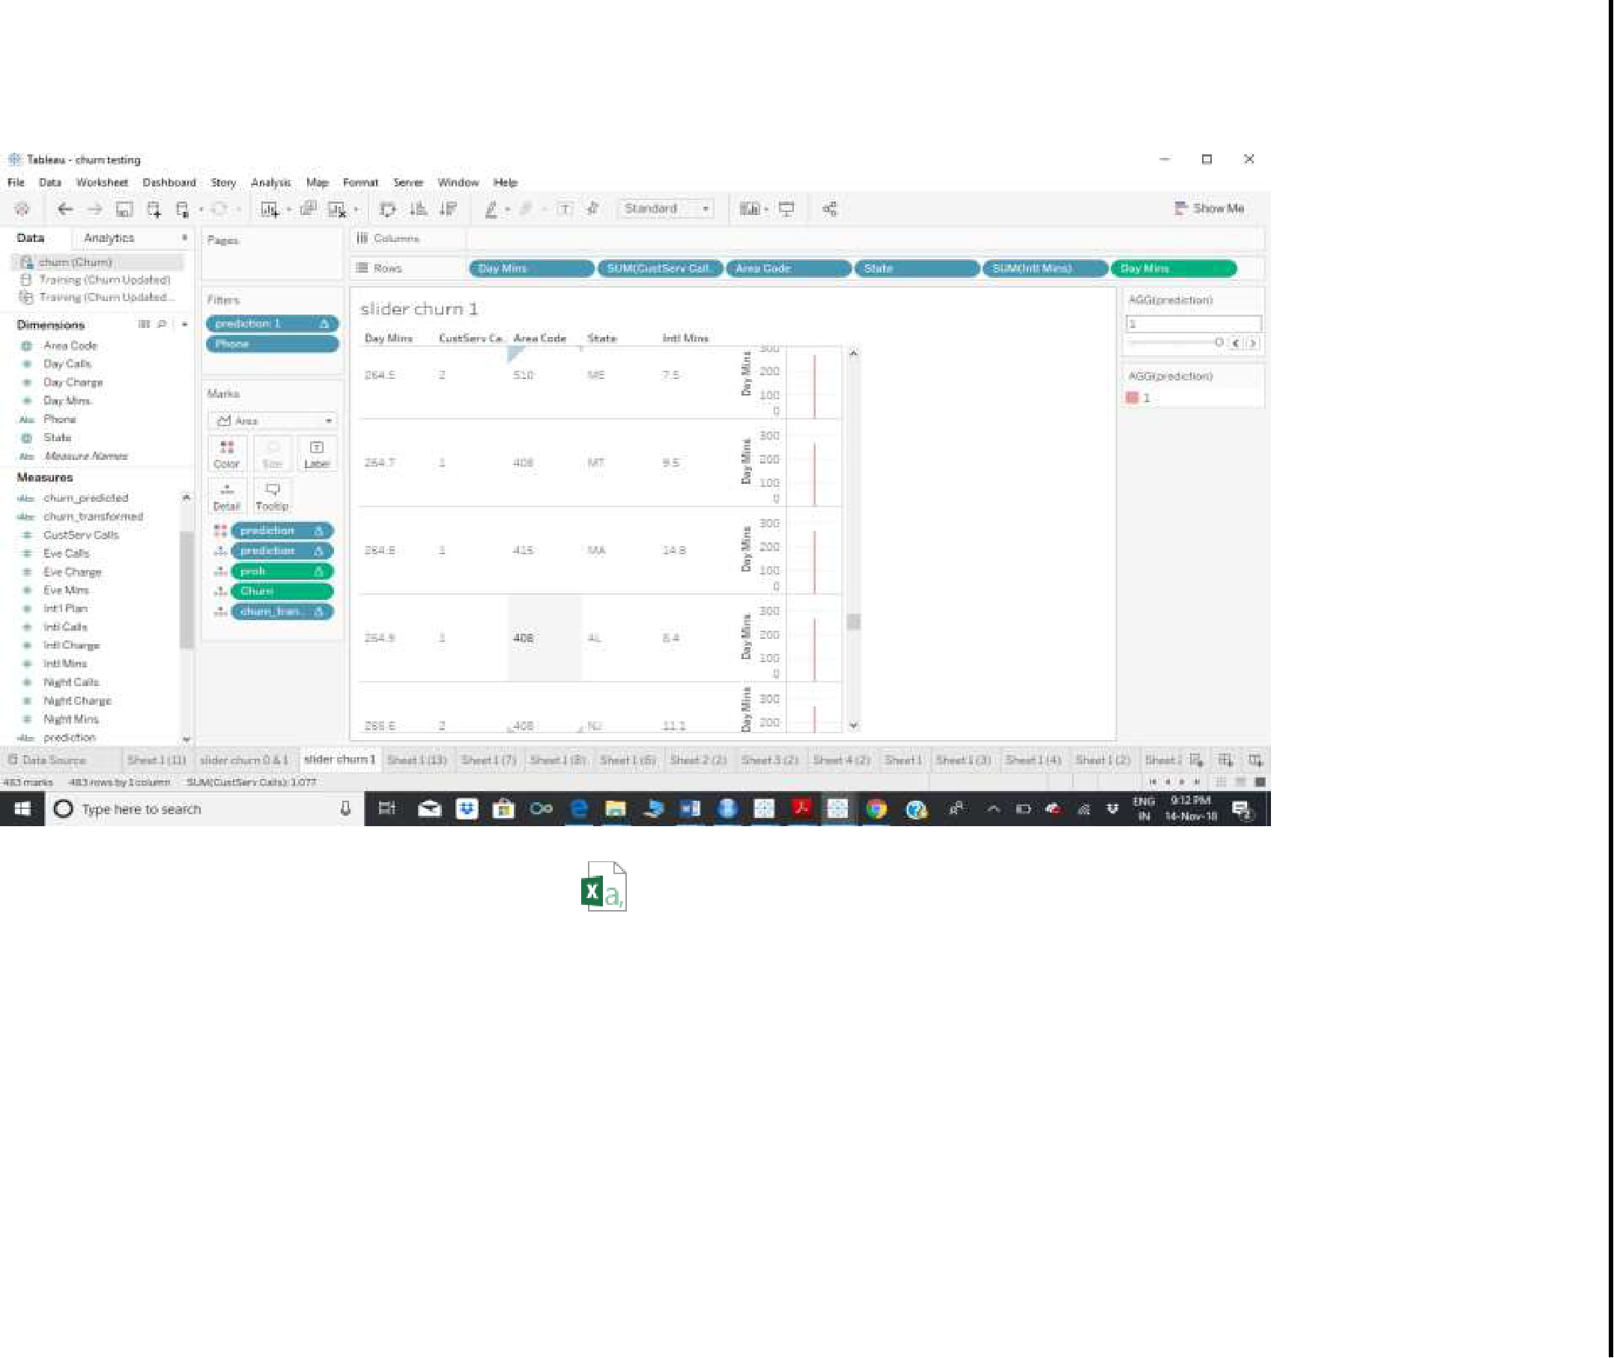

churn

churn all data.csv



churn 0 data.csv



All churn1 data.csv



prediction.csv